LUISA
PICCARRETA
A collection of memories
of the
Servant of God

To Aunt Rosaria,
faithful custodian of the life of the Servant of God Luisa Piccarreta
BERNARDINO GIUSEPPE BUCCI, O.F.M.

LUISA PICCARRETA
A collection of memories of the Servant of God
Property of the author
On the cover:
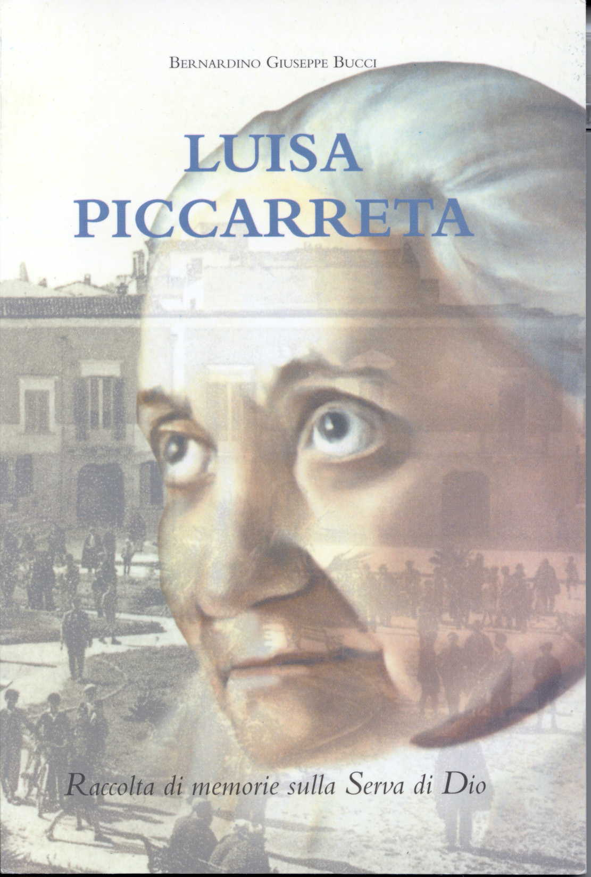
1. Portrait of Luisa Piccarreta by Angela Ciccone
2. Corato, Largo Plebiscito, 1938 (Private collection, Prof. Giuseppe Gallo)
The photographs reproduced in this book are from the "Luisa Piccarreta" Archives of Fr. Bernardino Bucci
Printed by Tipolitografia Miulli
Via Roma 52, San Ferdinando di Puglia - Tel. 0883 622036
© 2000 Property of the author
71049 Trinitapoli, Foggia
Parrocchia Immacolata dei Frati Minori Cappuccini
Nihil obstat imprimatur.
Trani, 4 ottobre 2000
Il Vicario Generale
Mons. Savino Giannotti
NON-COMMERCIAL EDITION
CONTENTS
INTRODUCTION
PREFACE
CHAPTER ONE
Biographical notes
Important dates
Confessors and spiritual advisers
Bishops
List of Luisa Piccarreta’s diaries
CHAPTER TWO
The Kingdom of the Divine Will
Some unpublished prayers
CHAPTER THREE
The healing of the epileptic
The bell of discord
A perfect lace-maker
The mysterious sores
Blessed Padre Pio, Luisa Piccarreta and Rosaria Bucci
Aunt Rosaria’s secret
CHAPTER FOUR
Annibale Maria di Francia and Luisa Piccarreta
Rosaria Bucci’s memories
Blessed Annibale and the Capuchin Friars of the Monastic Province of Puglia
Luisa’s special love for the Capuchins
Fr. Salvatore from Corato and Luisa Piccarreta
CHAPTER FIVE
A strange lunch
The broken promise of mortification
A prophecy
A rough sea
CHAPTER SIX
Promotion to the cardinalate foretold
The bishop healed
CHAPTER SEVEN
Luisa and the children of Corato
The soldier who never was
The baby brought back to life
Isa Bucci and Luisa Piccarreta
Gemma Bucci and Luisa Piccarreta
CHAPTER EIGHT
A healing
The horses’ whim
The "upper room" of Via Panseri
The horse cured
The soldier who became engaged
CHAPTER NINE
Luisa, the terror of demonic forces
The holy death of Luisa Piccarreta
The young man killed and restored to life
BIOGRAPHY OF THE AUTHOR
INTRODUCTION
His loving care to keep alive the memory of the people of our land who with their humble daily work and acceptance of life’s sufferings were distinguished for their love of God and neighbor, was what prompted Fr. Bernardino Bucci, our Capuchin Friar, to write these "family memoirs" of Luisa Piccarreta, nicknamed "Luisa the Saint".
The interest in Luisa is worth mentioning, both because of the attention devoted today to acquiring a deeper knowledge of this mystic (and Luisa is such since with her contemplation and acceptance of physical and spiritual sufferings she attained a remarkable intimacy with Jesus) and because Luisa was known and visited by several of our friars (Fr. Fedele from Montescaglioso, Fr. Guglielmo from Barletta, Fr. Salvatore from Corato, Fr. Terenzio from Campi Salentina, Fr. Daniele from Triggiano, Fr. Antonio from Stigliano, Fr. Giuseppe from Francavilla Fontana, to mention but a few), who were able to communicate to her essential elements of Franciscan spirituality, while from her they assimilated love for Christ and commitment in doing God’s will.
May this book which involved Fr. Bernardino with such love and enthusiasm give enjoyment to all who read it, so that they feel impelled to learn more of Luisa’s spirituality and to further her beatification.
Fr. Mariano Bubbico
Provincial Minister of the Friars Minor Capuchin of Puglia
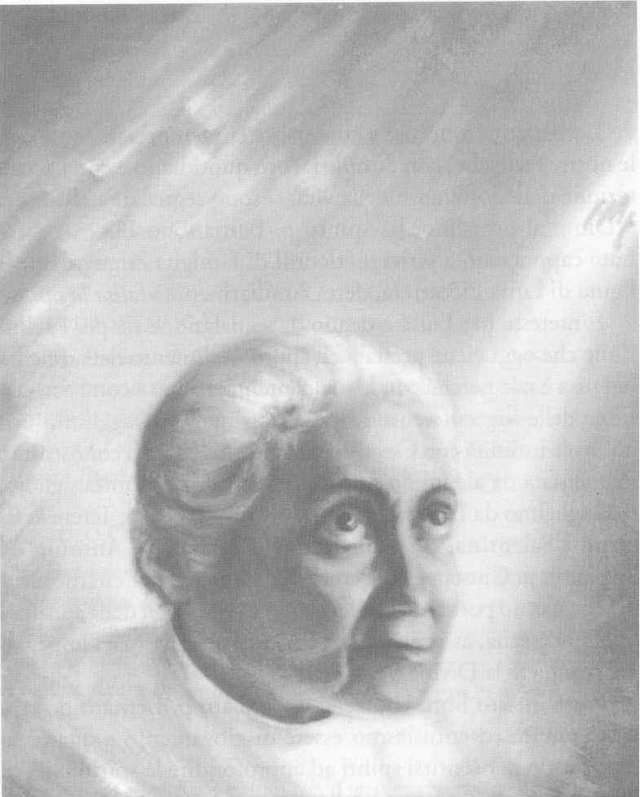
Luisa, contemplating the SUPREME FIAT
PREFACE
The warm insistence of Archbishop Carata of Trani – now emeritus – impelled me to put down in writing the testimonies about Luisa Piccarreta. They were told to me by friends and others who knew the Servant of God personally. In some episodes I was directly involved.
During my childhood I had continuous and direct contact with the Servant of God, made easier by my aunt, Rosaria Bucci, who assisted the her day and night for about forty years. The two of them worked together at lace-making and embroidery by which they earned a living. My relatives were connected to the Piccarreta family by many family ties. My sisters, Isa, Maria and Gemma, were frequent visitors to Luisa’s house, where they learned how to make lace. Gemma, the little one, was the favorite of Luisa who, when she was born, suggested she be given that name. Luisa’s sister, Angelina, was godmother at the baptism and sponsor at my sisters’ confirmations. We were therefore so intimate with her that everyone in the family called her "Aunt Angelina".
We spoke to Luisa with great familiarity. I remember that my mother used to go regularly to Luisa’s house and have long conversations with her. Nothing is known of what they said. I think Luisa foretold her premature death. I presume this from the fact that my mother would often speak of her own death and stressed to us that she had not long to live. She died at the age of fifty-one, three years after Luisa, wearing one of the Servant of God’s nightdresses.
I myself was given holy pictures and images by the Servant of God. Despite our familiarity, I was tongue-tied in Luisa’s presence, spell-bound by her fascination.
I have collected and sorted a wealth of material, but I am unable to organize it all for printing; this would require a lot of work and time which is denied me. I have had to choose and publish what I considered most interesting. By this I do not mean that other episodes recorded do not deserve to be known. I am absolutely convinced that any episode concerning Luisa Piccarreta serves to set her in the context of her time.
I have promised myself to continue the task of organizing and researching the memoirs and to give the printer a more exhaustive biography of the Servant of God, a work I began some time ago, and which I hope I shall complete as soon as possible.
Father Bernadino Giuseppe Bucci
CHAPTER ONE
Biographical notes
The Servant of God Luisa Piccarreta was born in Corato in the Province of Bari, on April 23,1865 and died there in the odor of sanctity on March 4, 1947.
Luisa had the good fortune to be born into one of those patriarchal families that still survive in our realm of Puglia and like to live deep in the country, peopling our farmhouses. Her parents, Vito Nicola and Rosa Tarantino, had five children: Maria, Rachele, Filomena, Luisa and Angela. Maria, Rachele and Filomena married. Angela, commonly called Angelina, remained single and looked after her sister until she died.
Luisa was born on the Sunday after Easter and was baptized that same day. Her father – a few hours after her birth – wrapped her in a blanket and carried her to the parish church where holy Baptism was administered to her.
Nicola Piccarreta was a worker on a farm belonging to the Mastrorilli family, located at the middle of Via delle Murge in a neighborhood called Torre Disperata, 27 kilometers from Corato. Those who know these places, set among the sunny, bare and stony hills, can appreciate the solemnity of the silence that envelops them. Luisa spent many years of her childhood and adolescence on this farm. In front of the old house, the impressive, centuries-old mulberry tree still stands, with the great hollow in its trunk where Luisa used to hide when she was little in order to pray, far from prying eyes. It was in this lonely, sunny spot place that Luisa’s divine adventure began which was to lead her down the paths of suffering and holiness. Indeed, it was in this very place that she came to suffer unspeakably from the attacks of the devil who at times even tormented her physically. Luisa, to be rid of this suffering, turned ceaselessly to prayer, addressing in particular the Virgin Most Holy, who comforted her by her presence.
Divine Providence led the little girl down paths so mysterious that she knew no joys other than God and his grace. One day, in fact, the Lord said to her: "I have gone round and round the world again and again, and I looked one by one at all my creatures to find the smallest one of all. Among so many I found you. Your littleness pleased me and I chose you; I entrusted you to my angels so that they would care for you, not to make you great, but to preserve your littleness, and now I want to begin the great work of fulfilling my will. Nor will you feel any greater through this, indeed it is my will to make you even smaller, and you will continue to be the little daughter of the Divine Will" (cf. Volume XII, March 23, 1921).
When she was nine, Luisa received Jesus in the Eucharist for the first time and Holy Confirmation, and from that moment learned to remain for hours praying before the Blessed Sacrament. When she was eleven she wanted to enroll in the Association of the Daughters of Mary – flourishing at the time – in the Church of San Giuseppe. At the age of eighteen, Luisa became a Dominican Tertiary taking the name of Sr. Maddalena. She was one of the first to enroll in the Third Order, which her parish priest was promoting. Luisa’s devotion to the Mother of God was to develop into a profound Marian spirituality, a prelude to what she would one day write about Our Lady.
Jesus’ voice led Luisa to detachment from herself and from everyone. At about eighteen, from the balcony of her house in Via Nazario Sauro, she had a vision of Jesus suffering under the weight of the Cross, who raised his eyes to her saying: "O soul, help me!". From that moment an insatiable longing to suffer for Jesus and for the salvation of souls was enkindled in Luisa. So began those physical sufferings which, in addition to her spiritual and moral sufferings, reached the point of heroism.
The family mistook these phenomena for sickness and sought medical help. But all the doctors consulted were perplexed at such an unusual clinical case. Luisa was subject to a state of corpse-like rigidity – although she showed signs of life – and no treatment could relieve her of this unspeakable torment. When all the resources of science had been exhausted, her family turned to their last hope: priests. An Augustinian priest, Fr. Cosma Loiodice, at home because of the Siccardian* laws, was summoned to her bedside: to the wonder of all present, the sign of the Cross which this priest made over the poor body, sufficed to restore her normal faculties instantly to the sick girl. After Fr. Loiodice had left for his friary, certain secular priests were called in who restored Luisa to normality with the sign of the Cross. She was convinced that all priests were holy, but one day the Lord told her: "Not because they are all holy – indeed, if they only were! – but simply because they are the continuation of my priesthood in the world you must always submit to their priestly authority; never oppose them, whether they are good or bad" (cf. Volume I). Throughout her life, Luisa was to be submissive to priestly authority. This was to be one of the greatest sources of her suffering. Her daily need for the priestly authority in order to return to her usual tasks was her deepest mortification. In the beginning, she suffered the most humiliating misunderstandings on the part of the priests themselves who considered her a lunatic filled with exalted ideas, who simply wanted to attract attention. Once they left her in that state for more than twenty days. Luisa, having accepted the role of victim, came to experience a most peculiar condition: every morning she found herself rigid, immobile, huddled up in bed, and no one was able to stretch her out, to raise her arms or move her head or legs. As we know, it required the presence of a priest who, by blessing her with the sign of the Cross, dispelled that corpse-like rigidity and enabled her to return to her usual tasks (lace-making). She was a unique case in that her confessors were never spiritual directors, a task that Our Lord wanted to keep for himself. Jesus made her hear his voice directly, training her, correcting her, reprimanding her if necessary and gradually leading her to the loftiest peaks of perfection. Luisa was wisely instructed and prepared during many years to receive the gift of the Divine Will.
The archbishop at that time, Giuseppe Bianchi Dottula (December 22, 1848-September 22,1892), came to know of what was happening in Corato; having heard the opinion of several priests, he wished to exercise his authority and assume responsibility for this case. After mature reflection he thought it right to delegate to Luisa a special confessor, Fr. Michele De Benedictis, a splendid figure of a priest, to whom she opened every nook and cranny of her soul. Fr. Michele, a prudent priest with holy ways, imposed limits on her suffering and instructed her to do nothing without his permission. Indeed, it was Fr. Michele who ordered her to eat at least once a day, even if she immediately threw up everything she had swallowed. Luisa was to live on the Divine Will alone. It was under this priest that she received permission to stay in bed all the time as a victim of expiation. This was in 1888. Luisa remained nailed to her bed of pain, sitting there for another 59 years, until her death. It should be noted that until that time, although she had accepted her state as a victim, she had only occasionally stayed in bed, since obedience had never permitted her to stay in bed all the time. However, from New Year 1889 she was to remain there permanently.
In 1898 the new prelate, Archbishop Tommaso de Stefano (March 24, 1898 - 13 May 1906) delegated as her new confessor Fr. Gennaro Di Gennaro, who carried out this task for twenty-four years. The new confessor, glimpsing the marvels that the Lord was working in this soul, categorically ordered Luisa to put down in writing all that God’s grace was working within her. None of the excuses made by the Servant of God to avoid obeying her confessor in this were to any avail. Not even her scant literary education could excuse her from obedience to her confessor. Fr. Gennaro Di Gennaro remained cold and implacable, although he knew that the poor woman had only been to elementary school. Thus on February 28, 1899, she began to write her diary, of which there are thirty-six large volumes! The last chapter was written on December 28, 1939, the day on which she was ordered to stop writing.
Her confessor, who died on September 10,1922, was succeeded by the canon, Fr. Francesco De Benedictis, who only assisted her for four years, because he died on January 30, 1926. Archbishop Giuseppe Leo (January 17, 1920-January 20,1939) delegated a young priest, Fr. Benedetto Calvi, as her ordinary confessor. He stayed with Luisa until she died, sharing all those sufferings and misunderstandings that beset the Servant of God in the last years of her life.
At the beginning of the century, our people were lucky enough to have Blessed Annibale Maria Di Francia present in Puglia. He wanted to open in Trani male and female branches of his newly founded congregation. When he heard about Luisa Piccarreta, he paid her a visit and from that time these two souls were inseparably linked by their common aims. Other famous priests also visited Luisa, such as, for example, Fr. Gennaro Braccali, the Jesuit, Fr. Eustachio Montemurro, who died in the odor of sanctity, and Fr. Ferdinando Cento, Apostolic Nuncio and Cardinal of Holy Mother Church. Blessed Annibale became her extraordinary confessor and edited her writings, which were little by little properly examined and approved by the ecclesiastical authorities. In about 1926, Blessed Annibale ordered Luisa to write a book of memoirs of her childhood and adolescence. He published various writings of Luisa’s, including the book L’orologio della Passione, which acquired widespread fame and was reprinted four times. On October 7,1928, when the house of the sisters of the Congregation of Divine Zeal in Corato was ready, Luisa was taken to the convent in accordance with the wishes of Blessed Annibale. Blessed Annibale had already died in the odor of sanctity in Messina.
In 1938, a tremendous storm was unleashed upon Luisa Piccarreta: she was publicly disowned by Rome and her books were put on the Index. At the publication of the condemnation by the Holy Office, she immediately submitted to the authority of the Church.
A priest was sent from Rome by the ecclesiastical authorities, who asked her for all her manuscripts, which Luisa handed over promptly and without a fuss. Thus all her writings were hidden away in the secrecy of the Holy Office.
On October 7, 1938, because of orders from above, Luisa was obliged to leave the convent and find a new place to live. She spent the last nine years of her life in a house in Via Maddalena, a place which the elderly of Corato know well and from where, on March 8, 1947, they saw her body carried out.
Luisa’s life was very modest; she possessed little or nothing. She lived in a rented house, cared for lovingly by her sister Angela and a few devout women. The little she had was not even enough to pay the rent. To support herself she worked diligently at making lace, earning from this the pittance she needed to keep her sister, since she herself needed neither clothes nor shoes. Her sustenance consisted of a few grams of food, which were prepared for her by her assistant, Rosaria Bucci. Luisa ordered nothing, desired nothing, and instantly vomited the food she swallowed. She did not look like a person near death’s door, but nor did she appear perfectly healthy. Yet she was never idle, she spent her energy either in her daily suffering or her work, and her life, for those who knew her well, was considered a continuous miracle.
Her detachment from any payments that did not come from her daily work was marvelous! She firmly refused money and the various presents offered to her on any pretext. She never accepted money for the publication of her books. Thus one day she told Blessed Annibale that she wanted to give him the money from her author’s royalties: "I have no right to it, because what is written there is not mine" (cf. Preface of the L’orologio della Passione, Messina, 1926). She scornfully refused and returned the money that pious people sometimes sent her.
Luisa’s house was like a monastery, not to be entered by any curious person. She was always surrounded by a few women who lived according to her own spirituality, and by several girls who came to her house to learn lace-making. Many religious vocations emerged from this "upper room". However, her work of formation was not limited to girls alone, many young men were also sent by her to various religious institutes and to the priesthood.
Her day began at about 5.00 a.m., when the priest came to the house to bless it and to celebrate Holy Mass. Either her confessor officiated, or some delegate of his: a privileged granted by Leo XIII and confirmed by St. Pius X in 1907. After Holy Mass, Luisa would remain in prayer and thanksgiving for about two hours. At about 8.00 a.m. she would begin her work which she continued until midday; after her frugal lunch she would stay alone in her room in meditation. In the afternoon – after several hours of work – she would recite the holy Rosary. In the evening, towards 8.00 p.m., Luisa would begin to write her diary; at about midnight she would fall asleep. In the morning she would be found immobile, rigid, huddled up on her bed, her head turned to the right, and the intervention of priestly authority would be necessary to recall her to her daily tasks and allow her to sit up in bed.
Luisa died at the age of eighty-one years, ten months and nine days, on March 4, 1947, after a fortnight of illness, the only one diagnosed in her life, a bad attack of pneumonia. She died at the end of the night, at the same hour when every day the priest’s blessing had freed her from her state of rigidity. Archbishop Francesco Petronelli (May 25, 1939-June 16, 1947) archbishop at the time. Luisa remained sitting up in bed. It was impossible to lay her out and – an extraordinary phenomenon – her body never suffered rigor mortis and remained in the position in which it had always been.
Hardly had the news of Luisa’s death spread, like a river in full spate, all the people streamed into her house and police intervention was necessary to control the crowds that flocked there day and night to visit Luisa, a woman very dear to them. A voice rang out: "Luisa the Saint has died". To contain all the people who were going to see her, with the permission of the civil authorities and health officials, her body was exposed for four days with no sign of corruption. Luisa did not seem dead, she was sitting up in bed, dressed in white; it was as though she were asleep, because as has already been said, her body did not suffer rigor mortis. Indeed, without any effort her head could be moved in all directions, her arms raised, her hands and all her fingers bent. It was even possible to lift her eyelids and see her shining eyes that had not grown dim. Everyone believed that she was still alive, immersed in a deep sleep. A council of doctors, summoned for this purpose, declared, after attentively examining the corpse, that Luisa was truly dead and that her death should be accepted as real and not merely apparent, as everyone had imagined.
Luisa had said that she was born "upside down", and that therefore it was right that her death should be "upside down" in comparison with that of other creatures. She remained in a sitting position as she had always lived, and had to be carried to the cemetery in this position, in a coffin specially made for her with a glass front and sides, so that she could be seen by everyone, like a queen upon her throne, dressed in white with the Fiat on her breast. More than forty priests, the chapter and the local clergy took part in the funeral procession; the sisters took turns to carry her on their shoulders, and an immense crowd of citizens surrounded her: the streets were incredibly full; even the balconies and rooftops of the houses were swarming with people, so that the procession wound slowly onwards with great difficulty. The funeral rite of the little daughter of the Divine Will was celebrated in the main church by the entire chapter. All the people of Corato followed the body to the cemetery. Everyone tried to take home a keepsake or a flower, after having touched her body with it; a few years later, her remains were translated to the parish of Santa Maria Greca.
In 1994, on the day of the Feast of Christ the King, in the main church, Archbishop Carmelo Cassati, in the presence of a large crowd including foreign representatives, officially opened the beatification cause of the Servant of God Luisa Piccarreta.
Important dates
1865 - Luisa Piccarreta was born on April 23, the Sunday after Easter, in Corato, Bari, to Nicola Vito and Rosa Tarantino, who had five daughters: Maria, Rachele, Filomena, Luisa and Angela. A few hours after Luisa’s birth, her father wrapped her in a blanket and took her to the main church for baptism. Her mother had not suffered the pangs of labor: her birth was painless.
1872 - She received Jesus in the Eucharist on the Sunday after Easter, and the sacrament of Confirmation was administered to her on that same day by Archbishop Giuseppe Bianchi Dottula of Trani.
1883 - At the age of eighteen, from the balcony of her house, she saw Jesus, bent beneath the weight of the Cross, who said to her: "O soul! Help me!". From that moment, solitary soul that she was, she lived in continuous union with the ineffable sufferings of her Divine Bridegroom.
1888 - She became a Daughter of Mary and a Dominican Tertiary with the name of Sr. Maddalena
1885-1947 - A chosen soul, a seraphic bride of Christ, humble and devout, whom God had endowed with extraordinary gifts, an innocent victim, a lightening conductor of Divine Justice, bedridden for sixty-two years without interruption, she was a herald of the Kingdom of the Divine Will.
March 4 - Full of merits, in the eternal light of the Divine Will she ended her days as she had lived them, to triumph with the angels and saints in the eternal splendor of the Divine Will.
March 7 - For four days her mortal remains were exposed for the veneration of an immense throng of the faithful who went to her house to have a last look at Luisa the Saint, so dear to their hearts. The funeral was a realm triumph; Luisa passed like a queen, borne aloft on shoulders among the lines of people. All the clergy, secular and religious, accompanied Luisa’s body. The funeral liturgy took place in the main church with the participation of the entire chapter. In the afternoon, Luisa was buried in the family Chapel of the Calvi family.
Jul 3,1963 - Her mortal remains were definitively laid to rest in Santa Maria Greca.
Nov 20, - Feast of Christ the King: Archbishop Cassati officially opened the
1994 beatification cause of the Servant of God Luisa Piccarreta in the principal church of Corato, in the presence of a huge crowd of people, locals and foreigners.
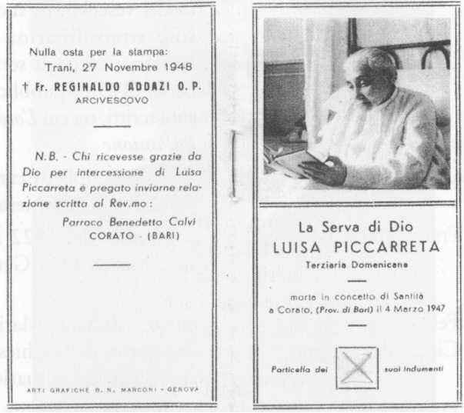
The first holy picture with an image of the Servant of God Luisa Piccarreta, printed in 1948 with the imprimatur of Archbishop Reginaldo Addazi, O.P.
Confessors and spiritual advisers
1. Fr. Cosma Loiodice | friar and first confessor
2. Fr. Michele De Benedictis | Luisa’s confessor in childhood, appointed in 1884 as her official confessor by order of Bishop Giuseppe B. Dottula
3. Fr. Gennaro di Gennaro | parish priest of San Giuseppe, her confessor from 1898 to 1922; he ordered the Servant of God to keep a record of what the Lord revealed to her day by day.
4. Fr. Annibale Maria di Francia | from 1919 to 1927, at the bishop’s orders, he was her extraordinary confessor, the ecclesiastical editor of the Servant of God’s writings; he published some of her works, including L’orologio della Passione
5. Mgr. Ferdinando Cento | Apostolic Nuncio and Cardinal of the Holy Roman Church
6. Fr. Francesco De Benedictis | confessor from 1922 to 1926, successor to Fr. Gennaro di Gennaro
7. Fr. Felice Torelli | parish priest of Santa Maria Greca
8. Fr. Ciccio Bevilacqua | coadjutor of the principal church, occasional confessor
9. Fr. Luca Mazzilli | coadjutor, occasional confessor
10. Fr. Benedetto Calvi | regular confessor, from 1926 to 1947, appointed by Archbishop Giuseppe Leo
Fr. Peppino Ferrara, occasional celebrant.
Fr. Vitantonio Patruno, occasional celebrant.
Fr. Clemente Ferrara, archpriest and occasional celebrant.
Fr. Cataldo Tota, rector of the Seminary of Bisceglie and parish priest of the Church of San Francesco.
Mgr. Michele Samarelli, Vicar General of Bari.
Mgr. Ernesto Balducci, Vicar General of Salerno.
Mgr. Luigi D’Oria, Spiritual Director of the regional Seminary of Molfetta and Vicar General of Trani.
Many other religious and secular priests, who are not listed here, also regularly visited the house of the Servant of God for various reasons.
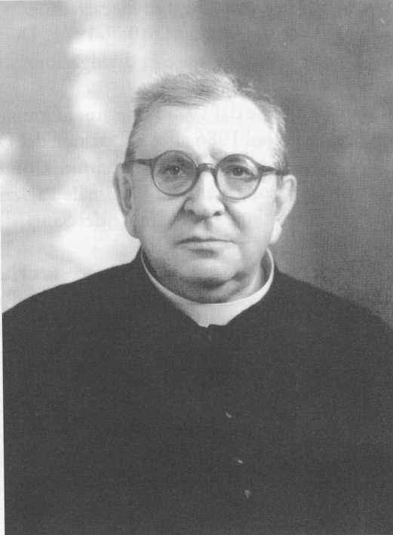
Fr. Benedetto Calvi, Luisa Piccarreta’s last confessor.
Bishops
1. Archbishop Giuseppe Bianchi Dottula, 1848-1892
2. Archbishop Domenico Marinangeli, 1893-1898
3. Archbishop Tommaso de Stefano, 1898-1906 [Luisa begins to write her diaries]
4. Archbishop Giulio Vaccaro, 1906, administrator
5. Archbishop Francesco P. Carraro, 1906-1915
6. Archbishop Govanni Regime, 1915-1918
7. Archbishop Eugenio Tosi, 1918-1920, administrator
8. Archbishop Giuseppe M. Leo, 1920-1939
9. Archbishop Francesco Petronelli, 1939-1947. He died on June 16, 1947, three months after the pious death of Luisa Piccarreta.
10. Archbishop Reginaldo G.M. Addazzi, 1947-1971. He gave Luisa the title of Servant of God and authorized the issue of the figurine with the prayer.
11. Archbishop Giuseppe Carata, from 1971, emeritus. He began the Association of the Divine Will with canonical approval in 1986 after procedures which had lasted for ten years. At the same time, he gave orders, at the request of Cardinal Palazzini, Prefect of the Sacred Congregation for the Causes of Saints, for testimonies to be collected regarding the Servant of God.
12. Archbishop emeritus Carmelo Cassati. He opened Luisa Piccarreta’s cause of beatification on the day of the Feast of Christ the King in 1994.
13. Archbishop Giovanni Battista Picchierri, current Archbishop of Trani. It is he who requested that the cause of beatification of the Servant of God Luisa Piccarreta be continued.
List of Luisa Piccarreta’s diaries
Dates of the diaries written by Luisa Piccarreta out of obedience to her confessors.
Even in her personal writings, Luisa depended solely on the authority of the Church.
Indeed, it was with extreme reluctance and out of obedience that she began to write on February 28, 1899.
Volumes Dates
Volumes I and II from February 28, to October 30,1899
Volume II from November 1, 1899 to September 4, 1900
Volume IV from September 5, 1900 to March 18, 1903
Volume V from March 19, 1903 to October 30,1903
Volume VI from November 1,1903 to January 16, 1906
Volume VII from January 30, 1906 to May 30, 1907
Volume VIII from June 23, 1907 to January 30, 1909
Volume IX from March 10, 1909 to November 3, 1910
Volume X from November 9, 1910 to February 10, 1912
Volume XI from February 14, 1912 to February 24, 1917
Volume XII from March 16, 1917 to April 26, 1921
Volume XIII from May 1, 1921 to February 4, 1922
Volume XIV from February 4, 1922 to November 24, 1922
Volume XV from November 28, 1922 to July 14, 1923
Volume VI from July 23, 1923 to June 6, 1924
Volume XVII from June 10, 1924 to August 4, 1925
Volume XVIII from August 9, 1925 to February 21, 1926
Volume XIX from February 23, 1926 to September 15, 1926
Volume XX from September 17, 1926 to February 21, 1927
Volume XXI from February 23 to May 26, 1927
Volume XXII from June 1 to September 14, 1927
Volume XXIII from September 17, 1927 to March 11, 1928
Volume XXIV from March 19 to October 3, 1928
Volume XXV from October 7, 1928 to April 4, 1929
Volume XXVI from April 7 to September 20, 1929
Volume XXVII from September 23, 1929 to February 17, 1930
Volume XXVIII from February 22, 1930 to February 8, 1931
Volume XXIX from February 13 to October 26, 1931
Volume XXX from November 4, 1931 to July 14, 1932
Volume XXXI from July 24, 1932 to March 5, 1933
Volume XXXII from March 12 to November 10, 1933
Volume XXXIII from November 19, 1933 to November 24, 1935
Volume XXXIV from December 2, 1935 to August 2, 1937
Volume XXXV from August 9, 1937 to April 10,1938
Volume XXXVI from April 12 to December 28,1938.
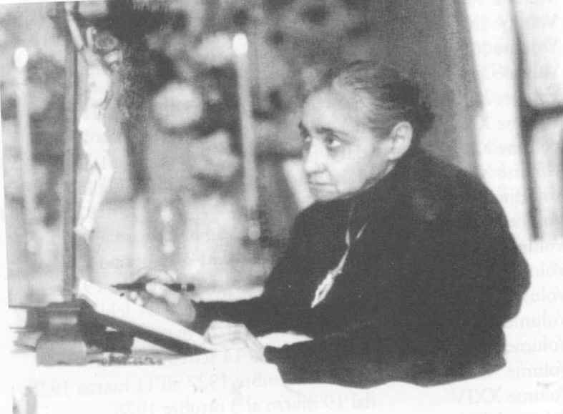
The Servant of God writes her diary gazing at the crucifix
CHAPTER TWO
The Kingdom of the Divine Will
"And now a word to all of you who read these writings... I beg you, I implore you to receive with love what Jesus wants to gives us, that is, His Will.
But to give you His Will, He wants yours, otherwise His own cannot reign. If you only knew... With this love my Jesus wants to give you the greatest gift that exists in both heaven and earth: His Will!
Oh, what bitter tears He sheds, for He sees that in following your own will you wander all over the wretched earth! You are no good at keeping a good resolution, and do you know why? Because His Will does not reign in you.
Oh, how Jesus weeps and sighs over your destiny! And sobbing, He begs you to make His will reign in you. He wants to make you change your lot: from sick to healthy, from poor to rich, from weak to strong, from hesitant to steadfast, from slaves to kings. He wants no great penances, no lengthy prayers nor anything else; except that His Will reign in you and that yours live no more.
Ah, listen to Him, and I am ready to give my life for each one of you, to suffer any hardship so that you open the doors of your soul and the Will of my Jesus can reign and triumph over the human generations!
Now will you all deign to accept my invitation? Come with me to Eden, the place of your origins where the Supreme One created man, made him king and gave him a kingdom to rule over; this kingdom was the whole universe; but his scepter, his crown and his orders came from the depths of his soul in which the divine Fiat dwells as a ruling King and constitutes man’s true kingship. His robes were royal, brighter than the sun, his acts noble, his beauty entrancing. God so loved him, entertained himself with him, called him my little king and son. All was happiness, order and harmony
This man, our first father, betrayed himself, betrayed his kingdom and in doing his own will, saddened his Creator who had so exalted and loved him; and he lost his kingdom, the Kingdom of the Divine Will, in which all things had been given to him. The gates of the kingdom were closed to him and God reclaimed the kingdom he had given man. Meanwhile, listen to my secret.
In reclaiming the Kingdom of the Divine Will, God did not say He would never return it to man, but kept it in reserve, awaiting future generations to assail them with amazing graces, with blinding light, thus eclipsing the human will that had caused man to lose such a holy kingdom; and through the appeal of miraculous and prodigious knowledge of the Divine Will, to make them feel the need, the desire to ban our own will which makes us unhappy, and to embrace the Divine Will. Therefore the kingdom is ours; so, courage!
The Supreme Fiat awaits us, calls us, urges us to take possession. Will anyone have the heart to refuse, be so devious as to not hear the call and not to accept such happiness?
Let us leave the miserable rags and tatters of our own will, the mourning clothes in which our slavery has decked us, let us dress ourselves in royal robes and adorn ourselves with divine ornaments!
I therefore appeal to everyone: listen to me! May you know that I am a Piccina (Little One), the smallest of all creatures.… I will bilocate to be in the Divine Will together with Jesus, I will come like a tiny child to your womb, and with groans and cries I will knock at the doors of your hearts, to ask you, like a little beggar girl, for your donations, your rags and tatters, your mourning clothes, your unhappy will, to give it to Jesus; so that He will burn it all and in restoring His Will to you, will give you His kingdom, His happiness, the brightness of His royal robes. If you but knew what God’s Will means! It contains Heaven and earth; if we are with it, everything is ours and everything derives from us; if we are not with it, everything is against us; and if we have anything at all, we are true thieves of our Creator and live by fraud and stealing.
Therefore if you would like to become acquainted with it, read these pages: you will find in them the balm for the cruelty inflicted upon us by the human will, together with new, entirely divine air, a new, entirely heavenly life; you will feel Heaven within your soul, you will see new horizons, new suns and will often find Jesus, His face bathed in tears, who is longing to give you His Will. He weeps because He wants to see you happy, and seeing you unhappy He sobs, sighs and prays for His children’s happiness; and, in asking you for your will, to tear you away from your misery, He offers you His own Will, as He confirms with the gift of His Kingdom.
I therefore appeal to everyone. And I am making this appeal with Jesus, with His own tears, His ardent sighs, His burning Heart which longs to give His Fiat. From within the Fiat we emerged, we had life; it is right, it is our duty to return to it, our dear and never-ending heritage.
First of all I appeal to the Supreme Pontiff, to His Holiness, the Representative of Holy Church and consequently the Representative of the Kingdom of the Divine Will. At his holy feet this tiny Piccina places this kingdom, so that he will make it known; and so that with his authoritative fatherly voice he may summon his children to dwell in this most holy Kingdom. May the Supreme Fiat invest him and form the first Sun of the Divine Will in His Representative on earth; and, in forming His primary life in him who is the Head of the whole Church, may He spread His never ending rays throughout the world; and eclipsing everyone with His light, may He form one fold and one Shepherd!
I make my second appeal to all Priests. Prostrate at the feet of each one, I pray, I implore them to be concerned with knowing the Divine Will. And I say to them: let it inspire your first movement, your first act, indeed, enclose yourselves in the Fiat, and you will feel how sweet and dear your life is; you will draw from it all your activity; you will feel a divine power within you, a voice that speaks continuously that will tell you wonderful things that have never been heard, you will feel a light that will eclipse all evils, and in stirring peoples, will give you dominion over them.
How many fruitless efforts, because the life of the Divine Will is lacking! You have broken bread for the people which did not contain the leaven of the Fiat, so that in eating it they found it hard, almost indigestible; and feeling no life within them, they were not receptive to your teachings. May you therefore partake of this bread of the Divine Fiat, thus you will form them with its full life and one will.
I make the third appeal to the whole world, to all my brothers and sisters and children. Do you know why I am calling you all? Because I want to give the life of the Divine Will to you all! It is more than air that we can all breathe; it is like a sun, from which we can all receive the good of light; it is like the beating of a heart that wants to beat in everyone; and like a little child, I would like, I long for everyone to draw life from the Fiat! Oh, if you but knew the good you would receive, you would give your life to make it reign within all of you!
This little Piccina wants to tell you another secret which Jesus has entrusted to her; and I am telling it to you so that you give me your will and in exchange receive God’s, which will make you happy in body and soul.
Do you want to know why the earth is unproductive? Why it is that at various points in the world there are earthquakes and the earth’s crust often gapes open and buries cities and people in its depths? Why the wind and the waters whip up storms that destroy everything? Why there are so many evils, as you all know?
Because created things possess a Divine Will which dominates them, and therefore they are powerful and imperious; they are nobler than us because we are dominated by a human will and so we are degraded, weak and helpless. If, through our good fortune, we ban our human will and take the life of the Divine Will, we too will be strong and imperious; we will be brothers and sisters of all created things, which will not only trouble us no longer, but will give us dominion over them and we will be happy for ever and ever!
Are you glad? So make haste: listen to this poor Piccina who loves you so. Then how happy I will be when I can say that all my brothers and sisters are Kings and Queens because they all posses the life of the Divine Will.
So courage, respond to my appeal!
Yes, I hope that you will all respond to me unanimously, and far more, for it is not only I who am calling you, imploring you. With me, my sweet Jesus calls you in a tender, touching voice, telling us over and over again, even in tears: "take my Will for your life; and come into its Kingdom".
Know that Our Lord was the first to pray to the heavenly Father that His Kingdom might come and His Will be done on earth as it is in Heaven, when He said the Pater Noster, and passing His prayer on to us, He appealed to us, begging us all to ask: "Fiat Voluntas Tua sicut in coelo et in terra".
Therefore, every time you recite the Pater Jesus is overcome by such a longing to give you His Kingdom, His Fiat, that He hastens to say, with us, "My Father, it is I who ask this for my children, do it quickly". Thus the first to pray is Jesus himself, and then you too ask this in the Pater. So don’t you want all this goodness?
One last word.
Know that in seeing the longings, raptures and tears of Jesus, who yearns to give you his Kingdom, his Fiat, this little Child so longs, sighs and yearns to see you all in the Kingdom of the Divine Will, all happy at making Jesus smile, that if she does not succeed with prayers and tears, she will try making scenes to succeed, both with Jesus and with you.
So listen to this little Piccina, cause her no further sighs, tell her, through grace: "so be it, so be it... we all want the Kingdom of the Divine Will. Fiat".¹
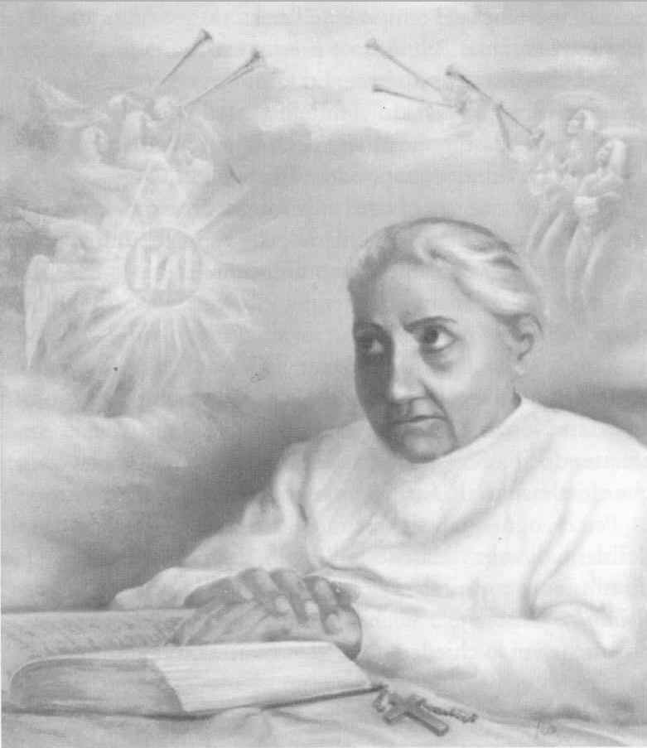
Luisa Contemplating the Triumph of the Fiat.
Some unpublished prayers²
I enclose myself in your Will
My Jesus, I enclose myself in your Will so that I may breathe with your breath to breathe with the breath of all and turn them into so many affectionate kisses.
I make my heartbeat beat in your Will, to tell you in its every pulsation, "I love you, I love you", and moving within your Will, I offer to you everyone’s embrace, so that in clasping you, embraced by your arms, no one will ever offend you again and everyone will love you, adore you, bless you and do your holy Will.
Be my guide
My sweet Jesus, immure me in your Will so that I see nothing, feel nothing, touch nothing but your holy Will, and with your power, make me holy, Jesus, in my acts to fill Heaven and earth with the Divine life.
O Queen, my Mother, be my teacher and my guide, and do not let me draw a single breath without the Divine Will.
Take my will
My Jesus, give me your Will and take my own, so that I may be sanctified with your holiness, love with your love, beat with your heart, walk with your footsteps, repair with your reparation, and form a Jesus with my words in the hearts of all who hear me.
Queen, my Mother, hide me beneath your mantle, to keep me safe from all things and all people.
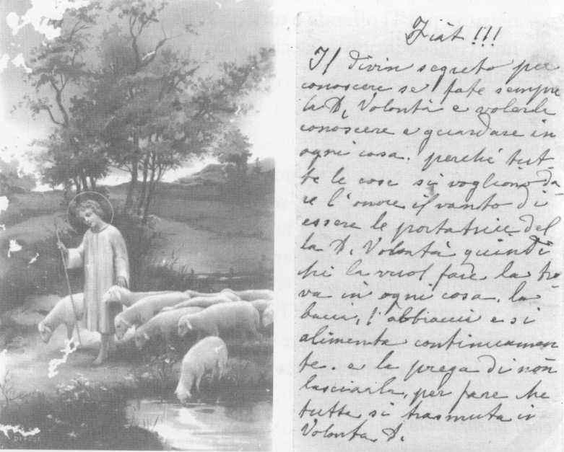
One of the many prayers which the Servant of God loved to spread with holy cards; the prayer in her handwriting is written on the back of the holy image.
CHAPTER THREE
The healing of the epileptic
Aunt Rosaria, the last of numerous offspring, was born on April 4, 1898. My grandmother claimed that she was the only "unlucky" member of the family in that she was subject to epileptic attacks. In addition, of the middle, fourth and little fingers of her right hand had been amputated at the joints because of a minor accident.
My grandmother, in the hope of a cure, took her to Luisa; a group of girls to whom she taught lace-making were on their way to her house. She asked Luisa to let her join them, so that she could learn this craft. Aunt Rosaria was barely nine years old at the time, although she looked older. It was a cold, rainy day in January 1907. Luisa was already famous throughout Corato and everyone called her Luisa the Saint. She was not only a woman who lived a holy life, respected by all, but was also a social worker. Indeed, at home she had set up a lace-making school which in those times was a significant social advancement for many girls, who left their homes and the farming environment.¹
This is how the meeting occurred….
It was about 10.00 in the morning when my grandmother went with my aunt to Luisa’s house in Via Nazario Sauro, known as Via dell’Ospedale. Luisa’s mother, an elderly woman, came to open the door and stayed chatting to my grandmother, asking her for news of some relatives.²
At the end of the discussion, Luisa’s mother took them both into her daughter’s room where Luisa was giving the girls embroidery lessons from her bed.
Angelina, Luisa’s sister, had the girls who were making lace leave the room and brought in a chair for my grandmother. My grandmother sat down and the two began to talk.
This is my aunt’s testimony: "They both talked about different matters that I don’t remember clearly, like two old friends who had not seen one another for some time. Finally, my mother kissed Luisa and left. I had the impression that they had also been talking about me and that Luisa had consented to my mother’s request. When I was left alone with Luisa, she looked at me with a profoundly benevolent expression, as though she wished to encourage me. I had no suspicion of what was to happen to me later, that I would remain beside her without interruption for forty years".
Several days later, my aunt was stricken with a sudden epileptic fit, just as she was being taught the basic elements of lace-making. My aunt never related this episode, because she was rather shy and reserved about all that concerned Luisa and rarely mentioned her at home. My mother told me of the event; she had heard it from a friend of hers who was present when it happened.
As soon as my aunt fell to the ground in a fit, foaming at the mouth and with her tongue protruding, the girls in the room were frightened and fled, while my aunt was helped by Angelina, Luisa’s sister. In the meantime, Luisa was not in the least upset, but continued her work as if she had not the slightest interest in the event. One girl, who had stayed where she was despite the shock, attests: "Luisa, seeing Rosaria on the ground, raised her eyes to heaven and spoke these words: ‘Lord, if you have put her beside me, I want her healthy’. And she continued her work". Because of the great commotion, no one attached any importance to Luisa’s prayer.
Whether or not this prayer is true, from that moment Aunt Rosaria suffered no more epileptic fits. She lived to the age of eighty, and died from a diabetic crisis (this is what it was diagnosed as) Her illness lasted a day and a half.
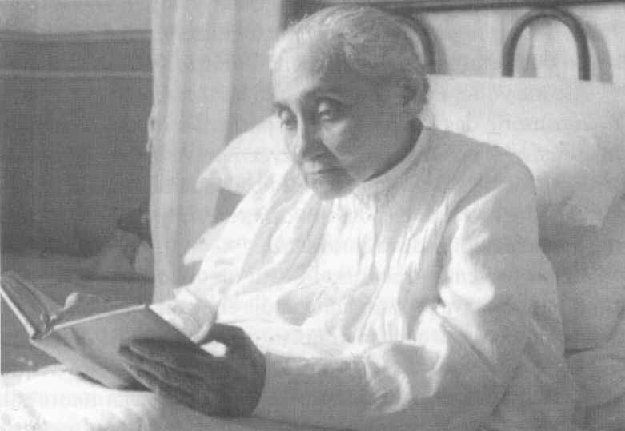
Luisa Piccarreta reading the Sacred Scriptures
The bell of discord
Aunt Rosaria, the co-owner of family property, had renounced in our favor practically half her income, which at that time could be considered a substantial sum, because we were a large family, six children, all at school. She would come for a meal at home almost every day and felt in command of the situation. The work my aunt did at home was invaluable, especially as regards domestic chores: she assisted with the cooking, set the table and helped to clear before she left.
Her contribution was much appreciated, for my mother was a teacher and we were all at school and found it difficult to attend to the housework. The few times that Aunt Rosaria did not come, there was pandemonium and everything was rushed. I remember that when we got back from school we would always find Aunt Rosaria ready to encourage us to wash our hands and make the sign of the cross before we started eating.
Sometimes however, she gave signs of a strangeness that prompted us, especially my mother, to protest. Her behavior seemed to us insolent, challenging, as though she wanted to assert that it was she who was mistress of the house.
This also depended on her strong and independent character, which made her reluctant to confide in others.
Her presence threw everyone into a certain confusion, no one daring to say a word out of place, and she seldom complied with any of our wishes: she never gave us little gifts or pocket-money. She was only available when we showed a desire to go to confession or to church, especially vespers, which she never missed. She regularly attended the parish of Santa Maria Greca and she was to be found in the chapel of the Blessed Sacrament kneeling in her usual place. When we looked for her for some family matter, if she was not at Luisa’s house we would find in the church her kneeling in her customary place. One day I said to her: "Don’t your knees hurt?" She smiled at me and, not answering the question, added: "This is the place where Luisa knelt when she could come to church. And this is where Luisa spoke to Jesus".
Her strange conduct was annoying, and as a result some rather harsh remarks were made in our household. The causes of the family quarrels, especially between my aunt and my mother, were the following.
Very often, while we were eating, our aunt would leave the table in a hurry, put on her overcoat and go.
On other occasions, when important family affairs were being discussed, she would cut the conversation and disappear. This behavior of hers left everyone speechless, because it had no logical explanation. Aunt Rosaria was therefore considered a false and hypocritical woman and my mother attributed this attitude to her pride. Only my father, who was very fond of his sister, kept the balance and always made excuses for her, provoking the anger of my mother who felt offended by the lack of consideration he showed for her observations on our aunt.
As children, we sided with our mother, considering Aunt Rosaria the black sheep of the family and the object of our sarcasm. Our mother’s intervention was required to moderate our indiscreet insistence. In spite of all this, my mother held Aunt Rosaria in high esteem and warned us: "Remember, she is nonetheless a consecrated soul!".
Perhaps what most upset us was that the following day Aunt Rosaria would present herself at home as though nothing had happened, and never responded to my mother’s requests for an explanation of her attitude.
As a priest, when my aunt was already very old and the object of the family’s veneration, I asked her the reason for her behavior. She said to me: "Do you really want to know? Are you so very interested?". "Yes", I answered.
So she began to speak: "I suffered deeply from misunderstandings, but those were the tremendous tests to which the Lord subjected me, to make me a worthy custodian of Luisa. She used to spend many hours of the day in prayer. I guessed when she wanted to be left alone, without her saying anything to me. I would get up from my work, take her lace-making pillow from her, put it on the table and make everyone leave the room. I would draw the curtains round the bed, and close her door, and work would continue in silence in the next room. Many hours would pass and when I heard the bell, I would enter Luisa’s room alone; I would draw back the curtains round the bed and I would put the lace cushion in her hands, so that everyone, returning to her room would find her as they had left her, intent on her work. In the morning, too, while I was still in bed, I was the only one who heard her bell, sometimes at about three or four o’clock. Her sister, Angelina, grumbled because she was woken by hearing me getting up. I would go to Luisa’s room and find her as though dead, showing no signs of life, motionless. I would arrange her hair and put the pillows, which I often found on the floor, behind her back. It should be noted that pillows (three) were placed behind Luisa, but she never leaned back on them, they only served to fill the space between her body and the bed-head. Having tidied Luisa, I would prepare the altar for Holy Mass. When the priest arrived for the celebration, I would let him in to the room alone. He would make the sign of the cross over her body and call her back to life. Once Luisa had returned to normality, all the others would enter to take part in Holy Mass, including the ever present altar-boy. Luisa participated in Holy Mass as though she were in ecstasy, with very great devotion and responding in perfect Latin. After communion, everyone left, while Luisa immersed herself in a lengthy and deep thanksgiving which lasted several hours. Towards nine o’clock in the morning she would ring her bell, at which we would enter her room and begin the lace-making. I worked beside Luisa and we used the same bobbins, the same thread and the same pins, and I would correct Luisa’s work because her stitches were somewhat loose since she had not the strength to pull the threads tight, because of the pain in her hands due to the stigmata she had received".
At this point I interrupted her and said: "But I never saw the stigmata on her hands!".
She answered me: "Of course not, because they were internal and only I and a few other people saw them. Among these were her confessors and the Cimadomo sisters, and I think her niece, Giuseppina, too. In fact, if one took Luisa’s hand and held it up to the light, the internal hole was visible. When I entered her room during the night, I would frequently find her covered in blood: so much blood was seeping from her feet, her hands and her side, that her nightdress and the bed were soaked in it. Sometimes, the blood was even dripping onto the floor. Not only her body, but her head and face were also covered in blood: she seemed crucified. The first time I was deeply shocked, believing her to be dead through loss of blood, and I ran to fetch cloths to clean her, but when I returned I found her absolutely clean, except for the sheet. It had all disappeared. This phenomenon would occur two or three times a year".
"But you", I said to her, "you never told anyone about this phenomenon?".
"No", she replied, "only Fr. Benedetto Calvi knew of it. He absolutely forbade me to speak of it, and said that he would deny me absolution if I were ever foolish enough to tell anyone about it. You are the only one to know, and I hope that Luisa will not take it badly".
After a pause she continued. "I beg you not to tell of this phenomenon".
She gave me the impression that she regretted having told me of it. Indeed, it was the first time that she had ever mentioned it.
This is one of the many phenomena concerning Luisa’s life which had continued to be unknown.
My aunt, after a long pause, went on: "Luisa usually worked only for churches, she would make pieces of lace for altar cloths, vestments and cassocks for priests. Sometimes, when they pestered her, she would make lace bedspreads for young couples. Luisa had a special soft spot for the sanctification of families, and many young husbands and wives would go to her for advice. How much good she did, and how many families did she save from ruin! I would leave the house when Luisa withdrew into prayer and when I returned, shortly afterwards, she would ring her bell, so I was not at all worried. Whenever I had to go away for a few days, her niece, Giuseppina, replaced me. But sometimes when I was somewhere else, at home, in church or at some friend’s house, I would hear her bell; I would interrupt anything, even lunch, and hurry to Luisa’s house. Because of my way of doing things I was considered odd, not only by the family but also by strangers. I could give no explanations because I alone could hear the sound of her bell and if I had told others, they would have taken me for a mental case and a visionary, so I was silent and when pressed to give a reason for this attitude, I always tried to change the subject, pretending not to hear. All this caused me immense suffering. Often after a great rush to get to her, I would find Luisa still praying".
I asked her: "And who was ringing the bell?".
"I don’t know", she replied.
"And what did Luisa say?".
"Nothing".
"And what did you do?".
"I knelt down beside her bed and prayed".
"But didn’t you notice anything while Luisa was praying? Is what has been said of Luisa true, that she was often suspended in the air?".
"I cannot speak of these things, Luisa always forbade me to speak of them. Her confessor was the only one to know everything, and he was the repository of her extraordinary phenomena. Luisa, for her part, always pretended that nothing had happened, nor did she allow a single word to be said of it. It all had to be submitted to the authority of the priest and he alone could decide whether the phenomena were to be divulged. Luisa did nothing and wrote nothing without the authorization of her confessor, she was so submissive to the Church’s authority that nothing was to be known or written and divulged without his permission. It is on these lines that it will be possible to know all about Luisa; it is all recorded in her writings"
I added: "But her writings can’t reveal everything about Luisa’s life, because it was far more complex".
"That’s true" she answered. "I could tell of many things that no one knows".
"So why do you insistently refuse to speak?" "If Luisa had wished them to be known she would have written them down, or the Church would have ordered her to write them; it is clear that certain phenomena which occurred, which I and others witnessed, do not serve for the sanctification of souls. The Lord permitted to be known all that is of use to the Church and to souls, the rest serves no purpose. In speaking of these things I feel as if I were profaning the intimacy that was built up between God and Luisa, human beings would not understand. The message bequeathed by Luisa exceeds her very person. Luisa wanted the Lord alone to have all the honor and glory, and she was to disappear into nothingness; this is why she loved solitude and silence, and showed great distress when she noticed that she was the object of people’ veneration, for she considered herself only a poor sick person, in need of everything. I and others knew very well that Luisa had no need of anything, and that we had to be the custodians of her mystery. How often in the morning did I find Luisa all tidy and the altar already prepared for Holy Mass with the candles lit".
"And how did this happen, if Luisa never set foot out of bed for about sixty years? Are you sure of what you say?".
"Absolutely certain! Because I was the only one who entered her room"
"Did you never wonder what the explanation was?".
"I thought that Angels served her, especially her guardian Angel, to whom she was deeply devoted. Her room was often found full of fragrance".
"And did others smell this fragrance?".
"Yes, those who took part in Holy Mass. I remember that once Fr. Cataldo De Benedictis, who had come to celebrate Holy Mass in the absence of her confessor, said to me: ‘Don’t scent the room, or I will come out with a headache’. I assured him that no one had put scent in the room, but he did not believe me".
"Is it true that Luisa vomited everything she ate?".
"Yes. However, this phenomenon was common knowledge, because Luisa was to live on God’s Will alone. But many did not believe it, and thought that she must be eating something".
"I saw this too, several times, when I came to visit you in Luisa’s house".
"So then what else do you want to know? A lot of food was wasted, and at the time, as you know, poverty was widespread. I also pointed this out to Luisa, even if her food was so scant that it would have hardly sufficed to keep a new born baby alive. Her answer was: ‘Let us obey’. In fact her confessors were adamant, harsh and inflexible about this phenomenon. It seems to me that there was a precise order from the Bishop. Once the confessor told me very firmly : she must eat every day and every one must know that she eats, or they will set the police at her door as they did with Teresa Newmah, with all the publicity of the newspapers".
"But did she drink water or other liquids?".
"I never gave her water to drink; she drank nothing but the juice of bitter almonds which the Cimadomo sisters would bring her. Sometimes your sister Isa also prepared this juice, which she extracted from Aunt Nunzia’s almonds".³
"But don’t bitter almonds contain a poisonous substance? And in the long term don’t they harm the organism?".
"That I can’t say, but I can assert with a clear conscience that it was the only liquid she drank without vomiting".
"Was it at least sweetened?".
"No", she replied, "now that’s enough, I have said almost all that I could say, which moreover, was common knowledge".
"But I would like to know more!".
"No! That is merely curiosity; if Luisa so wishes, I will be able to tell you a great many other things, and then it will be I who call you".
So ended my conversation with Aunt Rosaria.⁴ It was October 15, 1970.
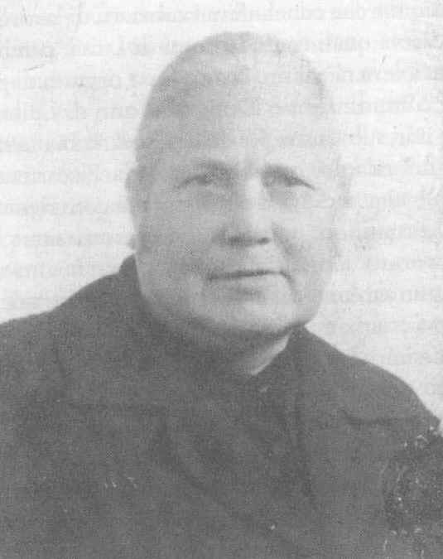
Rosaria Bucci, who lived with Luisa Piccarreta for forty years.
A perfect lace-maker
Despite the mutilation of her fingers on one hand, Aunt Rosaria became a perfect lace-maker, to the wonder of all. She perfected Luisa’s work and taught all the girls who took the lace-making and embroidery course. In addition, she made herself indispensable and in fact, after the death of Luisa’s parents, became her housekeeper. It was she who received the commissions and finalized the work contracts. However, she told no one which pieces of lace had been made by Luisa, because the Servant of God did not want her own work to be the object of special attention or admiration. After Luisa’s death, the embroidery work did not cease, for Aunt Rosaria kept alive the tradition of lace-making and embroidery which Luisa had caused to flourish. That Aunt Rosaria was a perfect lace-maker was considered by all as a never-ending miracle, since her physical handicap was such as to prevent from her doing this kind of delicate craft. For work that could have earned millions – since it required years to complete – extremely modest sums were requested. This is why we nephews and nieces complained to our aunt, at which she used to reply: "Money does not matter much. What is important is to be able to live". Aunt Rosaria told us that Luisa had categorically forbidden her to accept money for any reason, especially donations. If, by chance, sums of money arrived in letters, these letters were immediately returned to the sender. Luisa would say that what she possessed was too much for her and that she had no need of anything. The small sums which they earned from their work were sufficient to support Aunt Rosaria and Luisa's sister, Angelina. The way the Servant of God answered Blessed Annibale when he tried to give her the royalties for the works she had published is typical: "I have no right", she said, refusing the money the blessed had offered her, "because what was written is not mine".
The mysterious sores
In about 1940, my Aunt Rosaria, a robust woman shining with health, developed sores which in time grew bigger and more purulent, although she felt no pain. Two big sores in particular, like two large swollen boils, were visible under her chin. These boils secreted pus almost all the time, and a few drops even fell into her plate while we were having lunch. I felt a sense of disgust during these unpleasant situations and tried to keep away from the table, but my mother, in order not to aggravate the embarrassment this caused us, would restrain me with her hand and, from time to time, pinch me. Aunt Rosaria, as a co-owner of the family possessions, often came home for meals. Her sores, which spread all over her body, especially on her breast and shoulders, were lovingly disinfected by my mother, who urged her to go to Bari to see a specialist. But one day my aunt sat down to eat completely cured. In fact, there were small scars where the sores had been. No one made any comment; only when my aunt was leaving did my father retort, remembering previous and new episodes: "Ched femn c fatt’ vdai caus nov" (that woman has always made us see new things), referring to Luisa. My father also had a great devotion for Luisa the Saint and on his deathbed he wanted to clasp her nightdress to his breast. My mother was wearing this same nightdress at the time of her own departure for heaven.
But what had happened to my aunt?
This is her account of what occurred, given during one of the visits I regularly paid her when I was curate at the Friary of Barletta.
My aunt, urged by my mother, consulted a dermatologist in Bari. The diagnosis was terrible: "Dear lady", the doctor said to her. "these are cancerous sores which will spread increasingly over your whole body. You have a form of leprosy, a very rare disease". Just imagine my aunt’s state of mind on hearing these words. After wandering about in Bari for several hours, in the evening she returned to Luisa’s house. Aunt Rosaria gave vent to her feelings with the Servant of God and said to her with irritation: "I’m with you all the time, and yet do you allow certain things? I have no children to take care of me.". Luisa let her speak and then said to her, "Rosaria, Rosaria... you have gone round all these doctors and you have neglected the one true doctor". On hearing these words, my aunt immediately took all the medicines, gauze and cotton wool, and flung them away, from the balcony (this happened in the house in the Via Maddalena, where they then lived). Then she said: "I now entrust myself to Our Lord and to your prayers". Before she went to bed, Luisa called her, made her kneel beside her bed and together they spent a long time praying. My aunt then went to bed. She slept in a double bed beside Angelina. That night, Aunt Rosaria felt her body flooded with a sense of well-being. When she rose the next morning she found that all her sores had dried up; they were covered only by thin scabs which came off during the day: she was perfectly cured. Rumors of the miracle spread, but no one dared to speak of it openly although everyone knew that Luisa had had a hand in it. The reason for this was that Luisa did not want these phenomena to be attributed to her. "I cannot work miracles, it is Our Lord who does them", she asserted. This is why no extraordinary episode that occurred through her intervention was made public; all the same, news of such matters spread in silence.
Blessed Padre Pio, Luisa Piccarreta and Rosaria Bucci
Luisa Piccarreta and Blessed Padre Pio of Pietrelcina knew one another for some time without ever having met, for Luisa was always confined to the bed where she sat, while Padre Pio was enclosed in the friary of the Capuchin Fathers of San Giovanni Rotondo.⁵
One question naturally arises, how did they come to know one another?
This is difficult to discover, yet one thing is certain, that the two did know and esteem one another.
My aunt recounts how Luisa would speak with respect and veneration of the blessed father, describing him as a "true man of God", who still had great suffering to face for the good of souls.
In about 1930, a well-known figure arrived at Luisa’s house, sent personally by Padre Pio. He was Federico Abresch, a convert of Padre Pio. Federico spoke at length with Luisa. What they said we are not given to know; but one thing is certain. Federico Abresch became an apostle of the Divine Will and regularly visited Luisa, with whom he always had long conversations.
When his little son received his first communion from Padre Pio’s hands, he was also immediately taken to see Luisa who, according to the story, foretold that he would become a priest.
The small boy of that time is now a priest and works at the Congregation for Bishops in Rome; he is known by the name of Mgr. Pio Abresch.
When Luisa was condemned by the Holy Office and her works put on the Index, Padre Pio sent her this message though Federico Abresch: "Dear Luisa, saints serve for the good of souls, but their suffering knows no bounds". At that time Padre Pio was also in very great difficulties.
Blessed Padre Pio sent many people to Luisa Piccarreta and would say to the people of Corato who went to San Giovanni Rotondo: "What have you come here for? You have Luisa, go to her".
Padre Pio recommended to certain of his faithful (including Federico Abresch) that they open a spirituality center at San Giovanni Rotondo, inspired by the Servant of God Luisa Piccarreta.
Miss Adriana Pallotti (a spiritual daughter of Padre Pio) is currently an heir to Padre Pio’s wishes. She has opened a House of the Divine Will at San Giovanni Rotondo, keeping alive the torch lit by Padre Pio with Federico Abresch. Miss Adriana Pallotti says that it was Blessed Padre Pio who encouraged her to spread Luisa Piccarreta’s spirituality in San Giovanni Rotondo and to help disseminate the Divine Will throughout the world, as Padre Pio desired.
Aunt Rosaria went regularly to San Giovanni Rotondo, especially after Luisa’s death. Padre Pio knew her very well, and when Luisa was still alive he would ask Aunt Rosaria when he saw her: "Rosa’, how is Luisa?".
Aunt Rosaria would answer him: "She is well!".
After Luisa’s death, Aunt Rosaria increased her visits to San Giovanni Rotondo, in order to receive enlightenment and advice from Padre Pio.
Aunt Rosaria was the one lamp that stayed alight to resolve Luisa Piccarreta’s case regarding the sentence of the Holy Office, visiting various ecclesiastical figures and, in addition, confronting the Congregation of the Holy Office. Once she managed – it is not known how – to enter the office of the Cardinal Prefect, Ottaviani, who heard her kindly and promised to take up the case.
Indeed, a few days later, Aunt Rosaria was summoned by Archbishop Addazi of Trani, who said to her: "Miss Rosaria, I do not know whether to reprimand you or to admire you for your courage. You have faced the guard dog of the Church, the great defender of the faith, without being bitten".
The conclusion was that permission was obtained to move Luisa’s body from the cemetery to the Church of Santa Maria Greca.
Luisa said to my aunt: "You will be my witness" and one day Padre Pio told her point-blank in his Benevento dialect: "Rosa’, va nanz, va nanz ca Luisa iè gran e u munn sarà chin di Luisa" (Rosaria, go ahead, go ahead for Luisa is great and the world will be full of Luisa). My aunt often recounted this episode, but things were not going well: everything indicated that Luisa would soon be forgotten.
After the venerated Padre Pio’s death, my aunt said one day: "Padre Pio prophesied that Luisa would be known throughout the world". And she repeated the phrase Padre Pio had said in his dialect.
I answered that there would be no easy solution to the case of Luisa Piccarreta Indeed nothing further was said of it in Corato either, and Padre Pio’s words could have been considered merely a comforting remark. But Aunt Rosaria retorted: "No! During my confession Padre Pio told me that Luisa is not a human factor, she is a work of God and he himself will make her emerge. The world will be astounded at her greatness; not many years will pass before this happens. The new millennium will see Luisa’s light".
I was silent at this assertion and my aunt asked me: "But do you believe in Luisa?".
I answered her that I did.
Then she said to me: "Come to my house in a few days’ time, because I have something very important to tell you".
It was during the 70s and Padre Pio had been dead for a several years.
Aunt Rosaria’s secret
In 1975, on 2 February to be exact – I remember it was a very chilly day – my aunt summoned me to her house. She was very old and was beginning to have problems with her sight, due to diabetes. My nephew and niece, Vincenzo and Sara, went to her house to keep her company.
That day, I found her sitting at the window as she recited the Rosary.
I sat down next to her, and having greeted her, asked her what it was she wanted to tell me that was so important.
She looked at me and said: "What I am going to tell you now is of the utmost importance. Try to use it well and I urge you to meditate on the miracles of the Lord who gave us Luisa, a precious creature in God’s eyes and an instrument of his mercy. You would find it hard to discover such a precious, great soul. Luisa goes beyond herself, and you can only contemplate her fully in God’s mystery. Mary was the One who brought redemption into the world with her Fiat, which is why the Lord enriched her in such a wonderful way that she became a creature who was raised to the dignity of Mother of God. Mary is the Mother of God, and no other creature will ever equal her in greatness and power; after God it is she alone who expresses the Lord’s marvels to the world. After Our Lady comes Luisa, who brings the world the third Fiat, the Fiat of Sanctification".
She said this quietly, marking her words well, convinced of what she was asserting. I was overwhelmed by these assertions.
"That is why Luisa was always nailed to her bed and every day offered to the Divine Majesty as a victim of expiation to God’s Most Holy Will", she continued. "God was pleased with this creature and so jealously guarded her that he removed her from human beings, entrusting her only to his Church, so that she could preserve her and humanly forge her with infinite penances and misunderstandings. My Luisa knew no human consolations but only divine ones; her body was continually suspended between heaven and earth, and her earthly life was a continuous contradiction in comparison with normal human lives. Even in her body, she had to belong entirely to God".
She then confided to me: "One day the Lord said to Luisa: ‘all those who have seen and known you will be saved’".⁶
"Dear Peppino, this is an extraordinary gift of God and it has remained shrouded in silence because Luisa did not want knowledge of it broadcast, or she would have become the object of curiosity or veneration which, she said, she did not deserve. Except that one day her confessor told me that I could speak of it and spread it with discretion. Now I have told you, in the hope that you may be able to make good use of it".
That day I was left enchanted by the language used by Aunt Rosaria, who expressed theological concepts perfectly, and even in a poetic vein.
By accident, the notes I had made were lost and I have limited myself to writing what I remember.
Her death, almost unexpected, gave me no time to ask her further questions, which would have provided a clear explanation of what she had told me.
Aunt Rosaria died in 1978.
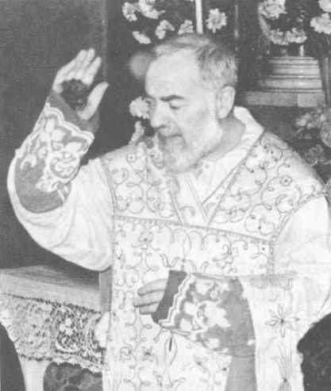
The bleeding hand of Padre Pio of Pietrelcina was raised thousands of times to bless the faithful at the end of Holy Mass
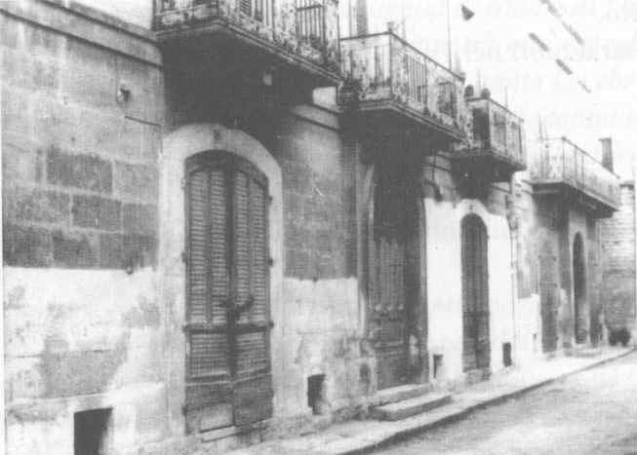
Corato, Via Maddalena: the house where the Servant of God Luisa Piccarreta lived in the last years of her life
CHAPTER FOUR
Annibale Maria di Francia and Luisa Piccarreta
Aunt Rosaria would often and willingly speak of Blessed Annibale Maria di Francia, founder of the Rogationist Fathers and the Sisters of Divine Zeal.
She spoke of the blessed as though he were intimately familiar to her, using the name "Fr. Francia". I personally took great interest in this figure and often asked the Rogationist Fathers if by chance there might be anything in their archives about the relations between Luisa and Blessed Annibale. I even went to the Sant’Antonio Institute in Corato, a house which the blessed had wanted personally, in order to move Luisa there to be with the sisters.
My aunt told me that Fr. Annibale had conceived of the project of taking Luisa to the Institute of sisters opened in Trani, but that Luisa had made him see that the Lord wanted her to stay in Corato. Fr. Annibale’s project was implemented in 1928, after his holy death.
Annibale di Francia was the extraordinary confessor of the Servant of God Luisa Piccarreta, and it was he who published her works. Blessed Annibale belonged to that array of priests who built up the Church of God with their holiness and their institutions for orphans and abandoned children. The work of these men was of great benefit to Italy and the Church, in a period when anti-clericalism was triumphant.
According to Aunt Rosaria, the blessed enjoyed the great esteem of St. .Pius X who willingly granted him private audiences. It seems that St. Pius X paid great attention to Luisa Piccarreta: our blessed submitted her writings to him before having them printed.
Aunt Rosaria affirmed that after reading some of Luisa’s writings, especially her famous work on the Passion of Our Lord, published under the title L’orologio della Passione, St. Pius X said to him: "Dear father, you must read these writings on your knees, because it is Our Lord Jesus Christ who is speaking in them". And it was the holy Pontiff who urged Fr. Annibale to publish them.¹
Annibale called on Luisa regularly, at her house in Via Nazario Sauro, staying with her for several hours, conversing with her on spiritual matters.
He often took some Italian or foreign bishop to visit Luisa, and my aunt remembers the visit of a prelate from Hungary. To dispel certain doubts, the blessed father took several theologians to Luisa; having spoken to the Servant of God at length, they would gather in another room for long discussions of what they had heard.
My aunt recalls that one Hungarian bishop, after talking to Luisa, emerged from her room in deep distress and said the following words in his imperfect Italian: "Pray for my people", for Luisa had informed him of the far from rosy future that awaited his homeland. Aunt Rosaria could not tell me precisely who the bishop was, nor exactly where he came from, she only told me: "a Magyar bishop".
I realized that he must have been a Hungarian bishop.
Fr. Annibale did not only visit Luisa to talk to her; he gave lectures to all those who frequented Luisa’s house, especially the young people. These lectures bore abundant fruits. Indeed, many of the girls became sisters, many of the young men were initiated to the priesthood and quite a few were admitted to his new congregation.
Many people went to Luisa’s house to confess to Fr. Annibale. This was confirmed to me by Canon Andrea Bevilacqua who, as a young seminarian, would also go to Luisa’s house to confess to Fr. Annibale, who was also the extraordinary and deeply loved confessor of Archbishop Leo of Trani.
In my earlier publication I did not mention Blessed Annibale di Francia, because I was advised to say nothing, to avoid creating obstacles to his cause of beatification under way.
It would be most interesting to consult the archives of the Rogationists and of the Sisters of Divine Zeal, where there must certainly be traces of the long correspondence between the Servant of God Luisa Piccarreta and Blessed Fr. Annibale. My aunt told me that Luisa’s spirituality was impressed upon the institute’s Rule. It would be most interesting to read the institute’s old Rule and Constitutions. I hope, now that Fr. Annibale has been beatified by the Church, that the Rogationists and the Sisters of Divine Zeal will be able to re-evaluate the Servant of God Luisa Piccarreta who contributed so much to their development with her prayers, her advice and her writings.
Much still remains to be said about the relations between Blessed Annibale, the Servant of God Luisa Piccarreta and St. Pius X, for whom Luisa had great veneration. At that time she already revered him as a saint, and on various occasions said these words: "The Lord has given the Church two great Pontiffs in these times; the first, a beloved son of Our Lady", with reference to Pius IX, "the second, a great defender of the faith and of the Eucharist".
Blessed Annibale di Francia had to overcome enormous obstacles in order to put into practice his plan to have Luisa taken to one of the houses of his congregation to be with the sisters. He often used to say these words: "The acceptance of Luisa in a house of my Institute will be a blessing of God for the whole Congregation".
Indeed, although there were already two houses of the Congregation of Divine Zeal in Trani, with holy persistence he opened a female house in Corato, close to Luisa’s birthplace. His project was not easy to implement: the holy founder died before the house had been completed.
Two years after his death, Luisa entered the house of the Sisters of Divine Zeal in Via delle Murge.
Rosaria Bucci’s memories
Blessed Annibale Maria di Francia paid frequent visits to the Servant of God, with whom he had long conversations, staying for hours in Luisa’s little room, where he also often celebrated Holy Mass.
This is what I remember of what Aunt Rosaria told me.
In 1910, a priest arrived at Luisa’s house and asked to speak to her. This was the first of the many encounters between the two "saints". That day, it was Aunt Rosaria who opened the door to him, then a young girl who had become familiar with Luisa’s milieu, who had been visiting her for four years and so collaborated with Angelina in the household affairs. Moreover, since Aunt Rosaria had mastered lace-making, she was acting as teacher for the other girls, who were apprentices; she was also called by Luisa to set right her own work that was often defective, for the Servant of God was unable to pull the knots tight enough because of the stigmata, hidden beneath her skin and a source of pain.²
Aunt Rosaria, on many occasions, prepared a little bed in a room in Luisa’s house on which Blessed Annibale would sometimes rest, especially when he was a guest of the Piccarreta family for more than a day.
The blessed’s stays in Luisa’s house were dictated by the fact that before giving her writings to Annibale, she had to read through them all and provide explanations on doubtful or incomprehensible points.
It was my aunt herself who gave Blessed Annibale the manuscript of the famous book on meditation of the Passion. Blessed Annibale had it printed with the name L’orologio dell Passione, a title about which Luisa was not at first enthusiastic. The publication, with a long preface by the Blessed, went into several editions, four to be precise.
Aunt Rosaria remembered that Blessed Annibale once urged all the girls and Luisa’s regular visitors to read and meditate upon the work. In giving it to them, the blessed said: "Before having the manuscript printed, I was received in audience by His Holiness Pius X, to whom I gave a copy. Several days later, having returned to see the Holy Father for matters concerning my new Congregation, he said these words: ‘Have Luisa Piccarreta’s L’orologio della Passione printed immediately. Read it on your knees, because it is Our Lord who is speaking in it".
Since we have no other documents available, we cannot but trust the testimony of Rosaria Bucci.
Blessed Annibale and the Capuchin Friars of the Monastic Province of Puglia
It seems that the Franciscan fathers, and particularly the Capuchins, suggested to Blessed Annibale that he place his works under the protection of St. Anthony of Padua. It is certain that there was a deep reciprocal esteem between Blessed Annibale and the Capuchins.
I personally heard a lot about Blessed Annibale Maria di Francia from our older fathers.
Fr. Annibale published Luisa’s writings, many of which were given to our friars, whom he warmly commended not to disclose the author’s name to anyone since the devout writer wished to remain anonymous.
The Capuchin friar who had the most to say about this was Fr. Isaia from Triggiano, who was simple and humble, the figure of an authentic priest. This father had a deep veneration for Luisa Piccarreta and jealously preserved her writings and a few objects that had belonged to the Servant of God. Among these was a holy card with a picture on which a prayer had been written by Luisa in her own hand.
Fr. Isaia often used to say: "Luisa is a great saint and Fr. Annibale another great saint, because he enabled us to know her. Saints understand one another. It is God who brings them together".
In far off 1917, Fr. Isaia from Triggiano was a Capuchin student at our friary in Francavilla Fontana, where on several occasions the friars gave hospitality to Fr. Annibale Maria di Francia, who was establishing one of his works in nearby Oria.
These are Fr. Isaia’s impressions of Fr. Annibale: "He was a priest who truly belonged to God, and at the sight of him, we students would gather round him with great sympathy. We all went to him for confession. He had an unusual appearance, as well as an unusual manner of speech and gestures, always moderate and with a reserve that did not command fear but filial trust. He constantly spoke to us of God’s Will and exhorted us to bear with hardships and contradictions. He told us that a soul who was consecrated entirely to God was suffering and praying for us all".
"This soul", Blessed Annibale said to Fr. Isaia, "is a daughter of your region, and this is a sign that the Lord is blessing the people of Bari". To comfort him in his doubts and sufferings, he gave him L’orologio della Passione, which he himself had had printed. Fra Isaia, a Capuchin student at the time, asked him where this holy soul lived and who she was, but Fr. Annibale answered: "just think about preparing yourself properly for the priesthood and always doing God’s Will, and in due course you will discover who this soul is".
Fr. Isaia, become a priest, went to see Luisa Piccarreta, from whom he sought advice and – not infrequently – comfort in his apostolate, threatened by malicious gossip.
At that time the Monastic Province of Puglia was passing through a difficult period because of various disagreements between the two Provinces of Bari and Lecce, united in a single Monastic Province. Certain fathers headed a reform that was blocked by St. Pius X.
The majority submitted, but others resisted and ended by being expelled from the Order and excommunicated. One of these was Fr. Gerardo, superior and director of the studentate of Francavilla.
This father had extraordinary ideas about running the students’ community with a draconian discipline; he frequently left the students fasting, because they had to mortify themselves and resemble the crucified Christ. The worst thing was that he did not even allow them to study. Their studying was to consist of the crucifix and penance; he consequently placed in the students’ rooms a large crucifix and a scourge. It is easy to grasp the state of mind of all the students, many of whom fell ill. Fr. Annibale di Francia, on one of his visits, called Fr. Gerardo and made him understand that young men who were still growing could not be treated with such a regime. And he himself set the example, by taking a great many provisions to the friary and begging them to eat their fill, at least sometimes. Fr. Annibale was very sensitive to the young students’ health, and would often say to them: "This is not God’s Will".
It seems that Fr. Gerardo was not totally unmoved by the exhortations of Fr. Annibale, who could speak with such conviction and love that he had an impact on even the hardest of hearts. In fact, the results were immediately noticed: books were bought for the priestly formation of the young men, and slightly larger portions of bread and soup began to appear.
Shortly afterwards Fr. Gerardo left the Order and was excommunicated for his bizarre ideas and his rebellion against the Church. The Venerable Annibale’s words came true. Indeed, when the despairing students knelt at his feet for confession, he would often say: "Continue to live God’s Will intensely, because in a little while everything will change. Courage!".
Many fathers were in contact with Fr. Annibale and through him became acquainted with Luisa. How is it possible to forget Fr. Daniel from Triggiano, a splendid figure of a Capuchin, a man who was a true little flower of St. Francis. Still today, his simplicity, his words and his acts live on throughout our Monastic Province.
Fr. Daniele spoke of Luisa Piccarreta as though she were a heavenly creature and when, as a young seminarian, I went to his room for confession, he always said this to me:
"Are you Bucci from Corato? Did you know Luisa? You should know that she is a great saint and you should never stop praying to her if you want to be a priest".
Fr. Daniele was the historian of Triggiano and also published several devotional manuals, drawing heavily from Luisa Piccarreta’s books. The way he spoke of Luisa suggests that he was in direct contact with the Servant of God and with Venerable Annibale.
I also heard the following fathers talk a lot about the Servant of God Luisa Piccarreta. Fr. Giovanni De Bellis, who was frequently invited to Corato to preach, went to Luisa’s house on these occasions. Fr. Giovanni, my confrere in the community of the Friary of Trinitapoli when I was superior and parish priest, often spoke to me of Luisa Piccarreta and Blessed Annibale Maria di Francia, whom he had known personally. I had the good fortune to be present at Fr. Giovanni’s last moments. This father died while he was completely immersed in prayer, ‘his hands joined, the beads of the rosary between them. His last words were: "May God’s Will be done". It was 1982.
Fr. Terenzio from Campi Salentina also deeply venerated the Servant of God Luisa Piccarreta and would talk of her every time he met me. It was he who told me that the beatification cause of Fr. Annibale, Luisa’s confessor, had been initiated. When I was a young novice at the Friary of Alessandro, Fr. Terenzio was superior. One day he offered me this testimony: "There was a period when I was going through a crisis in my faith, and one day I went to Luisa, who listened to me kindly. She clarified all my doubts, and gave me such clear and profound theological explanations that they were a revelation to me. All the doubts that my theological studies had not clarified were dispelled by Luisa. There is no doubt that Luisa had the gift of infused knowledge".
Fr. Guglielmo from Barletta, one of the most distinguished priests of the Province who had several times been Minster Provincial and was rector of our theology center for students, spoke one day, during a lesson on ascetics, of Venerable Fr. Annibale and his works. He spoke at length of L’orologio della Passione and of the book Maria nel Regno della Divina Voluntà. Referring to Luisa Piccarreta, he said: "She is a great and marvelous soul. We are not even worthy to be her finger-nail". Fr. Giuglielmo did not tell me whether he had known Luisa personally.
Almost all our older fathers had direct or indirect contact with the Venerable Annibale and Luisa Piccarreta. Among them those to be remembered are: Fr. Zaccaria from Triggiano, several times Provincial; Fr. Fedele from Montescaglioso; Fr. Giuseppe from Francavilla Fontana; Fr. Tobia from Trigiano; Fr. Antonio from Stigliano, who left some writings on the Servant of God; Fr. Dionisio from Barletta; Fr. Arcangelo from Barletta, also Provincial; Fr. Pio from Triggiano, Provincial; Fr. Gabriele from Corato; Fr. Timoteo from Aquarica, a great friend of Luisa’s last confessor, Fr. Benedetto Calvi, in whose parish he often preached (he also assisted at the translation of Luisa’s body from the cemetery to the church, and concelebrated at the Mass in the main church for the opening of the beatification cause of the Servant of God Luisa Piccarreta); Fr. Salvatore from Corato, of whom I shall speak in a separate chapter. Many lay brothers who went to Corato to beg for alms never failed to visit Luisa: Fra Ignazio, Fra Abele, Fra Rosario, Fra Vito and Fra Crispino, who often spoke to me enthusiastically of Luisa, whom they greatly revered.
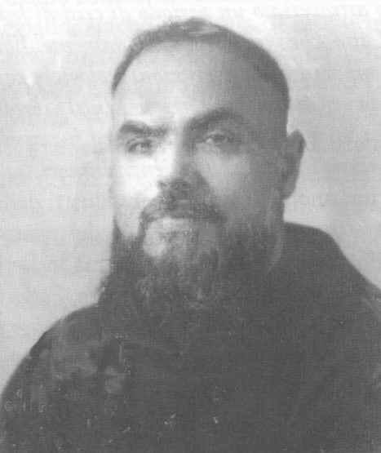
Fr. Terenzio from Campi Salentina, a great enthusiast of Luisa Piccarreta
Luisa’s special love for the Capuchins. Fr. Salvatore from Corato and Luisa Piccarreta
Fr. Salvatore from Corato was a Capuchin totally focused on Luisa the Saint. I knew him when I was a student at the seminary of Giovinazzo (the 4th and 5th years of secondary school). Fr. Salvatore came to spend his holidays with us. During our walks down the alleys in the friary garden, he always spoke about Luisa to me and about how his Capuchin vocation developed.
Fr. Salvatore was a splendid figure of a Capuchin. He came from a well-to-do family, he had very gentle manners and showed a delicacy of mind that I have rarely encountered in other friars. His Capuchin and priestly vocation caused him great suffering and gave rise to much opposition. As an orphan, he had been brought up by an aunt who often took him to visit Luisa the Saint, who regarded him with great kindness and gladly engaged in conversation with the young lad.
One day she said to him: "The Lord wants you to be a priest", but the boy did not attach much importance to her words. Having become a good-looking young man, rich and sought after by all the girls, he embarked upon a career in the navy and made many voyages. During the long ocean crossings, which sometimes lasted for months on end, the brilliant sailor would stay on the bridge of the ship to contemplate the infinite sea and the stars. He often remembered Luisa’s words: "The Lord wants you to be a priest".
Finding himself in danger of death, all that was left to him was to call upon Luisa: "Luisa, if you want me to be a priest, save me!". Chance had it that many of his companions died, whereas he was saved by a strange miracle. Shortly afterwards he abandoned his career, returned to Corato and went to see Luisa. After a long conversation, Luisa advised him to enter the Capuchins, telling him that he would encounter enormous difficulties. The Lord would be putting his vocation to the test.
Indeed, he had difficulty in being accepted by the Order, meeting with opposition from those in charge of the students’ formation. They cited his age, for he was already older than the normal students, his life as a sailor, certainly ridden with vice, and it was also said that coming from a well-off family, he would find it very difficult to embrace a Rule so strict in itself. The letters of introduction from the archpriest, Fr. Clemente Ferrara, and from Fr. Andrea Bevilacqua, who personally accompanied him to the novitiate in Montescaglioso, were to no avail.
The novice master and superior did not accept him nor did they allow him even to enter the friary. Thus the poor young man had to stay outside the friary for three days, awaiting an answer from the Father Provincial, to whom the superior and novice master had perhaps turned.
Luisa’s words came true.
Fr. Salvatore, received into the Capuchin Order, generously relinquished all his family possessions and embarked upon studies for the priesthood. Ordained a priest, he wanted to go to Luisa’s house to celebrate a thanksgiving Mass. He would end his stories with this words "Luisa is in my heart and in my life, I feel her very close, as though she still wanted to speak to me". And he added: "I am sure that I will not have a long life, because Luisa is in a hurry to bring me to heaven", and he would say this with a smile so heavenly that it is impossible to describe.
Fr. Salvatore was used by his superiors as teacher and director of our boys in the minor seminaries, and was highly appreciated and loved by all. His spiritual and human gifts enriched the exercise of his priestly ministry. His health, which had been shaky since his entry into the Order, was a sign of God’s Will which matured him for his Kingdom through suffering.
When I asked him if I could read Luisa’s writings which had been condemned by the Holy Office, he answered no, saying: "Luisa belongs entirely to the Church and in the Church, which often tells us to renounce even beautiful things. Remember that all the Church does is God’s Will, which has its own times. Perhaps the world is not yet ready to receive and understand this great saint. I believe that in a little while the Lord himself will put her on the lamp stand". Fr. Salvatore died on 3 September 1956, at the age of forty.
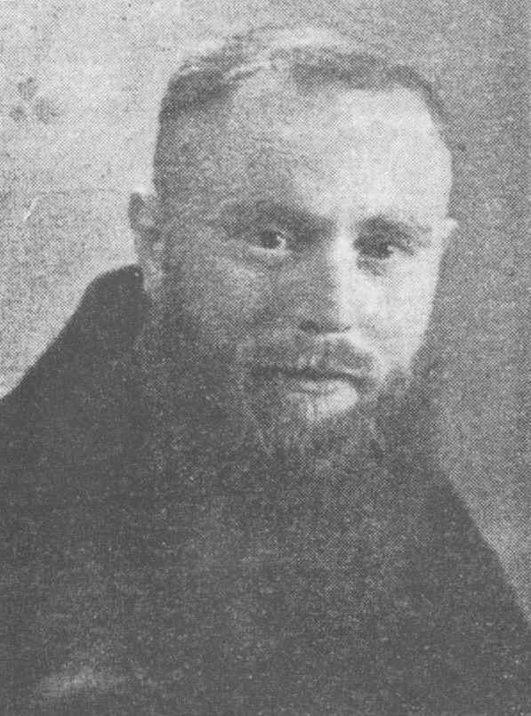
Fr. Salvatore da Corato
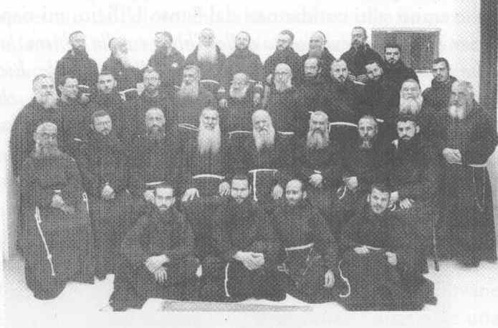
Most of the Capuchin friars pictured in the group had direct contact with Luisa Piccarreta and Blessed Annibale
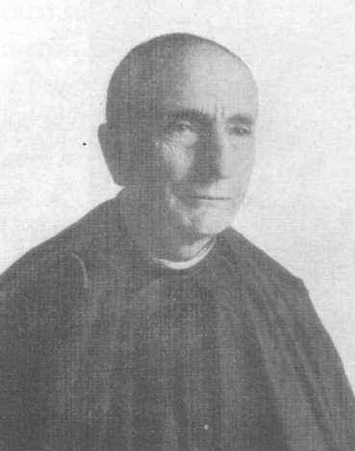
Blessed Annibale, extraordinary confessor and ecclesiastical reviser of Luisa Piccarreta’s writings
CHAPTER FIVE
A strange lunch
I began to visit Luisa Piccarreta’s house when I was five years old, taken there by Aunt Rosaria.
When I became a little older, I would often take Luisa baskets of fresh fruit which my father picked on our land.
On various occasions my aunt made me stay to lunch at the Piccarreta house. Luisa did not eat with us, because she was in bed in her room and it was there that she ate the few grams of food that she took every day.
One day, curious, I watched the menu that was being prepared for Luisa: her whole meal was on the same plate. It was a Sunday, the day our family ate orecchiette (ear-shaped pasta shells) with meat sauce. No more than five or six orecchiette had been put on a plate with three or four grapes. My aunt, seeing my surprise, looked at me compassionately and smiled. At a certain point she said: "Take this plate in to Luisa". More surprised than ever, I took the plate and carried it to the room of Luisa who was in bed. She had just put down her lace-making work; a stool had been set before her on which a cloth was spread, where I put the plate. She gave me a deep look with her large eyes without saying a word, took a grape and popped it into my mouth. I left the room while Luisa was beginning to eat her strange lunch. I had hardly sat down at table when we heard a bell ring. My aunt got up quickly, took a tray and went to Luisa’s room. I followed her instinctively and unwittingly saw something that left me perplexed. Luisa vomited all the food that she had eaten, unspoiled and whole. The most extraordinary thing is that she felt none of the discomfort or unpleasantness that usually accompanies vomiting. My aunt removed the stool from her knees, put it aside, drew the curtains round her bed, closed the shutters and said to me: "Let’s go now because Luisa has to pray". When I got home, I told my mother all about it. She was not in the least surprised, since she had known of this phenomenon for some time. Luisa actually never ate nor drank; she lived on the Divine Will alone. This phenomenon lasted for almost seventy years, through thick and thin. Out of obedience to her confessors, she was obliged to eat at least once a day, even if she vomited everything immediately afterwards.
The broken promise of mortification
One day, it was a Sunday, I was at Luisa’s house, when she called me and said: "Today is Sunday, at home you will be eating meat, leave a little for Baby Jesus". I assured her I would do so. However, having left Luisa’s house, I forgot everything, including the promise to leave some meat for Baby Jesus.
It should be emphasized that in those days meat was a luxury food, only eaten on feast days and in small quantities.
I enjoyed eating my meat, having forgotten the morning’s promise. Luisa, on the contrary, had not forgotten at all and as soon as I arrived at her house in the afternoon, the first thing she said to me was: "You forgot the promise you made to Baby Jesus". I was dumbfounded and did not know what excuse to make. Aunt Rosaria alleviated my embarrassment by saying: "He’s only a little boy, what can he understand!" But I realized that her unsolicited answer did not satisfy Luisa.
A prophecy
My family, deeply religious, wanted one of us boys to be a priest, given that my father’s branch of the family had been richly endowed with priests and a cousin of my mother’s was then Vicar General of the Diocese of Salerno, at the time of the famous Bishop Balducci Monterisi. My mother had kept up a correspondence with this cousin, with whom we were not personally acquainted. I only remember that she spoke enthusiastically of him.
The eyes of the family were focused on my brother Agostino, a tidy, well-educated, hard-working and reserved boy: in brief, a suitable type for an ecclesiastical career. Aunt Rosaria was very pleased when my brother expressed the wish to enter a seminary; the opinion of our parish priest, Fr. Cataldo Tota, of venerable and holy memory, was very flattering.
His clothes were prepared. My aunt prepared a cassock with lace borders. Everything was ready for my brother Agostino to enter the Seminary of Bisceglie. However, an unexpected event then occurred which upset everything, so that my brother never did enter the seminary. The cause of it all was Fr. Andrea Bevilacqua, who recommended that Agostino, his pupil in middle school, not be sent to the seminary, but wait until he had completed at least the fifth year of secondary school; he would then enter Molfetta Seminary directly without having been to the minor seminary, which Fr. Andrea did not think could guarantee an adequate formation. Aunt Rosaria was very upset at this event and one day complained to Luisa: "After having spent so much, Agostino will not even be entering the seminary".
It should be said that Luisa had already previously proved silent and indifferent to this plan. Although Agostino diligently visited her house and although she knew of his intentions, Luisa never gave him a word of encouragement as she had to other boys who had expressed the same wish. Luisa responded to my aunt’s complaints in my presence, by saying: "Rosaria, Rosaria.... You are trying to substitute God’s Will with your own! The Lord does not want him", and turning her eyes to me, she said to her: "Look after this one! Because the Lord wants this one and not that one". Aunt Rosaria was amazed to hear the words of Luisa who said: "Yes, this very one who is the rebel of the family!".
In fact, I loved street life. I was very lively and surrounded myself with poor children. My companions systematically played truant from school, they went about barefoot, smelling of the hens, sheep and rabbits that were raised in their homes. Therefore I did not work very hard at school either, and was the despair of my middle-class family (my mother was a teacher and my father, a municipal employee).
I did not attach much importance to Luisa’s words; I was only in the fourth year of elementary school; there were big social problems; the collapse of Fascism, the German occupation; schools were closed and food was scarce. I completely forgot Luisa’s words. After Luisa’s death, on 4 March 1947, my Aunt Rosaria often thought of what Luisa had said and began to look at me inquiringly, as though she wanted to detect any signs of my inclination. Later, to the great wonder of all, Peppino, the rowdiest boy in the district of Via Andria, entered the seminary, not the diocesan seminary but the Seraphic Seminary of the Friars Minor Capuchin of Barletta. It was 1948. A year had passed since Luisa Piccarreta’s death. Many bet, given my character, that my stay in the seminary would not last long, and that I would be a nuisance there too. Many even criticized my mother for rashly having allowed me to enter it.
Time proved these inauspicious predictions wrong and the townspeople began to give credit to the words of my Aunt Rosaria, who proudly told everyone how Luisa had prophesied that I would be a priest. Aunt Rosaria would say with determination: "Peppino will succeed in becoming a priest. It is God’s Will, expressed by Luisa".
A rough sea
Several years passed. My mother and father had died prematurely; our large family was dispersed. Three of us were married, one sister in Trieste, another in Bologna, my brother in Switzerland: the house, emptied of us, was lived in with our consent by Aunt Rosaria.
By then I was a theology student at the studentate in Santa Fara; I had already received the minor orders and the diaconate.
During the summer, all the students moved to the Friary of Giovinazzo. The building, virtually overlooking the sea, was an ideal place to spend a holiday and the major seminary was also based there. One day in August we went to the beach. The sea was very rough; a rash student flung himself into the water and was instantly submerged by the breakers. I and another two companions, expert swimmers, dived in after our confrere, but because of the turbulent water we were swept away by the waves, flung against the rocks and sucked back repeatedly.
In these circumstances, half dazed I meditated on my death and said to myself: "I will not be a priest after all!". Then I called upon Luisa and said: "Luisa the Saint, help me!" and abandoned myself without reacting. At a certain point I felt my body grasped by the hands of other confreres, who dragged me to safety before the waves sucked me back again once and for all.
I emerged from the water, bleeding and with cuts all over me, but alive. Luisa had saved me, together with the other three students, my companions in misfortune.
The following night I dreamed of Luisa who looked at me with those great eyes of hers that were imprinted upon my mind, but she said nothing.
Was it a premonitory dream or delirium? It is true that during the next days I had a very high temperature, but I then recovered from the illness.
The following year I became a priest. I was ordained by the Archbishop of Bari, at that time Archbishop Enrico Cicodemo, in the Capuchins’ church at Triggiano on March 14, 1964.
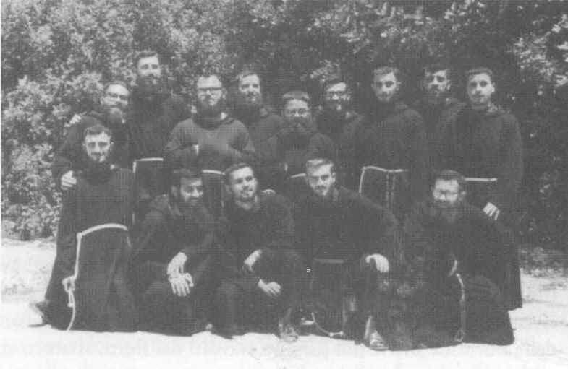
Fra Bernardino Giuseppe Bucci, a Capuchin student (standing, second from the left beside the director), with the other students in a souvenir photograph
CHAPTER SIX
Promotion to the cardinalate foretold
Another person who was very close to Luisa Piccarreta was the venerable Cardinal Cento of holy memory.
From the early days of his priesthood, Cardinal Cento had been a regular visitor to Luisa’s house. Aunt Rosaria often spoke to me of Cardinal Cento and although he had attained the high rank of cardinal, she always referred to him simply as Father or Fr. Cento.
At first I did not realize that she meant Cardinal Cento. Once, when I was at home, the postman handed me a letter covered in Vatican stamps, and bearing a cardinal’s coat of arms; only then did I understand who Fr. Cento was, whom I had heard my aunt mention so often. I asked her to explain why she called a cardinal by that name, but she answered: "I was very close to Fr. Cento, I treated him as if he were my brother. Every time he came to Corato, to Luisa’s house, it was I who accompanied him to various places, to see the archpriest or the Bishop in Trani, and I showed him the sights of Corato many times. He was a cheerful, jocular person, and when he celebrated Holy Mass he seemed an angel. I knew Fr. Cento from the days of my youth and on various occasions we had a meal together at Luisa’s house with Angelina. Cardinal Cento would spend a long time talking to Luisa, and he once said to me ‘Luisa always tells me that they will ‘dye me red’ (make me a Cardinal), but", and he said this jokingly, "‘I shall try not to have myself rigged out in fancy dress!’. One day I saw Fr. Cento with a dark look on his face, and it was the only time that he did not joke and had very little to say. It was when Luisa was condemned. Despite the censure of the Holy Office, Fr. Cento did not interrupt his visits to Luisa and he answered my question as to what had led to this disaster with these dry words: ‘Rosaria, please don’t talk about all this, because it is we who are the most hurt by it’. And after a long silence, he added: "These are tremendous trials that the Lord is sending us’".
As is common knowledge, Fr. Cento was an outstanding figure in the Roman Curia.
Aunt Rosaria kept in touch with Cardinal Cento by letter, and it seems that he used all his influence when it was a question of translating Luisa’s body from the cemetery to the Church of Santa Maria Greca.
At this point I must confess that I am seriously remiss: I was unable to save the letters that Cardinal Cento sent to my aunt. Indeed, at the pious death of Aunt Rosaria, my nephew and niece, in emptying the house, threw away all the material which, in their eyes had no importance, including Cardinal Cento’s letters.
This was a great loss. Such a source would have given great value to what I have explained above, and in addition, we would have known what Cardinal Cento thought of Luisa Piccarreta. The cardinal’s family archives should be researched, in order to recover this valuable material.
The bishop healed
It was during the year 1917. The new Archbishop of Trani, Archbishop Regime, perhaps influenced by that part of the clergy, who not only attached no importance to all that was happening to Luisa Piccarreta but openly manifested their hostility to the Servant of God, had established a very severe decree with regard to Luisa: priests were prohibited from entering her house and from celebrating Holy Mass there, a privilege which had been granted to Luisa by Pope Leo XIII and confirmed by Pope Pius X in 1907.
This measure was to be read out in all the churches of the diocese.
This is what happened.¹
While he was signing his "famous decree", he was suddenly afflicted by partial paralysis. When the priests present at that moment came to his help, he made them understand that he wanted to be taken to Luisa’s house.
Aunt Rosaria described this unusual episode in this way: "It was about eleven o’clock when we heard the sound of a carriage that stopped right outside the porch of Luisa’s house. I looked out from the balcony to see who it was and saw three priests, one of them, as it were, supported by the other two. Luisa said to me: ‘Open the door, the bishop is coming’. In fact, Archbishop Regime was at the door, supported by two other priests", probably the vicar and chancellor of the Curia of Trani, "the bishop was uttering incomprehensible words. He was immediately ushered into Luisa’s room. It was his first visit to the home of the Servant of God, who, as soon as she saw him, said: "Bless me, Your Excellency". The bishop raised his hand as though nothing had happened and blessed her. He was completely cured!
Archbishop Regime remained in Luisa’s room in a secret conversation for about two hours, and to the wonder of all, especially the priests, he emerged from her room smiling. He blessed those present and left".
An effort was made to keep the case secret, and so it remained to the wider public. As long as he was in Trani, Archbishop Regime regularly visited Luisa Piccarreta, with whom he would have spiritual conversations. This episode inspired a sacred fear in the clergy and Luisa’s holy confessor, Gennaro di Gennaro, was able to continue his ministry more peacefully. After this event, Annibale Maria di Francia also visited the Servant of God more often.
CHAPTER SEVEN
Luisa and the children of Corato
In Corato it was said among the elderly women, also during my childhood, that whenever Luisa went out, at night and in a closed carriage so as not to be seen, the children of Corato, would scamper in front of her carriage shouting: "Here comes Luisa the Saint!". Luisa only went out when it was dark as the ecclesiastical authority had prescribed, to avoid crowds gathering and scenes of fanaticism. At least once a year – usually in the summer – Luisa was taken to another house, so that the spring-cleaning could be done: the rooms whitewashed, and the straw or wool in the mattresses changed, washed and softened.
Many well-off families of Corato vied with one another to offer Luisa hospitality on these occasions. These included the Capano, Cimadomo, Padroni Griffi, Azzariti families and others who would send their own carriage to fetch Luisa. During this secret transportation, it would happen that the children of Corato, as though suddenly inspired, would gather together and shout out along the way the news that Luisa was passing, saying: "Come out everyone, Luisa the Saint is passing!", and everyone would come to the doors of their houses with lighted lamps.
One day I discovered that my father had frequently taken part in these nocturnal gatherings with the other village children when Luisa was passing. As an adult and a Capuchin student, I asked my father: "Did anyone warn you she would be passing?". He answered me: "No, we sensed something and understood that the carriage with Luisa in it would be passing by".
The soldier who never was
Due to a variety of events in the past and financial calamities, our family, from being well to do, had been reduced almost to dire poverty. Because of the various misfortunes which befell the family (the death of my aunt’s two sisters, the partial paralysis of her father, the emigration of her elder brother who had gone to Argentina to seek his fortune) the whole property was sold or mortgaged.
The very young brother, Francesco, was the only one left to administer the patrimony which consisted of a wood-burning baker’s oven, sufficient to relieve the family’s plight.
In the meantime the First World War had broken out and Francesco was called up.
My aunt’s mother begged her daughter to speak to Luisa, because only she could find a remedy for their situation. But Aunt Rosaria turned a deaf ear to her until one day her mother, using strong words, said to her: "If you don’t speak to Luisa, as from tomorrow I won’t visit her any more and you will have to stay at home to do the housework".
As soon as Aunt Rosaria, a scowl on her face, arrived at Luisa’s, Luisa called her and said: "‘Why don’t you tell me anything?’. I have known it all for ages. Tell your mother that Francesco will not leave". And so it came to pass....
The day on which my father had to present himself for recruitment, without causing any pain his neck swelled up enormously, so that he was considered unfit for service. On the journey home, the swelling disappeared. This same phenomenon happened for three consecutive years until he was rejected.
This was confirmed to me by my father, who said in the Corato dialect: "Ched femn ma fatt vdai aus nov" (that woman has made me see new things), and with words and gestures, he explained to me what had happened.
Indeed, by running the bakery, my father managed to repair at least part of the damage to the family’s financial situation.
The baby boy brought back to life
I was told of this incredible event by Miss Benedetta Mangione, a very old lady, the same age as Aunt Rosaria, who was also part of the group of girls who went to Luisa to learn to make lace.
This is her tale. "One morning in about 1920-21, while I was at Luisa’s house, after taking part in Holy Mass celebrated by her confessor, Gennaro di Gennaro, a deeply distressed young woman burst into the room of the Servant of God with cries of despair, and placed her dead baby on Luisa’s lap, whilst she knelt at her bedside, weeping desperate tears. Everyone was amazed and Rosaria tried to get the woman to her feet. From her way of speaking, I realized that she was one of her relatives. Luisa was not upset by the scene and began to caress the child that lay on her knees; she said to the mother: ‘What are you thinking of, Serafina? Take Luigi and give him some milk, he is hungry’ , and thereupon she put him in her arms".
Aunt Rosaria then asked her to leave the room and go home. The young woman wasted no time in obeying.
Miss Mangione, like all those in the room, had the feeling that the infant had been resuscitated. However, knowing that Luisa did not want certain things to be broadcast, they said nothing to anyone about what had happened.
Rosaria closed the curtains round Luisa’s bed and showed everyone out of the room, telling them that Luisa had to give thanks for the communion she had just received.
Nor did her confessor say a word, but left immediately, together with the baby boy’s mother.
A few days after this episode, Aunt Rosaria said to Angelina: "That couple", referring to her brother and sister-in-law, "should stop going to the theater, or they will both end up in prison".
This is the sequence of events that led to the presumed death of the new baby.
The young couple, Francesco Bucci and Serafina Garofalo, had a passion for the theater to which they went regularly. A son was born to them, whom they called Luigi. One evening at the theater in Corato, a Verdi opera was being performed, I think it was Rigoletto. The temptation was so strong that the two of them settled their baby in his cradle and went to the theater. On their return – it was almost dawn – they found that the baby, who had turned over in the cradle, had suffocated. Panicking, the father, Francesco, fled from Corato, while the mother, Serafina, overcome with despair, wrapped the baby in a shawl and carried him to Luisa. In the family this episode was never mentioned. Only once did my mother, Serafina Garofalo, tell the story of a baby boy restored to life but, perhaps feeling guilty, she did not say who was involved.
I can testify that my mother was very close to her first-born son and had such a deep veneration for Luisa the Saint that she often talked about her. My brother Luigi had the same veneration for Luisa. Indeed, after the condemnation of 1938, Aunt Rosaria came to our house wanting to burn all the objects that belonged to Luisa, but my brother, who was eighteen years old and on the point of leaving for military service, opposed this with all his might. And when he was told that those who disobey the Church go to hell, he answered: "I will go to hell, but her things will not be burned" and as a precaution, he put all the objects belonging to Luisa into a small box and took it away with him.
Today they are in the care of my sister-in-law, Rita Tarantino, and her children, who guard them jealously.
Isa Bucci and Luisa Piccarreta
My sisters, Luisa, Maria and Gemma, and my brothers Agostino, Luigi and also the youngest member of the family, Giuseppe, known as Peppino, would go frequently to Luisa’s house.
They all gave written testimonies on Luisa Piccarreta but, through a certain sense of modesty, limited themselves to the essentials. Indeed I know of other events which were recounted in the family.
My sister Luisa, the oldest, was the one who visited the Servant of God most often, not as an apprentice lace-maker but as Aunt Rosaria’s niece. On various occasions she helped Angelina and Aunt Rosaria with the domestic chores, and had a relationship of great familiarity with Luisa. Indeed it was she who nursed Luisa at night during her last illness. When the doctor had ascertained that Luisa was dead, it was she who took the initiative of undressing her, redressing her and trying to lay her out on the bed.
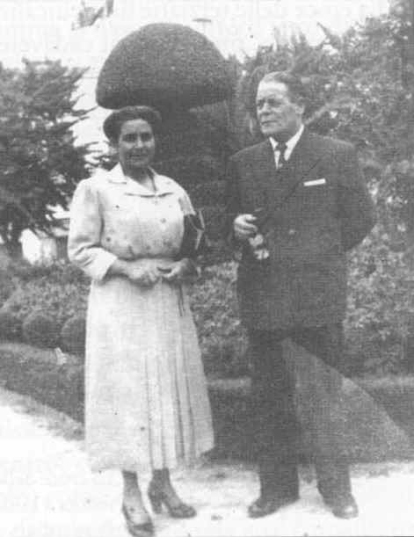
Francesco Bucci and his wife, Serafina Garofalo
This is what she said when she came home.
"Luisa’s death created an atmosphere of veneration mingled with fear. No one dared touch her. Aunt Rosaria and Angelina had been taken out of Luisa’s room crying. I attempted to lay her out on the bed but the task was beyond me. Either her legs would bend or her mouth would open, as if she wanted to say: ‘let me be’. Then I suggested to those present, including her niece Giuseppina, that we change her clothes immediately, before the stiffness set in. This is what we tried to do. Then we took her into the next room, where a sort of bier had been prepared, all in white. What astonished me most was that in carrying Luisa I had the impression that she was as light as a feather. Hence I understood how it was that very often when Aunt Rosaria was making her bed, she would carry her with extreme ease to her wheel-chair. A sort of bib was placed on Luisa’s breast, with the letters FIAT and the cross of the Dominican Tertiaries".
The nightdress that was taken off Luisa was folded by my sister and given to Aunt Rosaria who said to her: "Take it home". This nightdress is now in the possession of my sister Gemma.
The cross of the Dominican Tertiaries that Luisa was wearing on her deathbed, removed from her body on the day of her burial, was constantly worn by Aunt Rosaria. Today it is in my possession and jealously guarded.
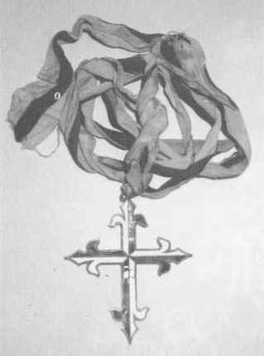
The cross of the Dominican Tertiaries which belonged to Luisa Piccarreta and is now in Fr. Bernardino’s possession
Gemma Bucci and Luisa Piccarreta
As children, we all visited Luisa’s house, especially my sisters who would also go there to learn the rudiments of lace-making. My sister Gemma was very close to me in age, and willingly went to Luisa Piccarreta’s house with Aunt Rosaria, almost every day. Gemma was a little whisp of a girl. Aunt Rosaria and Luisa were very fond of her. In fact, Gemma’s name had been given to her by Luisa herself. She suggested to my parents that they call me Giuseppe and have my sister’s name changed from Giuseppina to Gemma. This was done: I was given the name of Jesus’ earthly father; and my sister, from the age of two, was always called by the name of Gemma, although it proved impossible to change her name at the records office, because of the bureaucratic complications involved.
Gemma would come and go very confidently from Luisa’s room. Luisa liked her vivacity and gave her the task of picking up the pins that fell on the floor. Once, little Gemma hid under Luisa’s bed, perhaps to give Aunt Rosaria a surprise, and unwittingly witnessed a mystical phenomenon. Luisa had a bedside table on which stood a glass bell containing a figurine of the Child Jesus.
At a certain point my sister was aware of something unusual. A great silence fell, not even the chatter of the girls working in the next room could be heard.
Then Gemma came out from under the bed and saw the Child who had come to life, whom Luisa had taken in her arms and was covering with kisses. Gemma does not remember how long she kept still, contemplating this scene, she only remembers that, at a certain point, everything returned to normal. Aunt Rosaria entered the little room as usual, and Luisa was working at her lace-making as was her custom. My sister never told me of this episode in her childhood. She jealously stored up the event in her heart. I only came to know of it after the testimony (now in the acts) which she gave at the diocesan cause for her canonization. I believe that Luisa’s assistance to my sister Gemma has been continuous. In this regard, I witnessed a special grace.
At the birth of her second son, because of the incompetence of the doctor and his assistants, my sister came close to death. In fact, during the birth her uterus ruptured, causing a terrible hemorrhage. The doctor left the operating theater and said these chilling words to her relatives: "We have saved the child, but nothing more can be done for the mother". While the others were bursting into tears, I remembered Luisa’s nightdress. I hastened to Corato and went to my parent’s home. I awoke Aunt Rosaria in the middle of the night and told her what had happened; I then asked her for the nightgown which, weeping, she immediately took from the chest. We went back to the hospital of Bisceglie together. We suggested to a nurse that the nightgown be placed under Gemma’s head, and this was immediately done. The doctor in charge had already left. Immediately afterwards we saw his assistant who said: "If you give me permission, I will operate on her immediately". Permission was given, although Gemma’s husband had said: "If she is unconscious, operate; otherwise it is pointless making her suffer any more".
A friend of my brother-in-law, a nurse at the psychiatric hospital of Bisceglie, arrived and donated the six liters of blood necessary for the transfusion. The operation was successful and Gemma recovered. Aunt Rosaria was convinced that Luisa had intervened.
This is Gemma’s account. "While the doctor was operating on me, I saw Luisa at the foot of my bed with the baby in her arms. She said: ‘He is destined for heaven; you, instead, will live a long life’. And I was aware, I don’t know how, that my head was resting upon Luisa’s nightdress". The next day the baby sickened mysteriously with acute bronchitis. I baptized him, and immediately afterwards the newborn child died. This episode was considered a true and proper miracle by the whole family. Unfortunately, there was no thought at that time of the cause of canonization, so no one had the idea of gathering the testimonies of the surgeon and the nurses, who were also convinced that my sister recovered only by a miracle, since hers was a unique and inexplicable clinical case.
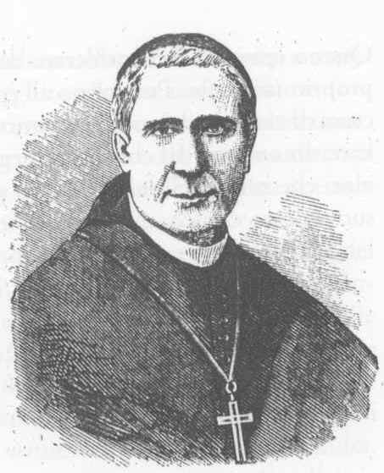
Archbishop Giuseppe Bianchi Dottula of Trani, who was the first to take an interest in the Servant of God Luisa Piccarreta
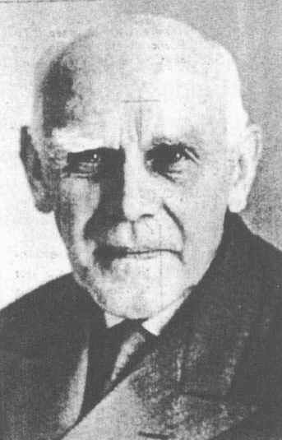
Federico Abresch, a Franciscan Tertiary. Complying with wishes of Padre Pio of Pietrelcina, he was the first apostle of the Divine Will in S. Giovanni Rotondo and did much to spread Luisa Piccarreta’s writings
CHAPTER EIGHT
A healing
A lady, one of our neighbors, told of an event which occurred in 1935.
A relative of hers, her sister-in-law, was dying from a tumor on her head.
Only one daughter, Nunzia, was left at home, because her father and two brothers had been called up for the conquest of Ethiopia.
This family possessed a great many hectares of land.
The girl turned to Aunt Rosaria to have a talk with Luisa, with a secret hope of a cure in her heart.
Aunt Rosaria, moved by the girl’s entreaty, promised to help her and spoke of the event to Luisa, who said: "She must not come to see me because I am not capable of working miracles; but if she does not come, I will pray the Lord for her all the same. In the meantime, give her this message. At Santa Maria Greca they have the Quarantore (forty hours of devotion). She should go there and pray to the Lord and she will be able to ask him for all the graces she needs, but tell her to do so with deep faith".
The girl was disappointed to receive this message. She would have liked to meet Luisa and discuss her problems with her.
Aunt Rosaria noticed how the girl felt and said to her: "Do as Luisa said!". Indeed, Aunt Rosaria knew Luisa well and could interpret her words.
The girl went to church, knelt before the Holy Sacrament and unburdened herself of all her sorrow.
About two hours later, on returning home, she noticed a deep silence. A relative of hers, whom she had left to care for her mother in her absence, had departed.
Entering the bedroom, Nunzia was devastated by the scene: her mother was lying in a pool of blood; the bed was soaked in it.
At this sight, the poor girl uttered a cry of pain, believing her mother to be dead; but something incredible occurred. She awoke as though from a long coma, asking her daughter with surprise why she had cried out in that way.
The tumor had liquefied, draining from her swollen head through her nose and spreading all over the bed.
She was completely cured.
A few days later, Nunzia went with her mother to thank Luisa; but the Servant of God did not receive them, because she made it clear that she knew nothing about this grace nor would she have anything to do with it, saying: "Let them go and thank the Lord for the grace received".¹
The horses’ whim
In 1970, when I was curate of the Immacolata Parish in Barletta and the local and regional assistant of Franciscan Youth, while I was taking off my sacred vestments after the 10 o’clock celebration of Holy Mass for the young people on Sunday morning, Mrs. Livia D’Adduzzio came into the sacristy. Having heard me speak of Luisa Piccarreta in the homily, she told me she was from Corato and had known Luisa in her youth.
I paid great attention to the words of Mrs. D’Aduzzio, a Franciscan Tertiary who took part regularly in parish activities.
This lady was the wife of Savino D’Adduzzio, a great benefactor of the friary; it was he who funded the graffitti done by Fr. Ugolino da Belluno to decorate the sanctuary.
The D’Adduzzio family was very rich and owned a lot of land, but the couple Savino and Livia had had no children.
I made an appointment with Mrs. D’Adduzzio to record her memories of the Servant of God. The next day, at 9 o’clock in the morning, I went to her house, located in a road crossing Via Milano, about 500 meters from the parish church.
Mrs. D’Adduzzio was well informed of Luisa’s life and the phenomena concerning her, about some of which I knew nothing at all. She also told me that she had known Aunt Rosaria and Angelina, Luisa’s sister, very well and had also been at the funeral of the Servant of God.
Among the many things she enthusiastically recounted, she drew my attention to the phenomenon of the horses, unknown to me. I had her repeat the episode several times and took notes.
Here is her testimony: "In 1915 I was ten years old and was with my mother in Santa Maria Greca, where the Holy ‘Forty hours’ was being solemnly celebrated. While we were listening to the priest’s Eucharistic reflection, we heard a noise outside the church, a man’s voice crying ‘gee up, gee up’, and the cracking of a whip.
Overcome by curiosity, all the children immediately rushed out of the church, followed by the priest and some of the faithful. We saw two horses kneeling before the church, harnessed to a closed carriage.
The priest immediately understood what was going on and, kneeling, said: ‘It is Luisa the Saint who is adoring Jesus in the Eucharist’.
We all knelt down in deep silence and, I’m not sure how much later it was, the priest opened the door of the carriage; he said a few words to Luisa; then the horses suddenly stood up and trotted off.
We all went back into the church, and continued to listen to the priest’s meditation".
After the story, I asked her several questions. "Are you sure that it really was Luisa in that carriage? I know that Luisa never went out".
"That’s true", she replied, "her outings were very rare and at night, and only for reasons of hygiene, so that the straw or wool mattresses could be cleansed of parasites, especially fleas and lice, common in a farming environment".
"How can you say that the horses were kneeling to give Luisa the opportunity to adore Jesus in the Eucharist?".
"I can only say that everyone believed it was a miracle and the phenomenon was the topic of discussion in all Corato. Of course, there were many who didn’t believe it, especially the priests, who lectured people saying that Luisa had nothing to do with it, that it was only a whim of the horses which had happened by chance to stop in front of the Church of Santa Maria Greca; they denied that Luisa had been in the carriage".
I asked her a last question: "Are you sure that Luisa was in that carriage?". "Absolutely certain", she answered. "I saw Luisa in the carriage when the priest opened the door and spoke to her. I think that the priest was Fr. Gennaro di Gennaro".
"But wasn’t he Luisa’s confessor, delegated by the bishop?", I continued.
"I don’t know about that, I can only say that he was a very holy priest, esteemed by all Corato, who had received a grace from Luisa".
The conversation with Mrs. D’Adduzzio ended with these words.²
The "upper room" of Via Panseri
In 1943-44, my family had a bakery with a wood-burning oven which was very profitable.
Next door to the bakery lived Aunt Nunzia, my mother’s sister, who having been left a widow, had married a man, also widowed, whom she called, zi’ Ciccil, a farmer by trade.
Opposite Aunt Nunzia’s house lived a very poor family with numerous children; their heritage consisted of a single cow. They lived by selling the milk and by other expedients, such as petty theft and the like.
The mother was called Maria, and was known to all as Marietta the Cow Woman.
However, there was something special about this family: the inhabitants of the street would gather at its home around a great fire and a blind old man was invited who would sing of the typical episodes of the town’s events, old and new, accompanying his songs with his mandolin. They enchanted everyone: what a pity that we did not have the means of recording him then, so as to have been able to collect all his ballads!
He sang, recounting on request events that had really happened.
He was a rhapsodist, a miniature Homer. His lovely tales ranged from the religious to the tragic, from the exemplary to the heroic, such as the story of the mother who had herself killed to save her son when he was pursued by the Garibaldini.
I, a boy of nine or ten, used to like visiting this "upper room" in Aunt Nunzia’s company. I remember that I sat on the knee of Marietta’s eldest son, who was called Pasquale.
One bitterly cold evening the blind man sang of the deeds of Luisa the Saint.
He described her as a great heroine, suspended between heaven and earth, between angels and saints. Two episodes impressed me in particular: Jesus who spoke while he carried the cross upon his shoulders, and the episode of Torre Disperata, where the Baby Jesus played and ran in the cornfields, holding the Piccirella (little Luisa) by the hand.
When I spoke of these things at home, my mother forbade me to visit that family and even scolded Aunt Nunzia.
When Aunt Rosaria heard things of this kind about Luisa, she would be deeply distressed and would beg my father to summon the blind old singer so that he might remove Luisa the Saint from his repertoire.
To my aunt, all this was a profanation.
When I grew up, I thought again and again of the blind old man: if only we had been able to record all his ballads about Luisa, perhaps we would have had an entire poem on the Servant of God. One thing is certain, Luisa had made such a deep impression on Corato as to be considered a heroine of holiness.
The horse cured
In Corato, especially on winter evenings, several families might meet around the hearth in one of the houses, and it was lovely to listen to the old people’s stories.
Among the ancient and recent events involving the townspeople that were told, there were many whose subject was Luisa.
It was precisely at one of these popular gatherings that the episode of the horse was heard. A hoary old man who was almost a hundred recounted the episode of the horse in vivid words with evocative gestures, using the Corato dialect, which was still pure at that time.
Here is his tale.
"When I was little, I lived in Via delle Murge, close to the house of Luisa the Saint. I was a young man" – in the vernacular ‘carusiddu’ – "when a misfortune befell her poor family. One morning their horse was found dying on floor in its stall. The veterinarian was called and advised Luisa’s father to sell the animal to the butcher immediately to make something out of it, since the poor beast had not long to live.
This news caused the whole Piccarreta family great anxiety, because the horse was a necessary means for their survival.
The Piccarreta family was not rich; its only income was the fruit of the father’s work. Nicola, on hearing this news said with deep sorrow: ‘And now how are we going to survive? Who will feed these five women?" – referring to the daughters.
"The whole family and the neighborhood were in the stable, except for Luisa, who was four years old at the time and very fond of the horse. Luisa’s mother did not let her enter the stable, for fear she would be upset.
The entire family lived in an apartment in the building belonging to the landowner who employed her father and for whom he worked on the farm of Torre Disperata.
But the little girl", in the local dialect ‘Mnen’, "made such a fuss that she was allowed into the stable.
I personally witnessed this scene.
Luisa approached the horse, stroked its head, spoke its name and said: ‘Don’t die, because I love you’.
Whereupon the horse stood up.
The vet noted that the horse’s fever had disappeared, and that the horse had recovered and was as ‘fit as a fiddle’.
Her Mother Rosa took her daughter in her arms, said: ‘my darling daughter’, and took her away.
We were all overwhelmed by this event, and for some time in the neighborhood of the Via delle Murge there was nothing but talk of the healing of the horse. One old woman said: ‘God has laid his hand upon that little girl, and all Corata will be spell-bound by the things that will happen’".
So ended the tale of the old man who was almost a hundred years old.
The soldier who became engaged
A very elderly lady called Maria Doria, someone I knew, told how her mother who was Luisa’s age used to go in summer to the district of Torre Disperata, to a farm near the one where the Piccarreta family lived.
This lady was perfectly informed of the phenomena concerning Luisa when she was a little girl, and knew of episodes full of details that her mother had told her.
Her mother, as a child, would talk to and play with Luisa and her sisters who were close friends.
Many people often noticed that Luisa was playing with an unknown boy.
At first, they thought he came from one of the homesteads nearby.
What was unusual was that he only played with and spoke to Luisa, and at a certain point would leave.
The sisters and friends asked her who he was.
Smiling, Luisa would refuse to reply. Once she said "yes", in response to the mischievous question: "Is he your boy friend?".
In time, they came to understand that that they were dealing with a supernatural phenomenon: it really was the Child Jesus who was manifesting himself as a teenager. This happened every time that Luisa was assaulted by diabolical forces.
The apparition was a consolation for what she had suffered. Once she found herself trapped like a spring between the iron bars of her bed, and the locksmith had to be called to set her free.
The wonder was that her body remained unharmed.
Another time, she was found hanging from the ceiling of the room, on the hook on which a ham or a string of onions was usually strung.
Luisa was generally liberated from these phenomena by prayers to the Most Holy Virgin, and would seek refuge in the hollow of the great trunk of a mulberry tree which still stands in the same place today.
On another occasion, a great flame was seen to flare up from a little hill not far from the farm. Since Luisa liked to play on that hill, her mother and father hastened there immediately to put out the fire. It turned out to be unnecessary: Luisa was quietly sitting on a rocky peak, gazing into the sky without a trace of fire around her.
Luisa would often contemplate the fierce midday sun, without suffering any damage to her eyes. Aunt Rosaria confided to me that this phenomenon continued until her death. In fact, we can glean from her writings that the sun was a privileged heavenly body for Luisa. She associated it with the Blessed Trinity.
Years had passed, Luisa was already renowned throughout Corato, and it was in the midst of the World War. The soldier brother of Mrs. Maria Doria announced in a letter from Sicily that he had become engaged to a girl of that island.
His mother was deeply distressed, because her son was already engaged to a "good match", a rich girl of Corato. This engagement had been arranged by the parents, as was normal at the time. The mother wept and exclaimed, "my poor son, he has been bewitched, the Mafia has entered our home!". In those times the bandit Giuliani was on the rampage.
One day she told her eldest daughter to go to Luisa’s house and tell her that she was the daughter of her childhood friend, and listen carefully to what Luisa might say.
The girl went to Luisa’s house in via Maddalena; she brought greetings from her mother, much appreciated by Luisa, and the conversation turned to the period when they had been at the Torre Disperata farm. Luisa added: "So many prayers and mortifications in that place!" Thanking the girl for her visit, Luisa told the girl to tell her mother to pray a lot, as they had done when they were on the farm, and to do all the devotional exercises which were never to be forgotten, so that God’s Will might be done.
Then looking at her, she asked point-blank: "But why are you sad?". And the daughter told her the story of her brother and her mother’s worries.
Luisa told her: "How can she tell that this girl is worse than the previous one? Let her pray to the Lord and her heart will be consoled."
The girl took Luisa’s answer home to her mother who exclaimed: "My son is saved!". Indeed, she discovered out that the Sicilian girl came from a good family and was most devout: she even had two uncles who were priests.
The young man was therefore married on the island, brought up an excellent family and thus made his mother happy.
CHAPTER NINE
Luisa, the terror of demonic forces
Reading Luisa’s biography, it is easy to see that in the early days she had to face tremendous struggles against demonic forces which did not even spare her body. At a certain point – in her writings – one reads these words: "I have touched you, I have not made you immaculate because I am not to become incarnate again, but I have removed from you the incitement to sin". It was the Lord Jesus who was speaking. It is easy for those who believe to see the impact of these words which appear theologically incredible. Some might well cry scandal and dismiss it all as heresy. I do not wish to join the discussion; the Church tribunals will have all the time they need to examine and judge the case. One thing is sure: at a certain point in her life, Luisa acquired an inner peace, a serene calm which emanated from her and impressed those who were fortunate enough to meet and talk to her. Anything could happen around her and she remained unscathed. When she was condemned by the Holy Office, in 1938, everyone was scared, all the clergy and the faithful were agitated; it seemed as though an earthquake had struck and destroyed a great edifice. But Luisa remained calm and serene, as if the case did not concern her. She complied with the will of the Church in docility, handed over all her manuscripts to the official of the Holy Office, quietly and serenely pursued her life of prayer and continued with her lace-making.
So it seems that Luisa had been strengthened in grace and therefore became the terror of the demons that fled from her noisily. Certain episodes seem to confirm this.
It is said that when Luisa was passing some spot – when she was being transported in a closed carriage for the annual spring-cleaning – some houses shook from the foundations to the roof and cries, the clanking of chains and sounds of people leaving were heard. This happened especially in a building that was still in the stages of restoration on the market square of Corato. Indeed it was said that appalling things had occurred there, murders, hangings, torture, etc.
One lady said that she had gone to live in a house at Rotondella in the Province of Matera, where she had been appointed to teach at an elementary school. However, she had felt very ill at ease in that house because there was frequently a man in it with a terrible look who would try to grab her; but the lady defended herself by holding up the rosary she had in her hands; at the sight of it he would flee. The distraught lady left everything and returned to Corato with her children. No one believed the poor soul and she was thought to be out of her mind, especially by her husband who had Masonic leanings. Completely at a loss as to what she should do, she went to see Luisa, who listened to her kindly, comforted her, told her not to be frightened because the devil had no power over her, and urged her to return to her work. The lady took her advice, but wanted to take a photograph of Luisa with her: she had it framed and put it on her bedside table. One evening, while she was reciting the Holy Rosary with her children, she saw the man again. He approached the bed, took the picture of Luisa, threw it on the floor and fled shrieking. From that moment nothing further happened; peace and serenity returned to the house. The photograph of Luisa which had been violently thrown on the floor was not damaged, indeed the glass did not even break. This framed photograph is now in the house of the lady’s daughter-in-law, on her bedside table.
Another very recent episode was the theft of the furniture. While we were at an international convention in Costa Rica, we received the news that Luisa’s house had been burgled. The thieves had stolen the antique furniture which had belonged to the parents of the Servant of God. This news upset us. On our return, we made it publicly known that the pieces of furniture could be dangerous because demons had danced on them when they had had the power to tempt Luisa. And she alone knew how to keep them at bay: the demons could go wild if they were free from the influence of Luisa the Saint. In fact, it is not known how – perhaps the demons really had gone wild – yet wherever those pieces of furniture were put, incredible things happened. A unique case in history: one night the thieves brought back the furniture, which they left outside the front door of Luisa’s house. Any comment would be superfluous.
Something else happened to me personally. Last year, I was taking part in an exorcism at a church in San Severo, which was being carried out by Fr. Cipriano, dean of the Italian exorcists. The church was full of people who thought they were possessed by the devil. I had taken with me a picture of Luisa which I showed to a lady asking her: "Do you know her?" The woman looked at it and said no, but at a certain point she narrowed her eyes and a voice could be heard coming from deep inside her chest saying: "I know her … I know her… away with you, away!" and she kicked me to make me go away, trying to tear off my stole. I always carry a picture or relic of Luisa about with me.
The holy death of Luisa Piccarreta
At the news of Luisa’s death which occurred on March 4,1947, it seemed that the people of Corato paused to live a unique and extraordinary event. Their Luisa, their Saint, was no more. And like a river in full spate they poured into Luisa’s house to look at her and express their affection to her, for so many years esteemed and beloved by all. On the day of her funeral official mourning was declared in the town. Luisa’s body remained exposed for public veneration (with the permission of the health service’s doctor) to satisfy the thousands of people of Corato and the surrounding area who poured into the house day and night. It was necessary to have recourse to the police to control the flow of people. Everyone was under the impression that Luisa had fallen asleep and was not dead. In fact, her body, laid on the bed, did not undergo rigor mortis. It was possible to raise her hands, move her head in all directions, bend her fingers without forcing them, and raise and bend her arms. Her eyelids could be lifted and one could see her shining eyes, undimmed by death: everyone – strangers, priests, ecclesiastical and civil figures – wanted to see this unique and marvelous case. A great many skeptics left the mortuary chamber shocked, crying and renewed. Luisa seemed alive, as if a placid and serene sleep had stopped her for an instant. Everyone was convinced that she wasn’t dead, and some said: "Call the bishop and you will see that by making the sign of the cross he will awaken her; isn’t Luisa a daughter of obedience?". This hope expressed the love they all felt for the Servant of God. But a council of doctors, summoned by the religious, civil and health authorities, declared after a careful examination that beloved Luisa really was dead. As long as she remained exposed for public veneration, she gave no sign of corruption nor did her body emanate any odors of putrefaction. Like a queen, she remained sitting on her bed. It proved impossible to lay her out, so that a special "p" shaped coffin had to be built for her, the front and sides of glass so that everyone could see her for the last time. Luisa the Saint, who for about 70 years had always remained sitting up in bed without ever leaving her room, passed among the immense lines of people, borne on the shoulders of a numerous group of sisters of all orders and surrounded by an unspecified number of priests and religious. Her funeral was celebrated by the entire chapter in the main church, with the participation of all the confraternities of Corato.
I visited Luisa’s body several times during the four days that she remained exposed, touching her several times and taking some of the flowers that were constantly placed upon her feet and legs, which I have guarded jealously for many years among my books. Many were given to the sick who were healed when they touched them and were able to attend her funeral. As the coffin passed, the bed-ridden were carried to the doors of their houses and many, it was said, received special graces. Luisa was buried in the Calvi family chapel. On July 3, 1963, her mortal remains were returned to Corato, to rest permanently in the parish Church of Santa Maria Greca.

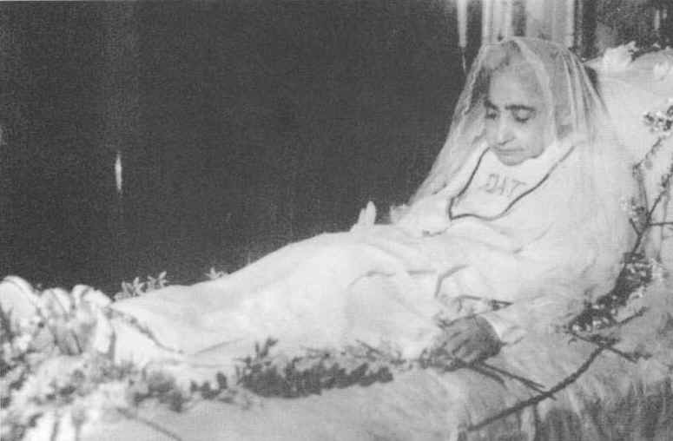
Luisa in the serenity of sister death
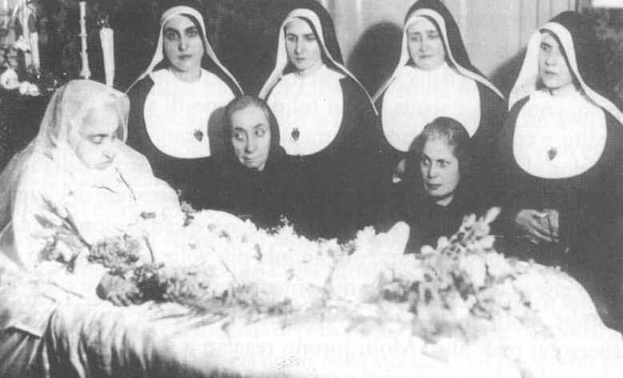
Luisa on her death-bed. Next to her: her sister Angelina, her faithful Rosaria and Sisters of the Divine Zeal paying her a visit
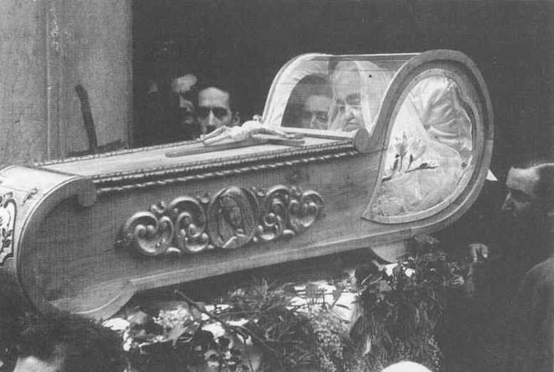
The special coffin, designed with front and side windows
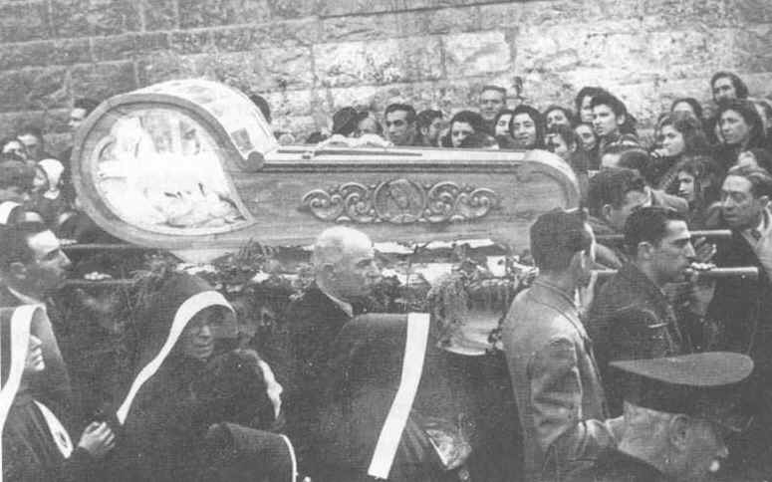
The coffin carried by the faithful of the Servant of God
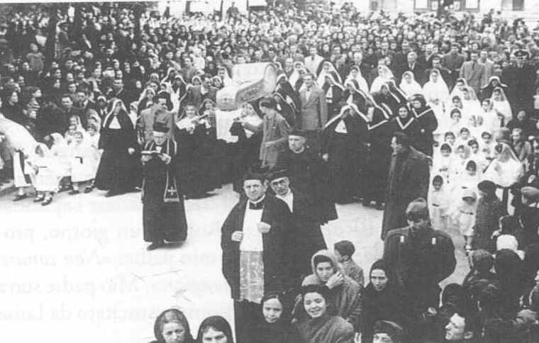
All the townspeople of Corato bid their last farewell to Luisa "the Saint". The Sisters of the Divine Zeal surround the coffin
The young man killed and restored to life
Before I end these memoirs, I cannot omit to record a most outstanding episode.
I had always heard tell of a young man who had been killed and was restored to life by Luisa. I had heard the story told by the old blind singer in the "upper room" of Via Panseri.
One day a young man was found dead, lying on the ground in a pool of blood. When his mother heard this fatal news, she did not rush to see her son but ran howling and disheveled to Luisa’s house where she knelt on the doorstep, crying: "Luisa, Luisa, they’ve killed my son!"
The holy little one – as the singer called Luisa – was moved and said: "Go and fetch your son, the Lord is giving him back to you".
The mother was helped to her feet and accompanied by a few devout persons to the place where her son lay dead.
At the sight of him, ignoring the police, the mother flung herself on the body, cradled it in her arms and kissed it desperately like the sorrowful Mary at the foot of the cross.
But suddenly the young man opened his eyes and said: "Mammà, sto ca nan pianger" (Mother, I’m here, don’t cry).
On hearing this story, the whole gathering was in tears, especially the older women whose sons were serving in the war.
Sometimes – though in hushed tones – I even heard this story told in my own home. I remember Aunt Rosaria addressing my father with these words: "Don’t start talking such nonsense, concentrate on eating your food". My father had in fact been telling the story of the man brought back to life by Luisa the Saint.
In my parish I once heard Miss Redda, Minister of the Franciscan Third Order, speaking of this miracle to a group of women. When she became aware of my presence, she immediately put her hand to her mouth, regretting her imprudence. Indeed, the parish priest, Fr. Cataldo Tota, who was present said: "Certain things should not be said in public while those concerned are still alive".
I never attached much importance to this episode – always spoken of in hushed tones – because it seemed incredible to me. Aunt Rosaria never wanted to discuss the matter. Whenever I asked about it, she would answer: "Leave that nonsense alone!".
I realized that talking about the event was totally forbidden, both by Luisa and by the clergy.
It seemed to me that the story told by the blind old man was too fantastic, too embellished and sounded more like a Greek tragedy than an event which had actually occurred. I never previously wanted to write anything about it so as not to make a laughing-stock of the Servant of God, Luisa Piccarreta (and I was also convinced that this episode was merely the fruit of popular imagination).
Later, having read a letter by the Blessed Annibale M. di Francia, which speaks of the miracle of the resuscitation of a young man who had been killed, I thought it appropriate to mention here the phenomenon about which I had heard so much.
Blessed Annibale confirms, bringing to bear all his authority as a saint, that it was due to Luisa Piccarreta’s prayers that this young man was restored to life.
His letter is dated May 5, 1927. A few days later, on June 1, 1927, Blessed Annibale died serenely in the town of Messina.
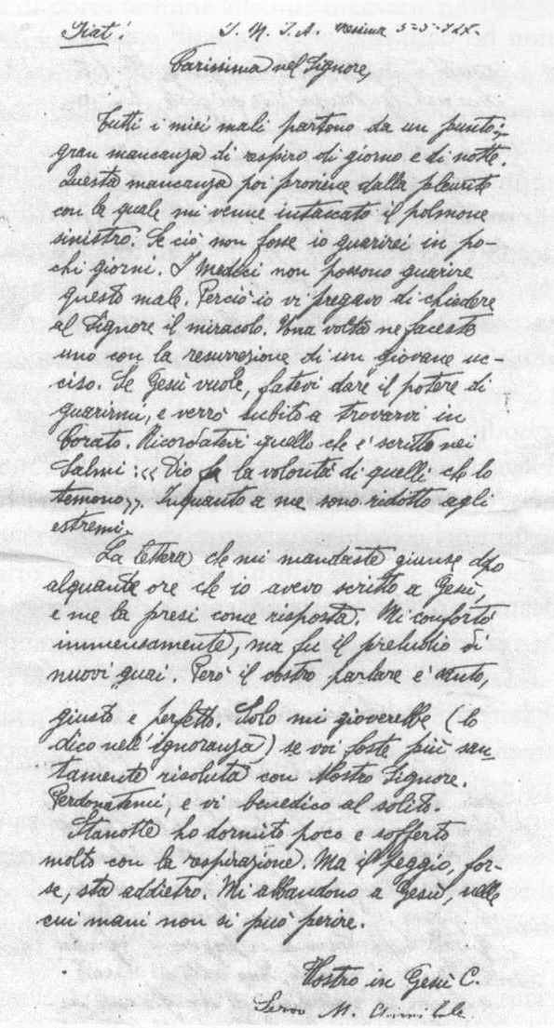
Letter from Blessed Annibale Maria di Francia to Luisa Piccarreta, sent a few days before his death, in which he confirms the miracle.
BIOGRAPHY OF THE AUTHOR
Father Bernardino Giuseppe Bucci was born in Corato on June 15, 1935. His parents were Francesco Bucci and Serafina Garofalo. He was the tenth of twelve children and in 1940, he was taken for the first time by his Aunt Rosaria to the home of Luisa Piccarreta who in 1944 prophesied that he would become a priest.
In 1947, he attended the solemn funeral of the Servant of God Luisa Piccarreta and in 1948 he entered the Seraphic Seminary of Barletta.
In 1951, while he was studying at the Seraphic Seminary of Francavilla Fontana, he lost his mother, to whom he was very close.
In 1955, he entered the Novitiate of the Capuchin Friars at Alessano, in the Province of Lecce, and completed his philosophical studies at the Studentate of Scorrano.
In 1959, his father died and in 1960 he was transferred to the Theological Studentate of S. Fara. On March 14, 1964, he was ordained a priest by Archbishop Nicodemo of Bari in the Capuchin church of Triggiano.
He was sent to the International College in Rome to specialize in Missionary Theology. When he returned to his Province, he was appointed Spiritual Director of the Seraphic Seminary at Scorrano.
In 1968, he was sent to Portugal to learn Portuguese in preparation for his departure as a missionary to Mozambique.
For political reasons, his departure for the mission was postponed indefinitely. On his return to the Province, he was made vice-parish priest of the Capuchins’ parish at Barletta and was appointed Provincial Assistant to Franciscan Youth.
He studied for a licentiate and a doctorate at the Ecumenical Faculty of St. Nicholas of Bari; where at the same time he acquired a degree in literature.
In 1976, he was promoted to the office of superior-parish priest at the friary of the Friars Minor Capuchin at Trinitapoli in the Province of Foggia. This was where he received the news of the death of his beloved Aunt Rosaria (1978), who had spent at least forty years of her life assisting Luisa Piccarreta.
In 1980, at the request of Archbishop Giuseppe Carata of Trani, with instructions not to mention Blessed Annibale M. di Francia so as not to hinder the cause for beatification that was under way, he gathered testimonies about the Servant of God Luisa Piccarreta and went to press with 30 thousand copies of the first short biography of the Servant of God Luisa Piccarreta, translated into various languages, thus contributing to the knowledge of the Servant of God.
In 1988, he was appointed Superior and parish priest of the Triggiano Friary and served at the same time as Provincial Secretary for Parishes.
In 1994, after being elected Provincial Definitor, he returned to Trinitapoli as parish priest. He still lives there as Provincial Definitor, Provincial Secretary of the parishes and Councilor of the National Secretariat for Parishes.
As Co-Founder with Sr. Assunta Marigliano of the Association of the Divine Will, he spent many years as spiritual adviser to the Association which was canonically established in Corato on March 4, 1987.
He is currently a member of the Tribunal for the cause of the beatification of the Servant of God Luisa Piccarretta, which was opened in the principal church of Corato on the Feast of Christ the King, 1994, by Archbishop Carmello Cassati, now emeritus, in his role as Promoter of the Faith.
PRAYERS
to implore the beatification of the Servant of God
LUISA PICCARRETAI
O Most Sacred Heart of my Jesus, who chose your humble Servant LUISA as the herald of the Kingdom of your Divine Will and the angel of reparation for the countless sins that grieve your Divine Heart, I humbly pray you to grant me the grace that through her intercession I implore of your Mercy, so that she may be glorified on earth as you have rewarded her in Heaven. Amen.
Pater, Ave, Gloria.
I
O Divine Heart of my Jesus who gave to your humble Servant LUISA as a victim of your Love the strength to suffer all her life the spasms of your painful Passion, grant that for your greatest glory the halo of the blesseds may shine around her head. And through her intercession grant me the grace that I humbly implore of you…
Pater, Ave, Gloria.
III
O Merciful Heart of my Jesus who, for the salvation and sanctification of so many souls, deigned to preserve for long years on earth your humble Servant LUISA, your little Daughter of the Divine Will, hear my prayer: that she may be glorified by your holy Church without delay. And through her intercession, grant me the grace that I humbly beseech of you...
Pater, Ave, Gloria.
Nulla osta:
Trani, 27 November 1948
ARCHBISHOP REGINALDO ADDAZI, O.P.

Prayer on the holy picture (with relic) printed immediately after Luisa Piccarreta’s death with the authorization of Archbishop Reginaldo Addazi O.P.
The interest in Luisa is worthy of note both because of the attention that is currently being paid to understanding mystics (and Luisa was one, because through her contemplation and acceptance of physical and spiritual sufferings she achieved considerable intimacy with Jesus) and because Luisa was known and visited by many of our friars (Fr. Fedele from Montescaglioso, Fr. Guglielmo from Barletta, Fr. Salvatore from Corato, Fr. Terenzio from Campi Salentina, Fr. Daniele from Triggiano, Fr. Antonio from Stigliano, Fr. Giuseppe from Francavilla Fontana, to name but a few) who were able to communicate to her the essential elements of Franciscan spirituality, while from her they assimilated her love for Christ and commitment in doing the Divine Will (from the Introduction by Fr. Mariano Bucci).
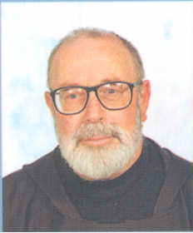
Father Bernardino Giuseppe Bucci was born in Corato on 15 June 1935.
In 1955, he entered the Novitiate of the Capuchin Friars at Alessano, in the Province of Lecce and completed his philosophical studies at the Studentate in Scorrano. On 14 March 1964, in the Capuchin church of Triggiano, he was ordained a priest by Archbishop Nicodemo of Bari.
He was sent to the International College in Rome to specialize in Missionary Theology. When he returned to his Province, he was appointed Spiritual Director of the Seraphic Seminary of Scorrano. He studied for a licentiate and a doctorate, taking the course at the Ecumenical Faculty of St. Nicholas of Bari; where at the same time, in 1972, he acquired a degree in Literature.
As co-founder with Sr. Assunta Marigliano of the Association of the Divine Will, he spent many years as the spiritual adviser of the Association which was canonically erected in Corato on March 4, 1987. He is currently a member of the Tribunal for the cause for beatification of the Servant of God Luisa Piccarretta, which was opened on the Feast of Christ the King, 1994, in the main church of Corato by Archbishop Carmello Cassati, now emeritus, in his role as Promoter of the Faith.

