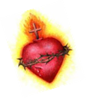
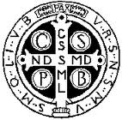
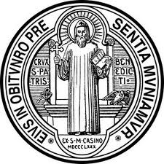
Benedictine Oblates of Divine Will
Profession of Promises

Questioning

Priest: Do you wish to profess promises as an Oblate of St. Benedict and thus be affiliated with the Benedictines of Divine Will?

Candidate(s): I do.

Priest: Do you dedicate yourself to the service of God and humanity according to the Rule of Saint Benedict and the Divine Will writings of the Servant of God Luisa Piccarreta?

Candidate(s): I do.

Priest: Will you strive to be faithful and persevere in your holy resolution for…(one year or the rest of your life)?

Candidate(s): With the help of God's grace, I will.

Priest: Thanks be to God. Since God has given you this good will and you trust in His help, you may now profess your promises.

Promises

If many candidates are present, then each in turn reads only his/her religious name and title alone. When the last one has finished with this, then all together read the remaining part of the promise formula (groups should be separated according to temporary and final promises):

+ In the Name of the Father and of the Son and of the Holy Spirit.
I, ___________________________, responding to the grace the Lord has given me, for the glory of God and with the will to live more perfectly the Gospel of Christ, promise to God to live for ____________ in obedience, in poverty, in chastity,
and in charity according to the Way of Life based on that of
the Holy Family of Nazareth and the Rule of Saint Benedict.

I consecrate myself to the Divine Will in Creation, Redemption and Sanctification on behalf of Holy Church. I give myself with my whole heart to the Benedictine Oblates of Divine Will so that by the power of the Holy Spirit and through the intercession of the Immaculate Mother of God, the Servant of God, Luisa Piccarreta, our Father,
Saint Benedict and our Mother, Saint Scholastica, under the protection of
Good Saint Joseph, I may live more perfectly my consecration. Amen.

Priest: And I on the part of God the Almighty promise you, if you observe all this faithfully, life everlasting. In the Name of the Father, and of the Son, and of the Holy Spirit. Amen.

Each one, when finished professing his/her promises, goes to the altar and signs his/her full religious name on the profession form. The formal acceptance of the newly professed Oblates is announced.

Priest: As God's representative, I now accept your promises and admit you into spiritual union and affiliation with the Benedictines of Divine Will as Oblates and give you the privilege of sharing in the prayers and good works of the community.

Final Blessing

The officiating priest prays over the newly professed Benedictine Oblates of Divine Will:

Let us pray.

O God, you blessed your holy confessor Benedict and your little daughter Luisa with the spirit of all the just. Grant that these newly accepted Oblates, with the help of your grace and through the intercession of the Blessed Virgin Mary, may be filled with the same spirit and faithfully carry out what they have promised. We ask this through Christ our Lord.

All: Amen.

Priest: May the peace and blessing of almighty God, the Father, the Son, + and the Holy Spirit, come down upon you and remain with you forever.

All: Amen.

