Divine Will Prayer Group
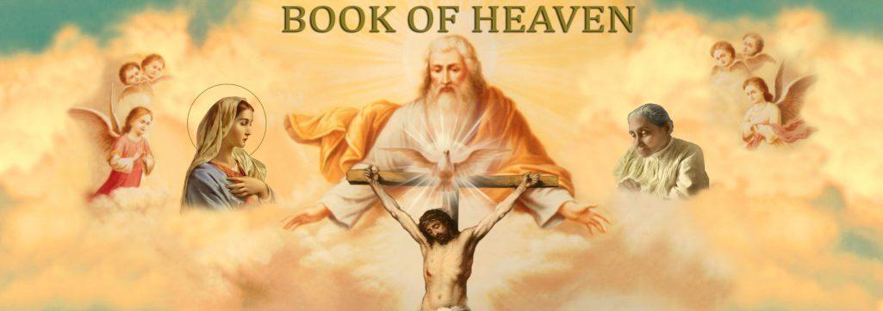

Agenda

Let us Pray in the Divine Will and with the Holy Spirit:

Come Holy Spirit, come by means of the power of the Flame of Love of the Immaculate Heart of Mary, fill the hearts of thy faithful and enkindle in them the fire of Your Love. Send forth Your Spirit and we shall be created, and You shall renew the face of the earth.

Our Father …… ALL

Introduction:

- General introduction of myself, Donna, and members of our DW team
- We have received approval from the Parish and Fr. Gerlach for these meetings
- We plan to meet in the Meehan Center the 2nd and 4th Wednesday of each month at 6:30 pm. Meeting will last 1 to 1 ½ hours

An Overview of the Divine Will of God:

- It is our intent to present you with sufficient information that will motivate you to come back and continue on this journey with us to learn of God’s greatest gift to mankind.
- It is about God’s plan for us, the creature, to return to the Order, to the Place, and to the Purpose for which it was created by God.
- It is the reason why Jesus taught His disciples how to pray the
- “Our Father Prayer” - Thy Will be done on earth as it is in Heaven.
- It is about a mystic, selected by Jesus, from all time, to receive this gift of Living in the DW
- What is the Divine Will of God?
- It is a gift from God. It is the essence of God.
- When you are in the DW you now share in His Divine Life.
- It is the loft at the top of the ladder, given in exchange for your human will.
- There is no higher place to go. Bl. Mary promises that hose in the DW, and their loved ones, will be protected, and safe from chastisements.
- Jesus tells us that “Living in the DW is the model that is closest to the blessed in Heaven, and as distant from doing the DW as that of heaven and earth.
- Jesus tells Luisa that when the predetermined number of Acts, as determined by God, are completed in the DW by mankind, God’s Kingdom will Come on earth as it is in Heaven.

Preview of: the video, Fr. Iannuzzi, and Mary’s Hill- source of DW information

https://www.queenofthedivinewill.org

Father Iannuzzi - Introduction Video to The Gift of Living In The Divine Will
What is The Gift of Living in The Divine Will? Part I ( from 7.10 to 30.15 min.)

In Summation:

- All your questions, and more will be discussed as we meet, pray, and read the 36
Volumes of the Book of Heaven, in the writings of The Servant of God, Luisa Piccarreta.

- Living in the Divine Will is a Gift, not a devotion.

- Think of this as a Spiritual Journey, that will guide you on your path to Heaven.

- Let’s say you want to become a professional baseball player without any knowledge
of the sport. You must first learn the basics and then identify someone who knows the game to guide and teach you. You would then have to practice and never stop. Then maybe you make the highschool and college teams, then the minor leagues, and finally the major leagues. The path to living in the DW is the same.

- Don’t expect quick answers. There are no shortcuts. You will need to read the
volumes.You must have patience and perseverance.

- We will guide you, provide Church approved teaching, and direct you to priests and
theologians who are in the Divine Will.

- You will encounter Divine Will Cenacle groups that are active throughout the world,
web-sites that will provide endless information, and training to help you to grow and live in the Divine Will of God.

- There are many movements, spiritual devotions, religious orders, and charismatic
movements that allow us to experience the presence of God, but these are all rungs in the ladder that bring us closer to God. But the gift of the DW is the loft at the top of the ladder.

- It is God’s very own Will given to you in exchange for your human will. There is no
higher place to go.

- You will learn many new things as we read the 36 volumes of the “Book of Heaven”,
as presented by Jesus to Luisa. These volumes have been studied and have received approval by the Vatican.

- Our next meeting will be held on July 17th - same time and place. We will cover the
next segment of Father Iannuzzi’s video. Be sure to provide your name and email address, or a way to contact you if you do not have a computer.

- How does one go about living in the DW? There are 4 levels, or steps:
- You must have a deep desire, and a firm commitment
- You can not escape knowledge - you must read the volumes
- you must have patience and perseverance
- You must remain in a state of grace.
- Upon receiving this gift of Living in the DW, you must never leave it. Continuously participating in
God’s Eternal Operation.

Closing Command Prayer:

Abba Father, in the name of Jesus, in union and power of the Holy Spirit, under the Mantle of Mary, with all the angels and saints, through the intercession of the Servant of God, Luisa Piccarreta, take my humble prayer and make it your command, that all will be accomplished and completed in your most Holy Divine Will. We believe, we receive. Fiat, Amen

_____________________________________________

Some of these mysteries that you will encounter and learn include:

- Why did God create man; What was God’s Original Plan (before original sin)?

- What is our purpose, and what are we supposed to be doing?

- What did Adam and Eve do before “The Fall”?
Adam and Eve had their human will, but were given the gift of
the Divine Will.

- What gifts were Adam and Eve given when they possessed the Divine Will? Immutability,
Immaculacy, Infused Knowledge, Divine Integrity, Immortality, and Impassibility

- What happened as a result of original sin? Why did Adam & Eve feel naked after they committed
original sin?

- What is the gift of the Divine Will?

- Why is the “Our Father Prayer” so significant?

- Who is Luisa Piccarreta? What are mystics, seers, prophets?

- Who has received the gift of Living in the Divine Will?

- Why did the saints not receive this gift?

- How long did it take God to create everything?

- What did God create everything from?

- Is God really our Father?

- What is the Holy Trinity, and how does the Father, Son, and Holy Spirit work, as one and
separately?

- What does Omnipotence, Omnipresence, and Omniscience mean?

- Are Heaven and Hell real?

- What happens to us in Heaven?

- Do angels exist? How many levels of angels are there?

- Was there really a battle in Heaven, and what happened as a result?

- Why did Lucifer defy God? What level was Lucifer? St. Michael the Archangel?

- What is the “Fiat of Creation”, the “Fiat of Redemption”, and the “Fiat of Sanctification”?

- What does “Fiat” mean?

- What is the gift of bilocation?

- How does God communicate to his creature?

- Why was the gift of Living in the Divine Will lost to man, and not regained for 6000 years?

- What are the Acts done in the Divine Will?

- What are the Rounds done in the Divine Will?

- How do you do these Acts and Rounds in the Divine Will?

- What happens to us after death?

- Where does our soul go – Heaven, Limbo, Purgatory, or Hell

- How can I escape Purgatory and go directly to Heaven?

- Does anyone in the Divine Will go to Purgatory?

- Why is suffering necessary?

- What did the baby Jesus do during His 9 months in Mary’s womb?

- What did Jesus do during his first 30 years of His Humanity?

