Prayer to St. Michael the Archangel

One day, after celebrating Mass, the aged Pope Leo XIII was in conference with the Cardinals when suddenly he sank to the floor in a deep swoon. Physicians who hastened to his side could find no trace of his pulse and feared that he had expired. However, after a short interval the Holy Father regained consciousness and exclaimed with great emotion: "Oh, what a horrible picture I have been permitted to see!"
He had been shown a vision of evil spirits who had been released from Hell and their efforts to destroy the Church. But in the midst of the horror the archangel St. Michael appeared and cast Satan and his legions into the abyss of hell. Soon afterwards Pope Leo XIII composed the following prayer to Saint Michael, which is the original version:

Original - Prayer to St. Michael
“O Glorious Prince of the heavenly host, St. Michael the Archangel, defend us in the battle and in the terrible warfare that we are waging against the principalities and powers, against the rulers of this world of darkness, against the evil spirits. Come to the aid of man, whom Almighty God created immortal, made in His own image and likeness, and redeemed at a great price from the tyranny of Satan.
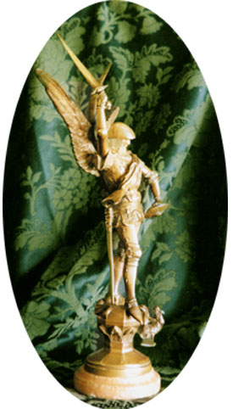

“Fight this day the battle of the Lord, together with the holy angels, as already thou hast fought the leader of the proud angels, Lucifer, and his apostate host, who were powerless to resist thee, nor was there place for them any longer in Heaven. That cruel, ancient serpent, who is called the devil or Satan who seduces the whole world, was cast into the abyss with his angels. Behold, this primeval enemy and slayer of men has taken courage. Transformed into an angel of light, he wanders about with all the multitude of wicked spirits, invading the earth in order to blot out the name of God and of His Christ, to seize upon, slay and cast into eternal perdition souls destined for the crown of eternal glory. This wicked dragon pours out, as a most impure flood, the venom of his malice on men of depraved mind and corrupt heart, the spirit of lying, of impiety, of blasphemy, and the pestilent breath of impurity, and of every vice and iniquity.
“These most crafty enemies have filled and inebriated with gall and bitterness the Church, the spouse of the immaculate Lamb, and have laid impious hands on her most sacred possessions. In the Holy Place itself, where the See of Holy Peter and the Chair of Truth has been set up as the light of the world, they have raised the throne of their abominable impiety, with the iniquitous design that when the Pastor has been struck, the sheep may be scattered.
“Arise then, O invincible Prince, bring help against the attacks of the lost spirits to the people of God, and give them the victory. They venerate thee as their protector and patron; in thee holy Church glories as her defense against the malicious power of hell; to thee has God entrusted the souls of men to be established in heavenly beatitude. Oh, pray to the God of peace that He may put Satan under our feet, so far conquered that he may no longer be able to hold men in captivity and harm the Church. Offer our prayers in the sight of the Most High, so that they may quickly find mercy in the sight of the Lord; and vanquishing the dragon, the ancient serpent, who is the devil and Satan, do thou again make him captive in the abyss, that he may no longer seduce the nations. Amen.
V. Behold the Cross of the Lord; be scattered ye hostile powers.
R. The Lion of the tribe of Judah has conquered, the root of David.
V. Let Thy mercies be upon us, O Lord.
R. As we have hoped in Thee.
V. O Lord, hear my prayer.
R. And let my cry come unto Thee.
Let us pray.
O God, the Father of our Lord Jesus Christ, we call upon Thy holy Name, and as supplicants, we implore Thy clemency, that by the intercession of Mary, ever Virgin Immaculate and our Mother, and of the glorious St. Michael the Archangel, Thou wouldst deign to help us against Satan and all the other unclean spirits who wander about the world for the injury of the human race and the ruin of souls. Amen.”
Roman Raccolta, July 23, 1898, supplement approved July 31, 1902,
London: Burnes, Oates & Washbourne Ltd., 1935, 12th edition.

