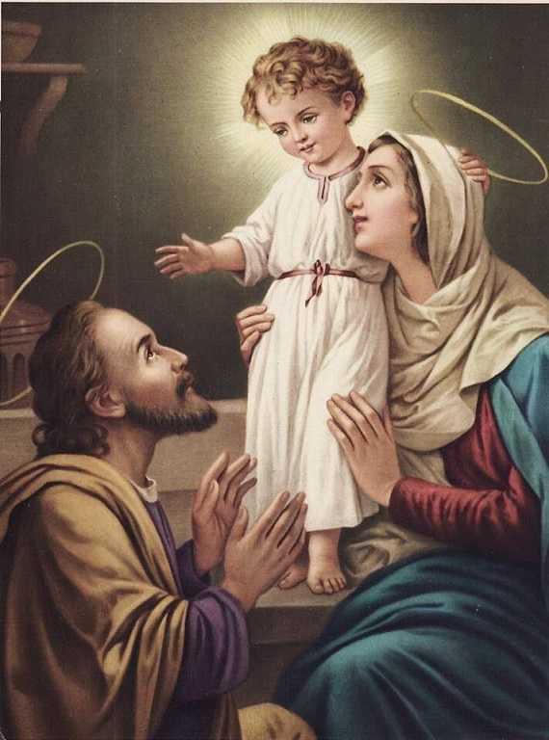
The Family of Nazareth in The Divine Will
Divine Will Reflections
By
Reverend Father B. Thomas Celso, BDV

V29 – May 31, 1931 - After this, I continued my acts in the Divine Fiat, and my poor mind paused in the little house of Nazareth, where the Queen of Heaven, the Celestial King Jesus, and Saint Joseph, were in possession of and Lived in the Kingdom of the Divine Will. So, this Kingdom is not foreign to the earth; the house of Nazareth, the little family that lived in It, belonged to this Kingdom and kept It in Full Force. But while I was thinking about this, my Great King Jesus told me: “My daughter, indeed the Kingdom of My Divine Will has existed upon earth, and therefore there is the sure hope that It will return again to Its full force. Our house of Nazareth was Its true Kingdom; however, We were without peoples.
“Now, you must know that each creature is a Kingdom; therefore, the one who lets the Divine Will Reign within herself can be called a little Kingdom of the Supreme Fiat. So, she is a tiny little house of Nazareth that We have upon earth; and, though little, since Our Divine Will is in her, Reigning, Heaven is not closed for her; she observes the same laws of the Celestial Fatherland, she loves with the same Love, feeds herself with the Foods from up there, and is incorporated into the Kingdom of Our interminable regions. Now, in order to form the great Kingdom of Our Will upon earth, first We will make the many tiny little houses of Nazareth—that is, the souls who shall want to know It in order to let It Reign within themselves. I, Myself, and the Sovereign Queen, shall be at the head of these tiny little houses, because, We having been the first to possess this Kingdom on earth, it is Our right, that We will not surrender to anyone, to be the directors of them. Then, with these tiny little houses, repeaters of Our house of Nazareth, We will form many little states of Ours, many Provinces, that, after they have been formed well, and ordered like many little Kingdoms of Our Divine Will, will Fuse Together and shall form one single Kingdom and one Great people. Therefore, in order to have Our Greatest Works, Our way of Acting is to begin, first alone, one on one with one single creature; when We have Formed this one, We make her a channel in order to enclose in Our Work two or three more creatures; then We expand, Forming a little group, and then We expand it so much as to take the whole entire world. Our works begin in the isolation of God and the soul, and end by continuing their life in the midst of Entire peoples. And when there is the beginning of a work of Ours, it is the Sure Sign that it will not die at birth; at the most, it may live hidden for some time, but then it shall go out and shall have its Perennial Life. Therefore, Always Forward do I Want you in My Divine Will.”

V34 – May 31, 1936 - “And My return to Nazareth, how well it symbolized My Divine Will. I Lived in It hidden; Its Reigning was in Full Vigor in the Holy Family. I was the Word, the Divine Will in person, veiled by My Holy Humanity. That same Will that Reigned in Me Diffused Itself to everyone, It embraced them, It was the Motion and Life of each one, I felt in Me the motion and the life of each one, of which My Fiat was the Actor. What suffering, what Sorrow, in not being recognized, nor receiving one thank You, one ‘I Love You,’ one act of gratitude, neither from the entire world, nor from Nazareth itself, because not only My Divine Will, but also My Holy Humanity Lived in their midst, that did not cease to Give Light to the one who could see Me and come near Me in order to make Myself Known…”

The Family of Nazareth in The Divine Will
Divine Will Reflections
By
Reverend Father B. Thomas Celso, BDV
January 24, 2021

Virgin Mary in the Kingdom of the Divine Will – Day Twenty-Five
Now, you must know that for your Mama, for dear and sweet Jesus, and for Saint Joseph, the little house of Nazareth was a paradise. Being the Eternal Word, my dear Son possessed the Divine Will within Himself, of His own virtue; immense seas of light, of sanctity, of infinite joys and beauties resided in that little Humanity. I possessed the Divine Will by grace, and even though I could not embrace immensity, as did beloved Jesus – since He was God and Man, while I was always His finite creature – still, the Divine Fiat filled Me so much as to form Its seas of light, of sanctity, of love, of beauties and of happiness. And the light that came from us, the love, and all that a Divine Will can possess, were so great that Saint Joseph remained eclipsed, inundated, and lived from our reflections.
Dear child, in this house, the Kingdom of the Divine Will was in Full Force. Every little act of ours – working, starting the fire, preparing the food… – all were animated by the Supreme Volition, and were formed on the solidity of the sanctity of pure love. Therefore, from the tiniest to the greatest of our acts, immense joys, happinesses and beatitudes were unleashed. And we remained so inundated as to feel ourselves as though under a pouring rain of new joys and indescribable contentments.
My child, you must know that the Divine Will possesses, by nature, the source of Joys, and when It Reigns in the creature It delights in giving, in each one of her acts, the new and continuous act of Its Joys and Happinesses. Oh, how Happy we were! Everything was Peace, Highest Union, and each of us felt Honored in obeying the other. My dear Son also competed in wanting to be commanded by Me and by dear Saint Joseph in the little jobs. Oh, how Beautiful it was to see Him in the act of helping His foster father in the smith-work, or to see Him take food! But how many seas of Grace did He let flow in those acts for the good of creatures?
Now, dear child, listen to Me: in this house of Nazareth, the Kingdom of the Divine Will was formed in your Mama and in the Humanity of my Son, to make of It a gift for the human family, when it would dispose itself to receive the good of this Kingdom. But even though my Son was King and I was Queen, We were King and Queen without a people. Our Kingdom, even though It could enclose all and give life to all, was deserted, because Redemption was needed first, in order to prepare and dispose man to come into this Kingdom, so holy. More so, since It was possessed by Me and by my Son, who belonged to the human family according to the human order, as well as to the Divine Family by virtue of the Divine Fiat and of the Incarnate Word, and therefore the creatures received the right to enter into this Kingdom. And the Divinity conceded this right, and left the doors open to those who wanted to enter. So, our hidden life of so many years served to prepare the Kingdom of the Divine Will for the creatures. This is why I want to let you know what this Supreme Fiat operated in Me, so that you may forget your will, and as you hold the hand of your Mama, I may lead you into the goods which I have prepared for you with so much love.
Tell me, child of my Heart, will you make Me content, and also your, and my, dear Jesus, who await you with so much love in this Kingdom so holy, to live together with us, and to live only of Divine Will?
Now, dear child, listen to another trait of love which my dear Jesus made for Me in the house of Nazareth: He made of Me the depository of His own life. When God does a work, He does not leave it suspended, or in the empty space, but He always looks for a creature in whom to enclose and place all of His work. Otherwise, there would be the danger that God might expose His works to uselessness – which cannot be. Therefore, my dear Son placed in Me His works, His words, His pains – everything. He deposited even His breath into His Mama. And when, withdrawn in our little room, He would speak sweetly and narrate to Me all the Gospels He was to preach to the public, and the Sacraments He was to institute, He entrusted everything to Me; and depositing everything in Me, He constituted Me perennial channel and source, because His life and all His goods were to come from Me for the good of all creatures. Oh, how rich and happy I felt in feeling that all that my dear Son Jesus did, was being deposited in Me! The Divine Will which reigned in Me gave Me the capacity to be able to receive everything, and Jesus felt He was receiving from His Mama the return of love and glory of the great work of Redemption. What did I not receive from God, because I never did my will, but always His? Everything; even the life of my Son was at my disposal; and while it remained always with Me, I could bilocate it, to give it to whomever would ask Me for it with love.
Now, my child, a little word to you. If you always do the Divine Will and never your own, and if you live in It, I, your Mama, will make the deposit of all the goods of my Son in your soul. Oh, how fortunate you will feel! You will have a divine life at your disposal, which will give you everything. And I, acting as your true Mama, will watch over you, so that this life may grow within you, forming the Kingdom of the Divine Will.

