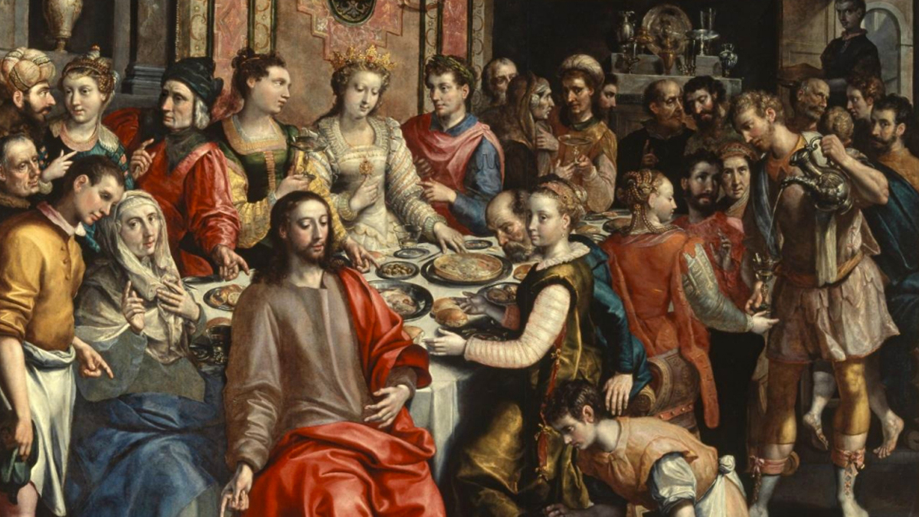

The Christian economy, therefore, since it is the new and definitive Covenant, will never pass away; and no new public revelation is to be expected before the glorious manifestation of our Lord Jesus Christ.” Yet even if Revelation is already complete, it has not been made completely explicit; it remains for Christian faith gradually to grasp its full significance over the course of the centuries. —Catechism of the Catholic Church, 66 +

It is not [so-called “private” revelations’] role to improve or complete Christ’s definitive Revelation, but to help live more fully by it in a certain period of history… —Catechism of the Catholic Church, n. 67 +

“Do not quench the Spirit. Do not despise prophetic utterances. Test everything; retain what is good” (1 Thess. 5:19–21) +

“I have many more things to say to you, but you cannot bear them at the present time”. -- John 16:12 +

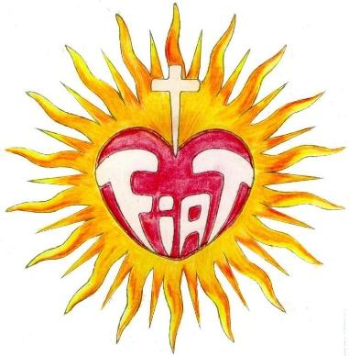

“At once virgin and mother, Mary is the symbol and the most perfect realization of the Church…” —Catechism of the Catholic Church, n. 507+

Meditation 6
The Wedding Feast of Cana
May 31, 2022

The soul to its Heavenly Mother:
Holy mother, here I am together with you and sweet Jesus to assist at this new wedding, to see the prodigies surrounding it, to comprehend its great mystery and to witness the depths of your maternal love for me and for all souls. I beseech you, dear mother, take me by the hand and place me upon your lap, envelop me with your love, purify my intelligence and tell me why you wish for me to assist at this wedding. +

Lesson of the Queen of Heaven:
My dearest child, my Heart is set ablaze with love, and so I, along with my Son, long for you to assist at this wedding in Cana. Do you think I desire your assistance at this wedding because of a simple ceremony? No, my child; these are profound mysteries. Be attentive to what I say and I will reveal to you new mysteries. For at this wedding my motherly love overflowed in an incredible way, and my Son displayed true signs of a paternal and royal love for souls. So be attentive to what I say. + (Stop what you are doing, even in Holy Things, always, according to the circumstances - The VMK Day 16)
My Son had returned from the desert and was preparing for his public life, but before doing so, he wanted to be present at this wedding. Therefore, He allowed himself to be invited. We went to this wedding not to celebrate, but to do great things for all human generations. + At this wedding my Son became the Father and King of all families, and I became their Mother and Queen. With our presence, we renewed the sanctity, the beauty and the [divine] order of the state of marriage that was established by God in the Garden of Eden – the same state of marriage that was enjoyed by Adam and Eve who were married by the Supreme Being in order to [be fruitful], multiply, populate the earth and give rise to [all] future generations.
Marriage is the substance from which the life of [all] human generations arise. + Marriage may be called the tree trunk from which the earth is populated, and Priests and Religious may be called the branches. If it were not for the trunk, the branches would not have life. + For this reason, when Adam and Eve sinned by withdrawing from the Divine Will, + (that was their sin) they caused the [tree of the human] family to lose its sanctity, beauty and [divine] order. + (not just about an apple) And I, your mother, the innocent Eve, together with my Son, set out to reorder the state of marriage that had been established by God in Eden. I was constituted the Queen of Families, whence I pleaded for the grace of the Divine Fiat to reign in families, so that I might have such families under my own care and rule over them as their Queen. + (Divine Oder) (now do we recognize why Jeus made Himself be invited)
But this is not all, my child. Our love was set ablaze. My Son and I wanted to let families know how much we love them by imparting to them the most sublime lessons, and this is how we did it. In the middle of lunch there was no more wine, and my motherly Heart, consumed with love, desired to assist those present. Knowing that my Son can do anything, I, with an imploring tone and certain that He would listen to me, said to him: “My Son, the bride and the groom have no more wine.” He replied: “My hour to do miracles has not yet come.” And knowing with certainty that He would not deny what his mother would ask him, I said to those serving at table: “Do whatever my Son tells you, and you will obtain what you desire; indeed, you will obtain more than what you ask and in superabundance.” + (This is the full quote)
My child, in these few words, I imparted the most useful, necessary and sublime lesson for souls. + I spoke with my motherly Heart, saying: “My children, do you want to be holy? Do the Will of my Son. If you do not refuse what He tells you, you will possess his likeness and sanctity. Do you wish to conquer all evils? Do whatever my Son tells you. Do you wish to obtain a grace, even one that is difficult to obtain? Do whatever My Son tells you and desires of you. Do you wish to have also the very basic things that are necessary in life? Do whatever my Son tells you and desires of you. Indeed, my Son’s words enclose such power that, as He speaks, his word, which contains whatever it is you ask, makes the graces you seek arise within your souls. + (“ask and you shall receive” - depending on our disposition determines its efficacy)
There are so many souls that find themselves filled with passions, weak, afflicted, unfortunate and wretched. And although they pray and pray, they obtain nothing because they do not do what my Son asks of them – heaven, it seems, is irresponsive to their prayers. + (“ask and you shall receive” – Grace utilized based on our disposition will determines its efficacy) And this is a cause of sorrow for your mother, for I see that as they pray, they greatly distance themselves from the source that contains all blessings, namely, the Will of my Son. + (Again “Mary is the symbol and the most perfect realization of the Church…” —Catechism of the Catholic Church, n. 507)
Now, those who were serving did precisely what my Son asked of them when He said, “Fill the jars with water and take them to the table.” My dear Jesus blessed the water and it turned into the most delightful wine. Oh, how blessed a thousand-fold is the one who does what Jesus asks and desires! + (lesson from the Queen of Heaven) With this miracle, my Son gave me the greatest honor, as He constituted me the Queen of Miracles. + And so He wanted me to be united with him in prayer while performing his first miracle. He loved me so much that He wanted me to occupy the first place of honor as the Queen also of miracles. And not with mere words but with deeds, He said: “If you want graces and miracles, go to My mother, as I will never deny her anything she asks of Me.” + (What would Jesus not do for His Church, what would He not do for Mary, the perfect example of His Church)
Furthermore, my child, while at this wedding, I peered into the future centuries [of mankind] and beheld the Kingdom of the Divine Will on earth. I beheld [all] families and [, with prayers,] pleaded with them to symbolize the love of the Most Holy Trinity, whereby the Kingdom of the Divine Will [on earth] may be fully realized. + (why? Because this is the Will of the Holy Trinity, which Mary always was in union with) And with the rights accorded to me as a Mother and a Queen, I considered the great importance of this Kingdom. And, since I possess [Jesus,] the source of this Kingdom, I placed at the disposal of souls all [of his] grace, assistance and sanctity that would be required for them to live in such a holy Kingdom. This is why I keep repeating: “Do whatever my Son tells you.” +
My child, listen closely. If you wish to exercise dominion over all things, and give me the joy of being able to make of you my true child and a child of the Divine Will, then seek nothing but [God’s Will]. If you do so, I will take on the commitment of forming a marriage between you and [God’s Divine] Fiat. As your true mother, I will ratify this marriage by giving you as a dowry the very life of my Son, and as a gift my maternity and all of my virtues. +

The soul:
Heavenly Mother, I thank you so much for your great love for me, for having always a thought for me in everything you do, and for preparing for me and granting me so much grace that heaven and earth are moved and enraptured along with me, whereby we all say: “Thank you! Thank you!” Holy mother, engrave your holy words within my heart, “Do whatever my Son tells you”, so that Jesus may engender in me the life of the Divine Will which I ardently long for and desire. And seal my will in such a way that it may always be submitted to the Divine Will. +

Aspiration:
In all our actions, let us attune our ears and listen to our Heavenly Mother who says to us: “Do whatever my Son tells you”, so that we may fulfill the Divine Will in all things. +

Exclamation:
Holy mother, come into my soul and perform the miracle of making me [submit my will to God so that I may] be possessed by the Divine Will. +

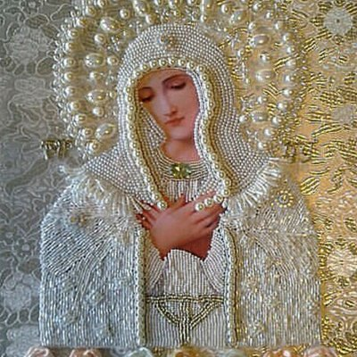

End

Noteworthy are the 12 titles Mary received throughout her life and that she reveals to Luisa in this book: 1) Mother of Jesus, the Eternal Word [Day 19; Assumption: Day 31] and Mother of all Souls, whereby her love redoubled [Meditation 1]; 2) Queen of the Heart of Jesus [Assumption: Day 31; 4pm Hour of the Passion]; 3) Queen of Heaven and Earth and Queen of all Creation [After the third step: Day 3; Assumption: Day 31]; 4) Queen of all Things [After her triumph in the test: 6th step: Day 6]; 5) Secretary of the Most Holy Trinity w/ scepter in hand [Day 7]; 6) Queen of Peace [Peacemaker who reconciles mankind with God: Day 9]; 7) Queen of her own Human Nature [Day 13]; 8) Mother of Jesus’ Blood and of Jesus’ Sorrows: Circumcision [Day 23; Meditation 3]; 9) Mother and Queen of all Sorrows: Presentation [Day 23; Meditation 4]; 10) Mother and Queen of all Families [Wedding Feast of Cana: Meditation 6]; 11) Queen and Mother of Love [Presentation: Meditation 4]; 12) Queen of Miracles [Wedding Feast of Cana: Mediation 6].
Mary’s expression, “The very life of my Son” alludes to the new indwelling of the three divine Persons in the soul, known as Jesus’ “Real Life”, which is progressively realized in the soul (cf. L.

