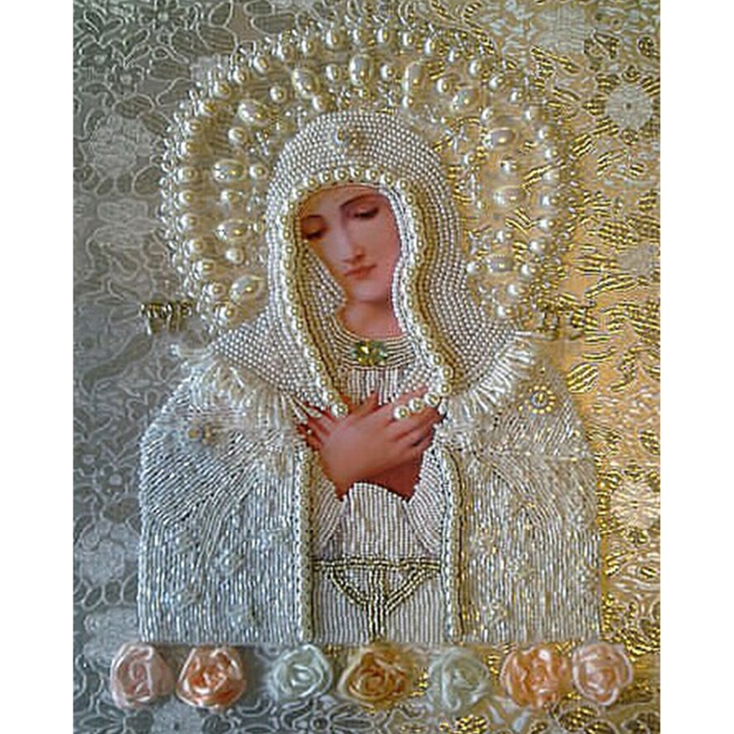
Exclamation:
My mother, enclose the Divine Will in my soul, so that it may acquire its primary place and establish therein its throne and indwelling.
Exclamation:
Sovereign Queen, with your Divine Rule, cast down my will so that the seed of the Divine Will may sprout up from within me.
Exclamation:
Powerful Queen, exercise your dominion over my will and convert it into the Divine Will.
Exclamation:
Heavenly Mother, take me into your arms and inscribe in my heart: “Fiat, Fiat, Fiat”!
Exclamation:
Triumphant Queen, snatch my will from me and grant me the Divine Will in exchange.
Exclamation:
Queen of Heaven, let me be possessed by God’s Divine Will.
Exclamation:
Heavenly Mother, enclose me in your Heart so that I may learn from you how to live in the Divine Will.
Exclamation:
Heavenly Mother, pour your tears into my soul so that they may heal the wounds created by my human will.
Exclamation:
Queen of Peace, may the Divine Will grant me its kiss of peace.
Exclamation:
My little mother, through your intercession may the dawn of the Divine Will arise within my soul.
Exclamation:
Heavenly Mother, let the daybreak of the Divine Will rise up in my soul.
Exclamation:
Powerful Queen, captivate my heart and enclose it in the Divine Will.
Exclamation:
Sovereign Queen, take my soul into your hands, and transform it completely into the Will of God.
Exclamation:
Heavenly Mother, empty me of everything and hide me in the Will of God.
Exclamation:
Holy Queen Mother, enclose me in the sacred Temple of the Will of God.
Exclamation:
My mother in whom I trust, may you form the day
of the Divine Will in my soul.
Exclamation:
Powerful Queen, grant me the weapons to wage war against my own will, so that I may allow myself to be won over by the Will of God.
Exclamation:
Heavenly Empress, impress the kiss of the Will of God upon my soul.
Exclamation:
Powerful Queen, pronounce your Fiat and establish in me the Divine Will.
Exclamation:
Mother of Jesus, be my mother and guide me along the pathway that leads me to the Will of God.
Exclamation:
My mother, enclose little Jesus in my heart so that He may transform it completely into the Will of God.
Exclamation:
Holy mother, pour the tears of Jesus into my heart so that He may dispose my soul for the triumph of God’s Will.
Exclamation:
My mother, pour out your sorrow into my soul and convert all of my sorrows into the Will of God.
Exclamation:
My mother, enclose little Jesus in my heart so that He may completely reorder it in the Divine Will.
Exclamation:
Jesus, Mary and Joseph, take me with you to live in the Kingdom of the Will of God.
Exclamation:
Divine mother, may your word and that of Jesus descend into my heart and form in me the Kingdom of the Divine Will.
Exclamation:
May the wounds of Jesus and the sorrows of my mother infuse in me the grace of making my will rise again in the Will of God.
Exclamation:
Dear mother, for the sake of the Resurrection of your Son, make me rise again in the Will of God.
Exclamation:
Dear mother, with your power, triumph over my soul and may I remain in the Will of God.
Exclamation:
Heavenly Mother, pour out onto my heart your loving fiery flames to consume me and vanquish from me whatever opposes the Will of God.
Exclamation:
Heavenly Mother, enclose my will within your Heart and infuse within my soul the sun of the Divine Will.

Thank You Blessed Jesus for Our Blessed Mother Mary!

