The doctrine of living in the Divine Will
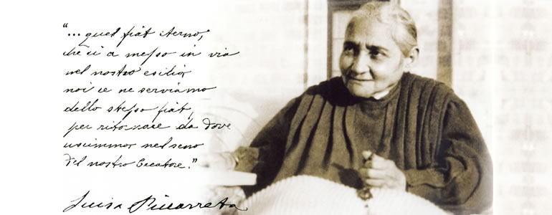
We can easily affirm that "living in the Divine Will" is the center of the mystical experience and of every page of the writings of Luisa. The simple language, full of examples, stories and images, often mediated by dialectal expressions, is able to capture and dispose the soul of those who are about to descend into the depths of the expression of the Lord's Prayer "Thy will be done, on earth as it is in heaven" (Mt 6, 10). The message that God entrusts her consists in understanding its meaning, asking for it as gift in the prayer and living every moment in the Divine Will of Jesus "as" a unique will. In other words, living in the Divine Will means for the creature "living with just one Will", that is God's Will. So there is a great difference between "doing" and "living in" the Divine Will. On the whole, we may say that "living in the Divine means "reigning" with Jesus, while "doing His Will" means "complying with His orders". The first is the state of one who "owns", the second is for those who "receive". By living in the Divine Will, the creature assumes the Divine Will as "something of his own", as to "have It at his disposal". Indeed, using another image, we may also say that "living in the Divine Will" means living as "a son", while "doing the Will of God" only means living as "a servant" and no one can deprive a son from the rights he has on his father's goods. It's possible to understand how this "living in the Divine Will" is very similar to the life of the Blessed in Heaven.
The question arises spontaneously on how a human creature could not only do the will of God, but even possess it as his own. Exactly on this point, Our Lord displays to Luisa all his plans, solemnly declaring that this is a "gift" He has decided to do " in these times so sad". And love calls love. With the understanding that Jesus has given them everything and He has no greatest gift to give them than the possession of His Will to win their love, creatures will appreciate "the great good they possess" and in It they will reciprocate love. Evidently, this reciprocity is very similar to the heavenly love between the Divine Persons of the Holy Trinity!
So here is the news of the message of Luisa Piccarreta: the Divine Will operating in the creature and the creature divinely operating in it. The news is this Grace of graces, this "gift of gifts": not only doing what God wants, but being sure that His Will becomes part of the creature, shapes in the man "His life", to live and reign with It and in It, in a constant exchange of human and Divine will, which returns to the creature the divine likeness lost through sin.
Since the day of her First Communion, with the Eucharist Luisa is conducted from the voice she interiorly hears, to a gradual assimilation of Christ’s humanity. Through a path of special graces, she immerges herself "into" the Holy Humanity of Jesus and observes how in Jesus the Divine Nature "completely overpowered Humanity". Jesus did nothing but entrusting Himself "to the mercy of the Will of the Father". Her understanding progresses, therefore, on the mystery of redemption made by Jesus. Indeed, as in Christ's Humanity His Divinity operated, she clearly understands that Jesus during His earthly life "operated for everyone in general and distinctly for each one" what everybody should have done for God. In this environment of the eternal will, He could see all the acts of creatures, the undone acts that could have been done and "the good ones, but badly done". His redemptive action let Him realize the undone acts and redo those "badly done". So, all that each one must do to love God, "has already been done before in the Heart of Christ". The acts not realized by creatures but only by Jesus are all "suspended" in His Divine Will waiting for the creatures repeat in His Will what He did or, in other words, they are willing to "live in the Divine Will of Jesus".
The Virgin Mary, the Heavenly Queen, was the first creature to "repeat" all the acts of His Son for the benefit of humanity. Who wants to live in the Divine Will has a powerful Queen and Mother who will compensate for what they lack and will shape their acts conforming them to those of Jesus in her.
Luisa, with her staying in a bed, has a dual mission. Even remaining a victim soul, she lives her "duty" in a new and original way. Jesus reveals her a second dimension of the mission entrusted to her, a sort of "second duty", which has to be expressed more in terms of being than of doing. He teaches her to be a victim, but in His Divine Will. Indeed, from that being in a bed for more than sixty years, one would have "simply" expected an attitude of resignation, of obedience, of unconditional surrender to the Will of God, a Fiat of passive submission to God. But Jesus teaches her a different way of staying in the Will of God, that is "entering" or "melting in the Will of God" by replacing in everything her will with the Divine Will, in an attitude of active and conscious participation in the Will of God.
Luisa, "merging" herself in the Holy Will of Jesus joins His Humanity and constituted, as a gift, by a single will with Jesus like Mary, she repeats the same acts of Jesus’ Humanity. She is called to imitate "the way" in which Jesus’ humanity has fulfilled the Will of the Father. It is a sanctity "all-depending, at the expense of Jesus".
In this way of living, Luisa Piccarreta is "the origin", "the first" that many others will follow. Rather, with her life, she is just a ring to which "crowd of souls" will attach, living in the Divine Will of Jesus, as and with Maria and Luisa, they will do again all the acts of creatures in order to give the glory to God on behalf of all.

