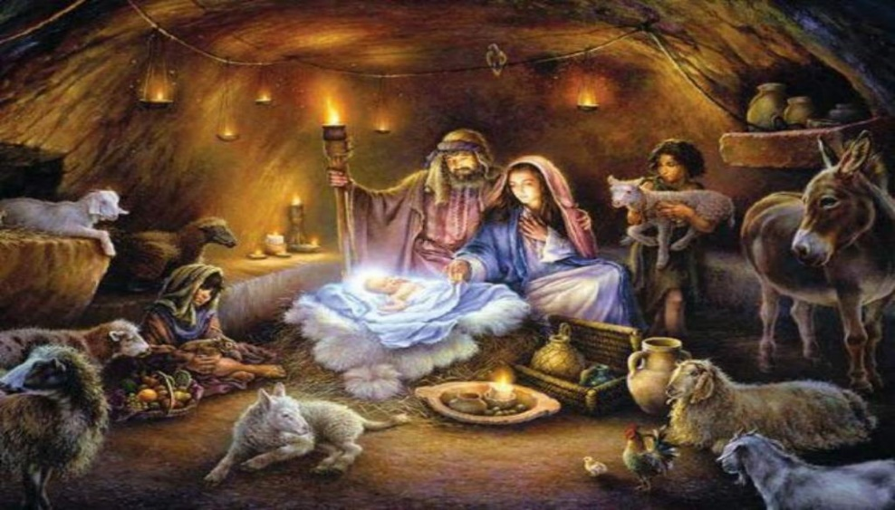

A Christmas Eve Divine Will Reflection
By
Reverend Father B. Thomas Celso, BDV
December 24, 2023

12/25/38 – Vol. 36

The Descent of the Word. How Easy it is to make Jesus be Born as long as we Live In His Will. The Paradise that the Queen of Heaven made Jesus find on earth.

My poor mind continues its path in the Divine Will. O! how Happy It Feels in Seeing that Its little Newborn wanders in search of Its Acts, to know them, Kiss them, Adore them, make them her own, and say: “How much You Loved me.”

I stopped at the Descent of the Word upon earth, and I felt sorry in seeing Him all alone. My sweet Jesus, with Unspeakable Tenderness, surprising me, Told me: “My dearest daughter, you're wrong. Loneliness is part of human ingratitude; but from the Divine side, All Our Works Accompanied Me, Never leaving Me Alone. Further, you must know that The Father and the Holy Spirit Descended Together With Me, while I Still Remained in Heaven With Them. They came down on earth Within Me, since We are inseparable. We Cannot be Separated, not even if We wished to be so—at the Most We Bilocate Ourselves, so as to Maintain Our Throne in Heaven while Forming Our Throne on earth. Being separated—Never. At the Most, the Word Took the Operative Part, but Always With the Concourse of The Father and the Holy Spirit.

“Furthermore, in the act of My Descent from Heaven, everyone moved to be My Court and render Me the Honors I Deserve. The sky Courted Me with All its stars, rendering Me the Honor of My Immutability and of My Everlasting Love. The sun Courted Me, Paying Me the Honor of My Eternal Light—O! how well it Praised the Variety of Its Effects. I can Say that, as I Found Myself With its Light and Heat, in its mute Language it Told Me: ‘You are the Light, and I Honor You, I Adore You, I Love You with the same Light With which You Created me.' All Surrounded Me: the wind, the sea, the little bird—Everyone and Everything, to Give Me the Love and the Glory with which I had Created them. And they Praised My Empire, My Immensity, My Infinite Joys. All Created things made Me a Feast, and if I Cried they Cried Together With Me, because My Divine Will, Residing In them, kept them Aware of All that I was Doing. O! how Honored they Felt, in Doing All that their Creator was Doing. Then I Received the Courting of the Angels, who Never left Me Alone. And since All times Belong to Me, I was also Courted by All the many peoples, who were going to Live In My Will. My Divine Will was Carrying them in Its arms, and I Felt them Beating In My Heart, In My Blood and In My Steps. In Feeling Invested by these people, Loved by My Own Divine Will, I Felt Repaid for My Descent from Heaven to earth.

“This was My Primary Scope: to Reorder the Kingdom of My Divine Will in the midst of My children. I would never have Created the world if I was not to have children who looked like Me and Lived in My Own Divine Will. My Will would find Itself in the same condition as a poor sterile mother who is not able to generate, and therefore form her own family. But My Will does have the Power to Generate and to form Its long Generations—Its own Family.”

Then I continued to think about the descent of the Divine Word, saying to myself: “How could Jesus be Born within our souls?”

And my Dear Baby said: “My daughter, to make Me be Born is the easiest thing—more so, since We do not know how to do difficult things. Our Power facilitates everything. Provided that the creature Lives in Our Will, all is done. As soon as the soul wants to Live in It, she has already formed the home for your Jesus; at the moment she wants to start doing her acts, she Conceives Me; as she does her act, she makes Me be Born. As she Loves in My Will, so she clothes Me with Light, warming Me from the great coldness of the creatures. Every time she gives Me her will to take My Own, I am amused—I have My toy to play with, and I sing My Victory over the human will, feeling like the little Triumphant King.

“See then, My daughter, how easy this is for your little Jesus, because when We find Our Will in the creature, We can do anything. It provides Us with all that is needed and all that We want, to form Our Life and Our Most Beautiful Works. But without Our Will, We remain hampered: now love is missing, now sanctity, now power, now purity, and all that it takes to make Our Life Rise Again and to form It within the creatures. Therefore, all depends on the creatures, since, from Our side, We place Ourselves at their disposal.

“Further, during My Birth, My Divine Mama made Me a Beautiful Surprise with Her Acts, with Her Love—with the Life of My Will that She possessed. She formed My Paradise on earth. She did nothing other than braid the whole Creation with Her Love, laying Seas of Beauty—making Me enjoy Our Divine Beauties within which Her Beauty was Shining. How Beautiful My Mother was—how Beautiful to find Her in the whole of Creation; She made Me enjoy Her Beauty and the Beauty of Her Acts. She spread Her Sea of Love to make Me find Her Love—My Paradise of Love—in all created things. I delighted and exulted in My Mama's Seas of Love. She made for Me, in My Will, the most Beautiful tunes and the most delightful concerts, so that Her little Jesus would not miss the Music of the Heavenly Fatherland. My Mother took care of everything, so that nothing would be lacking of the enjoyment of the Paradise I had left. She kept forming, in each one of Her Acts, New Joys to make Me happy. By just leaning on Her Heart I could feel such Harmonies and Contents as to be Enraptured. By Living in My Will, My Dear Mother carried Paradise in Her lap and let Her Son Enjoy it. All her Acts did nothing less than Make Me Happy and Redouble My Paradise on earth.

“Now, My daughter, let Me Tell you Another Surprise. One who Lives In My Will is Inseparable From me; she is Born Again Each time Together With Me. Therefore, I AM Never Alone. I make her be Born Again With Me to Divine Life—to New Love, to New Sanctity and to New Beauty. She is Reborn In the Knowledge of her Creator—Reborn In each one of her acts. More than this, in Every Act she Does, she Calls Me to be Born Again, forming a New Paradise for her Jesus; and I Make her be Born Again With Me, to Make her Happy. One of My Greatest Joys is to make those who Live Together With Me Happy. Therefore, Be Attentive to Live In My Will if you Want to Make Me Happy—if you Want Me to Find in your Acts My Paradise on earth; and I will take care to make you Enjoy the Sea of My Joy and Happiness. We will Make each other Happy!”

V10- 2.8.11
LUISA ‘Oh! my Jesus, Love are You, You are all Love, and Love do I want, Love I desire, for Love I long; Love I supplicate, and Love I implore of You.
Love invites me, Love is my life, Love kidnaps my heart deep into the womb of my Lord.
With Love He inebriates me, with Love He Delights me, I, all alone, and Only for You! You, alone and Only for me!
Now that we are alone, shall we Speak about Love? O please! let me comprehend how Much You Love me, Because Only in your Heart can one Comprehend Love.’

JESUS "Do you Want Me to Speak to you of Love? Listen, My beloved daughter: My Life is Love. If I breathe, I Love you; if My Heart beats, My heartbeat Says to you: Love, Love. I AM Mad With Love For you. If I move, I add Love for you, With Love I Inundate you, With Love I Surround you, With Love I Caress you, With Love I Dart Through you. With Love I Flash Through you, With Love I Attract you, With Love I Nourish you, and Sharp Arrows I Send to your heart."

LUISA- ‘Enough, Oh my Jesus, for now - I Already Feel Faint With Love; Sustain me In Your Arms, Enclose me In Your Heart, and from Within your Heart, let me too Give Vent to my Love; otherwise I die of Love.
With Love I Rave, with Love I Burn,
With Love I Make Feast, with Love I Languish, with Love I am Consumed; Love kills me and makes me Rise Again More Beautiful to New Life. My life escapes me, and I Feel Only the Life of Jesus, my Love, and In Jesus, my Love, I Feel Immersed and I Love Everyone; He Wounds me With Love, He Makes me ill With Love, With Love He Embellishes me, and makes me ever More Rich. I can say nothing More. Oh! Love, You Alone Understand me, You Alone Comprehend me, my Silence Tells You Even More. In Your Beautiful Heart one Says More by Keeping Silent than by speaking; and by Loving, one Learns how to Love. Love, Love - Speak, You Alone, because being Love, You Know How to Speak of Love.’

JESUS "Do you Want to Hear Love? All Creation Tells you Love. If the stars Twinkle, they Tell you Love; if the sun Rises, it Gilds you With Love. If it Shines With All of its Light in its Full Day, it Sends Arrows of Love to your heart; if the sun Sets, it Tells you:
‘It is Jesus that Dies of Love For you.’
In the Thunders and Lightnings, I Send you Love, and Smacking Kisses I Give to your heart. It is Love that Runs upon the Wings of the Winds; if the Waters Murmur, I Extend My Arms to you; if the Leaves Move, I Clasp you to My Heart; if the Flower Gives out its Fragrance, I Cheer you With Love.
All Creation, in mute language, Tells you, in Chorus:
‘From you Alone Do I Want Life Of Love’.
Love Do I Want, Love I desire, for Love I Beg from Within your heart.
I AM Only Content if you Give Me Love."

LUISA ‘My Good, my All, Insatiable Love, if You Want Love, then Give me Love; if You Want me Happy, then Speak to Me of Love; if You Want me Content, then Render me Love.
Love Invests me, Love Makes me Fly, and Brings me to the Throne of my Maker.
Love Shows me the Uncreated Wisdom.
It Leads me Into the Eternal Love, and there Do I Set my Home. Life of Love, I will Live in Your Heart; I will Love You for All, I will Love You With All, I will Love You In All.

Jesus, Seal me Completely With Love Inside Your Heart; Empty my veins, and instead of blood, let Love flow In them;
Take Away my Breath, and let me Breathe Air of Love;
Burn my bones and flesh, and Weave me Completely - Completely With Love.
May Love Transform me, may Love Conform me,
may Love Teach me how to Suffer With You;
may Love Crucify me, and Make me All Similar To You.”

FIAT!

